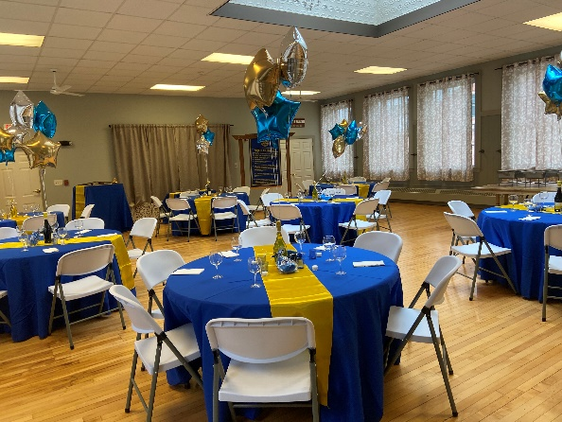
Mitchell Hill BBQ Back Room
Mitchell Hill BBQ at The Roberge

- DEPOSIT

- The Back Room Rental: $50.00 Non-refundable deposit due upon booking date. Rental is scheduled for three hours (3) hours from beginning to end. This includes set up and clean up

- Hall Rental Only: $200.00 Non-refundable deposit due upon booking date. Rental is scheduled for
three hours (3) hours from beginning to end. This includes set up, decorating and clean up.
Additional hours may be booked for $50.00 per hour

*********************************

- PAYMENT METHODS
MITCHELL HILL BBQ REQUIRES A CREDIT/DEBIT CARD NUMBER
IN THE EVENT OF ADDITIONAL FEES INCURRED

- Cash or Check: (made out to Mitchell Hill LLC) can be mailed or dropped off at our restaurant

- Credit Card Payments: (add a 4% convenience fee) You may call the restaurant with your credit card information or stop by our restaurant

- Half The Total is due no later than one (1) month prior to event

- Final Balance is due no later than two (2) weeks before event

- All payments made are nonrefundable and nonnegotiable

- Any modifications to the invoice can be done up two weeks prior to event

- EXTRA FEES

- MH BBQ requires a credit card to be on file at the time of booking. The card will only be used in the event of unforeseen circumstances such as:
- Serve Time: run later than scheduled the Client will be charged an additional fee of
$50.00 per one half (1/2) hour

- Extra Guests: Should there be more guests not already accounted for in the guestlist

- Extra Cleaning Fee: Client agrees to leave the property in its present state of cleanliness.
Client agrees to return the property in the same condition or pay a $50.00 per hour
cleaning fee. This includes any glitter or confetti are used in decorating.
- Balloons filled with confetti and/or glitter are prohibited

- Damages: Client agrees that the building and/or property remain in its present state These may
include (but not limited to) Wall damages i.e., peeling paint due to tape, nails, push pins, tacks and wall stickers. These things are prohibited.

- Service Charge: There will a 18% service charge for all events/functions which require
wait/server staff

- Crock Pots are NOT permitted at Mitchell Hill. Therefore, chafing set ups
may be provided for a fee of $10.00 each

- Bartender Service: $50.00 per hour CASH ONLY BAR

- Linen Service: Upon request (with at least two weeks’ notice) linens may be provided. The fee for
this service is $7.00 per tablecloth

- Formal Table Settings: To include ceramic dinnerware and stainless steel silverware.
Prices to be determined

POLICIES
- MENU
- The Client may provide their own menu choices or choose from Mitchell Hill BBQ catering menu or our restaurant menu. Menu must be confirmed thirty (30) days prior to the event date or Client may be subject to additional charges

- Due to the fluctuating cost and availability of food items, menu prices are subject to change.
Within fourteen (14) days prior to the event. If a change in the menu cost occurs, the Client has
two (2) options:
- Client will pay the additional cost based on the current adjusted price.
- When possible, clients can substitute other menu item(s) to maintain the agreed upon per person price
- PARKING
- There are three parking spaces on Factory Court, located between the Rochester Courthouse and
Collectiques. Municipal parking is available behind the Revolution Restaurant or in the parking lot
across from Lilac City Grill. During the weekends and off hours parking is available at the courthouse, Citizens Bank, or St. Elizabeth Seton School

- During the weekends and off hours additional parking is available Elizabeth Seton School or
Citizens Bank.

- We have one handicap spaces behind the hall on Bridge Street. This entrance has a chair lift to access the hall.

PARKING IS NOT PERMITTED IN ANY OF THE WYNDOTTE FALLS
PARKING SPACES OR VISITOR PARKING SPACES
VEHICLES WILL BE TOWED AT OWNERS EXPENSE
by the Rochester Housing Authority

- DECORATIONS OR DISPLAYS
- Client may supply their own decorations and/or displays, however, all items that are brought in need to go home with you. USING OUR DUMPSTERS IS PROHIBITED

- ALCOHOL: We provide a CASH - ONLY bar serving beer, wine, and basic liquor cocktails. No alcohol
will be served to minors or guests under the influence. At no time shall alcoholic beverages be taken
outside of the building. BYOB is a violation of state liquor laws. Therefore, are prohibited.

- SMOKING: is allowed only in designated smoking area outside of the building. There is a receptacle for disposal purposes. No other trash is to be placed in said receptacle.

- PHOTOGRAPHS: Mitchell Hill BBQ reserves the right to takes photos of events for advertising purposes.

- CATERER LIABILITY:
- Mitchell Hill BBQ does not assume the responsibility for any losses experienced surrounding your event

- Mitchell Hill BBQ does not assume responsibility for any acts of God (loss of power, water, etc.) or
other experiences which are out of our control.
- In addition, any injuries that may happen to you or your guests due to negligence is not the fault of Mitchell Hill BBQ.
- Caterer maintains general liability at the appropriate levels

- CANCELLATION BY CLIENT/VENUE:
- If the event is cancelled within 14 (fourteen) days of the event, all deposits and prepayments are
forfeited.

- All prepayments and deposits ARE NON-NEGOTIABLE AND NON-REFUNDABLE,

- Any additional costs incurred by the Caterer in the preparation of the event will also be charged to the
credit card on file.

- The Caterer reserves the right to terminate this contract for any reason. If the Caterer terminates this contract any time up to 30 days prior to the event date, all deposits and prepayments will be returned in full within 10 days. If the Caterer terminates this contract less than 30 days prior to the event date, all deposits and prepayments will be returned in full within 10 days as well as an additional $500 as penalty.

CONTRACT

Booking Date Fee: Date ______________ Amount: _______________ Reference # ___________

First Half Payment: Date ______________ Amount: _______________ Reference # ___________

Final or Full Payment: Date ______________ Amount: _______________ Reference # ___________

Credit Card Information: ______________________________________________
name on card
__________________________________ ___________ ___________
credit card number security code expiration date

The Parties agree to the terms and conditions stated above as demonstrated by their signatures as follows:
“CLIENT”
Signed: _____________________________________
Date: _______________________________________

“CATERER”
Signed: _____________________________________
Date: _______________________________________
- Enclosures:
- Quote
- Contact Sheet
- Schedule of Events Sheet
- Credit Card information

Attach Receipts To Invoice

01/04/2022

