~ 1 ~
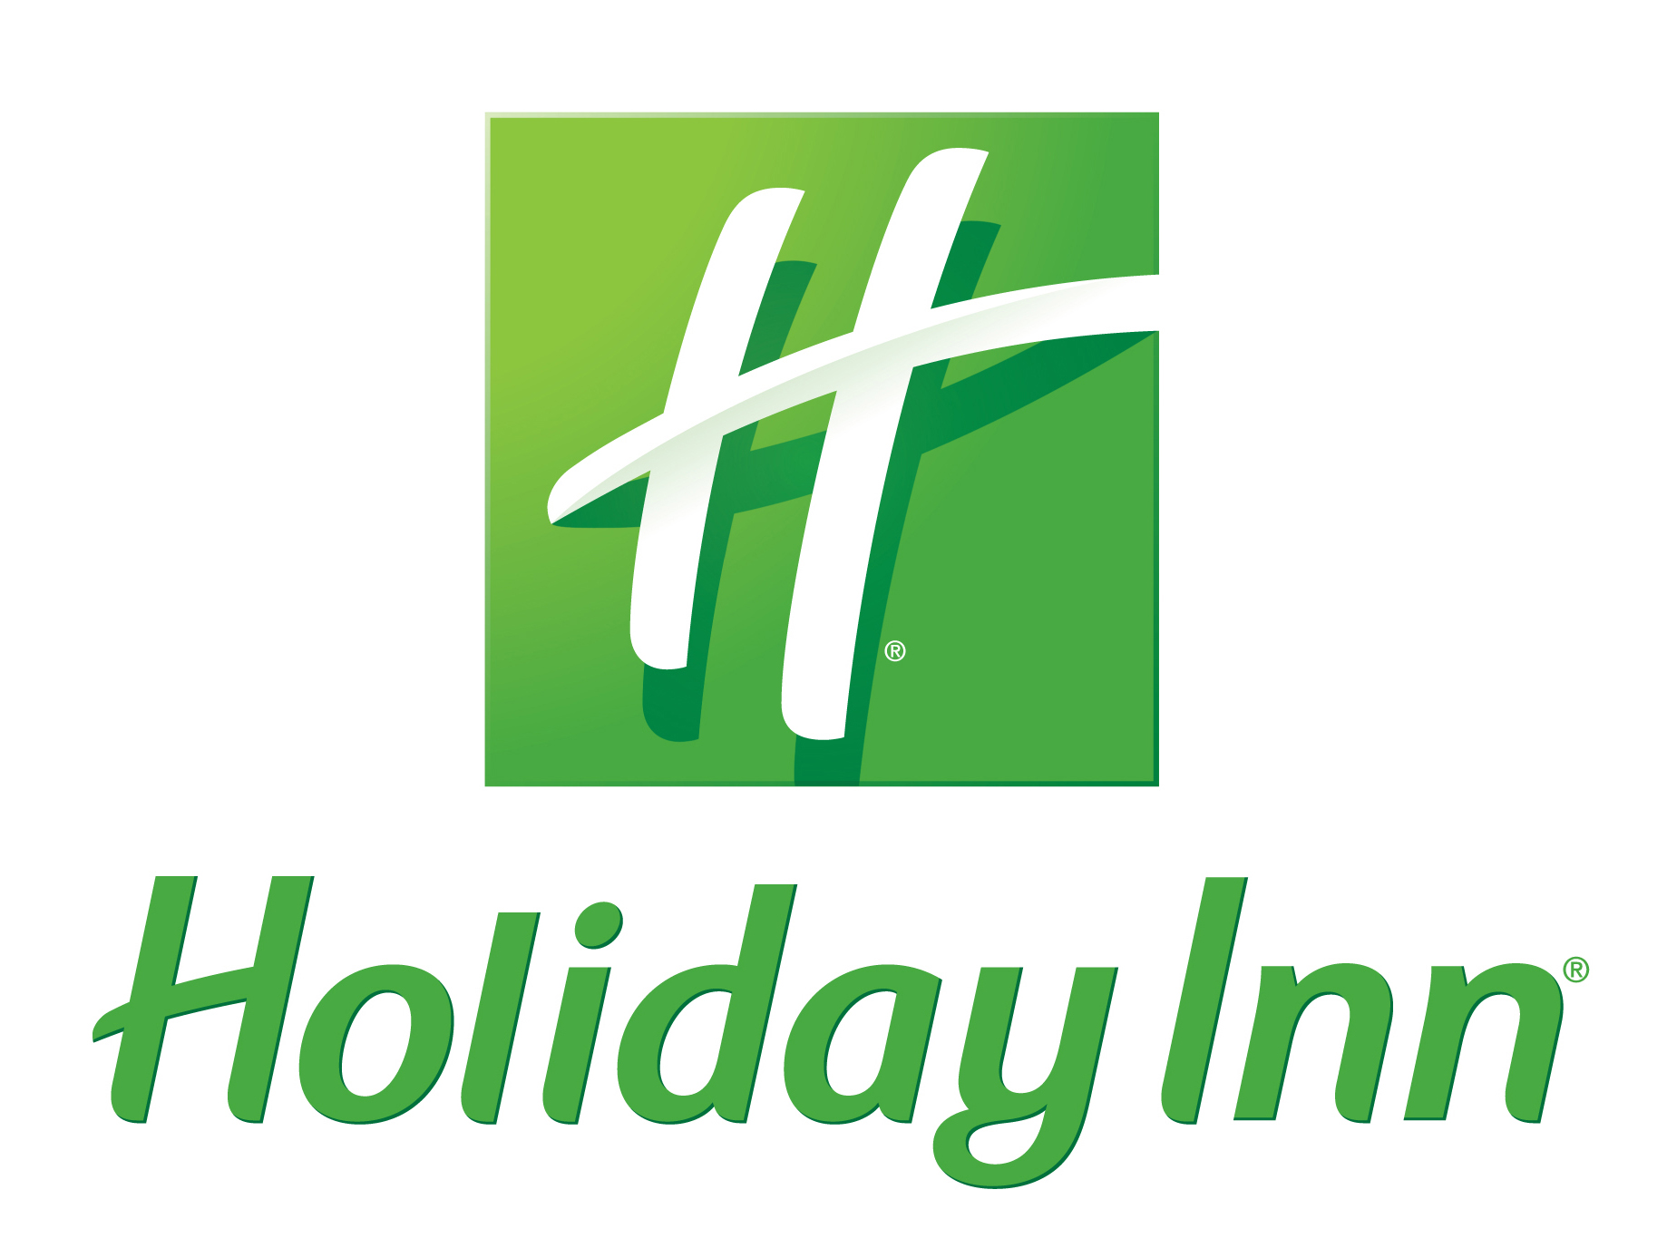

Breakfast Selections

Priced Per Person / Reserved for groups of 16 or more
All Breakfast Buffet Selections include Freshly Brewed Regular and Decaffeinated Coffee,
A Selection of Fine Teas, and a Variety of Breakfast Juices.

The Classic Continental $7.00
An Assortment of Muffins, Pastries & Danish

Light & Healthy $7.25
An Assortment of Yogurt Cups
Sliced Fresh Fruit

Rise & Shine Continental Breakfast Buffet $10.50
An Assortment of Muffins, Pastries, & Danish
Bagels served with Cream Cheese, Butter and Fruit Preserves
An Assortment of Yogurt Cups, Sliced Fresh Fruit

The Good Start Buffet $13.00
Scrambled Eggs, Choice of Bacon - OR - Sausage Links
Home Style Potatoes, Freshly Baked Biscuits*
*Substitute an Assortment of Muffins for .50 per person
*Add: Sliced Fresh Fruit for $2.00 per person

Classic Griddle Buffet $13.00 Your choice of Pancakes – OR – Belgian Waffles
Served with Butter & Warm Maple Syrup, Bacon

French Toast Buffet $13.00
French Toast Casserole Served with Warm Maple Syrup,
Bacon – OR – Sausage Links, Home Style Potatoes

Mornings at Home $16.50
Breakfast Casserole made with Eggs, Cheese, Sausage, Potatoes, &
Red & Green Peppers, Served with Bacon, Freshly Baked Biscuits with Gravy,
Sliced Fresh Fruit

All Prices are Subject to 21% Service Charge and Applicable Taxes
Consuming raw or undercooked meats, poultry, seafood, shellfish or eggs may increase your risk of food-borne illness
~ 2 ~

A La Carte Items
Yogurt Cups $2.25 per person
Assorted Whole Fruit $2.00 per person
Assorted Granola Bars $1.75 per person
Assorted Nutri-Grain Cereal Bars $1.75 per person
Assorted Dry Breakfast Cereals with Milk $2.75 per person
Sliced Fresh Fruit $3.50 per person
Assorted Danish $19.50 per dozen
Bagels with Cream Cheese $23.00 per dozen
Assorted Scones $23.00 per dozen
Large Blueberry Muffins $26.50 per dozen
Coffee Cake $21.00 per dozen servings
Warm Soft Pretzels with Mustard $2.50 per person
Warm Tortilla Chips & Salsa $3.00 per person
Fresh Popped Popcorn $2.00 per person
Assorted Large Freshly Baked Cookies $2.50 per person
Turtle Brownies $2.50 per person
Assorted Candy Bars $1.75 per person
Assorted Individual Bags of Chips $1.75 per person

Beverage Selections

Bottled Water $3.00 each**
Assorted Sodas $3.00 each**
**per consumed

Milk Half Pints (Choose 2%, Skim, Chocolate, or Assorted) $1.50 each
Carafe of Fresh Juice (Choose Apple, Cranberry, Pineapple, Orange) $6.00 each (serves 5)
Pitcher of Iced Tea $6.00 each (serves 5)
Pitcher of Lemonade $6.00 each (serves 5)

All Prices are Subject to 21% Service Charge and Applicable Taxes
Consuming raw or undercooked meats, poultry, seafood, shellfish or eggs may increase your risk of food-borne illness

~ 3 ~

Lunch Selections

Priced Per Person / Reserved for groups of 16 or more
All Lunch Buffet Selections include Freshly Brewed Regular and Decaffeinated Coffee,
A Selection of Fine Teas, and Freshly Brewed Iced Tea, unless otherwise stated.

Soup & Salad Buffet $14.50
Your choice of 1 Freshly Made Soup*,
Tossed Field Greens Salad with a selection of Salad Bar Toppings and Assorted Dressings
Served with Warm Rolls and Fresh Baked Cookies
Soup Selections: (choose 1)
Enchilada Soup Roasted Vegetable with Rice Chicken Noodle
Clam Chowder Broccoli and Cheese Potato and Ham
*Add a 2nd soup for $2.75 per person
*Add a Selection of Pre-Made Sandwiches for $2.75 per person

Classic Sandwich Buffet $15.75
A Selection of Freshly Sliced Deli Turkey, Ham, & Roast Beef,
Served with an Assortment of Breads, Cheeses, Lettuce, Tomato, & Onion
Individual Bags of Chips, Pickle Spears, A Selection of Whole Fruit, Large Freshly Baked Cookies
Bottled Waters & Assorted Sodas
*Substitute our Signature Pub Chips for .50 per person

*Add a Soup for $2.75 per person*
*Add a Salad $2.25 per person*

Lunch Selections Continued on Next Page . . . All Prices are Subject to 21% Service Charge and Applicable Taxes Consuming raw or undercooked meats, poultry, seafood, shellfish or eggs may increase your risk of food-borne illness

~ 4 ~

Lunch Selections

Priced Per Person / Reserved for groups of 16 or more
All Lunch Buffet Selections include Freshly Brewed Regular and Decaffeinated Coffee,
A Selection of Fine Teas, and Freshly Brewed Iced Tea unless otherwise stated.

Road Trip Deli Buffet $18.00
Fresh Selection of Turkey, Ham, and Roast Beef, Chicken Salad
Served with an Assortment of Breads, Cheeses, Lettuce, Tomato, & Onion
Pasta Salad, Pickle Spears, Our Signature Pub Chips
Brownies and Fresh Baked Cookies

Treat of the East Buffet $18.00
Your choice of Chicken, Beef, or Shrimp stir fry.
Comes with Fried or White rice, a mixture of vegetables.
Egg rolls, fortune cookies, Egg drop soup, rice pudding

South of the Border Buffet $18.75
Seasoned Ground Beef, Fajita Chicken with Sautéed Onions and Peppers, Hard Taco Shells and
Soft Flour Tortillas, Tortilla Chips and Salsa, Mexican Rice, Refried Beans, Guacamole, Shredded Cheese
Tomatoes, Lettuce, Onions, Sour Cream, Sopapillas

Taste of Italy Buffet $19.75
Caesar Salad, Garlic Bread
Chicken Alfredo or Spaghetti;
Your Choice of Beef – OR - Vegetable Lasagna,
Fresh Vegetable Medley, Cheesecake served with Assorted Toppings

Backyard BBQ Buffet $20.75
Fried Chicken, or Baked Chicken;
BBQ Pulled Pork served with Sandwich Buns or Country Fried Steak with Gravy;
Cole Slaw, Macaroni and Cheese, Baked Beans, Fruit Cobbler

*Add a Soup for $2.75 per person*
*Add a Salad for $2.25 per person*
Lunch Selections Continued on Next Page . . .
All Prices are Subject to 21% Service Charge and Applicable Taxes
Consuming raw or undercooked meats, poultry, seafood, shellfish or eggs may increase your risk of food-borne illness

~ 5 ~

Lunch Selections

Priced Per Person / Reserved for groups of 16 or more
Build Your Own Lunch Buffet
Lunch sized portions of your selected Entrée(s), Served with a Tossed Field Greens Salad with Dressings,
Choice of Dessert, Iced Tea, & Coffee

1 Entrée Buffet $19.75 Includes 1 Entrée Selection and Choice of 2 Side Items & Dessert
2 Entrée Buffet $23.00 Includes 2 Entrée Selections and Choice of 2 Side Items & Dessert

Entrée Choices:
Grilled Chicken Breast with Gravy Chicken Alfredo Beef Lasagna
Marinated Pork Tenderloin Vegetable Lasagna Chicken Marsala
Panko Crusted Whitefish Spaghetti Pesto Penne Pasta
with Grilled Vegetables

Side Item Choices: (choose 2)

Fresh Vegetable Medley Whole Green Beans Glazed Carrots
Steamed Broccoli with Butter Rice Pilaf Herbed Pasta
Garlic Mashed Potatoes Herb Roasted Potatoes Cheesy Potatoes

Dessert Choices: (choose 1)

Sander’s Chocolate Bumpy Cake New York Style Cheesecake Turtle Brownies
Apple Pie Fresh Baked Cookies Chef’s Selection
Fruit Cobbler Lemon Bars

*Add a Soup for $2.75 per person*
*Add an Additional Side Item for $2.20 per person*

All Prices are Subject to 21% Service Charge and Applicable Taxes
Consuming raw or undercooked meats, poultry, seafood, shellfish or eggs may increase your risk of food-borne illness

~ 6 ~

Snack Breaks

Priced Per Person, 16 person minimum
Movie Time $7.25
Freshly Popped Popcorn & Assorted Candy Bars
Sodas & Bottled Water

Yogurt Parfaits $8.00
Make your own Yogurt Parfait with Vanilla Yogurt, Granola Cereal,
Fresh Blueberries, Fresh Strawberries, Served with Sodas & Bottled Waters

Fiesta Siesta $8.00
Warm Tortilla Chips Served with Salsa, Sour Cream,
And Freshly Made Guacamole
Sodas & Bottled Water

Grandma’s Cookie Jar $9.50
An Assortment of Large Freshly Baked Cookies, Chocolate Brownies
Sodas & Milk

Make Your Own Trail Mix Bar $10.00
Create your own customized snack mix with Sunflower Seeds, Mini Pretzels,
Raisins, M&M’s Candies, and Peanuts.
Served with Assorted Sodas and Bottled Waters

Health Break $10.50
Granola Bars, Nutri-Grain Bars, Assorted Whole Fresh Fruit,
Assorted Yogurts, Bottled Water

7th Inning Stretch $11.00
Warm Soft Pretzels served with mustard, Freshly Popped Popcorn
Roasted Peanuts, Tortilla Chips with Salsa
Assorted Sodas and Bottled Water

All Prices are Subject to 21% Service Charge and Applicable Taxes
Consuming raw or undercooked meats, poultry, seafood, shellfish or eggs may increase your risk of food-borne illness

~ 7 ~

Hors D’Oeuvres
Cold Hors d’Oeuvres Selections

Antipasto Platter Serves 50 $135.00
An Assortment of Ham, Salami, Olives, Marinated Mushrooms, Green and Red Peppers,
and Provolone Cheese Cubes

Assorted Cheese Tray Serves 50 $135.00
Cubed Dill Havarti, Pepper Jack, Cheddar, Swiss, and Smoked Gouda.
Served with an Assortment of Crackers, and Garnished with Fresh Fruit

Fresh Fruit Tray Serves 50 $125.00
Sliced Seasonal Fresh Fruit, Melons, and Berries.

Vegetable Crudité Serves 50 $110.00
Yellow Squash, Zucchini, Carrots, Celery, Broccoli, and Green and Red Peppers
Served with a Dill Vegetable Dip

Classic Shrimp Cocktail 50 Shrimp $200.00
Steamed Jumbo Shrimp served with Fresh Lemon and Cocktail Sauce

Dessert Table Serves 50 $250.00
Chef’s Selection of Assorted Desserts

Hot Hors d’Oeuvres Selections
50 pieces per Order

Chicken Quesadillas $75.00
Meatballs (Choose Sweet & Sour, Swedish, or BBQ)(serves 50) $75.00
Chicken Tenders with Dipping Sauce $80.50
Spinach & Artichoke Dip with Tortilla Chips (serves 50) $110.00
Boneless Chicken Wings (choose Plain, Honey BBQ or Buffalo Style) $85.00
Mozzarella Cheese Sticks with Marinara Dipping Sauce $75.00
All Prices are Subject to 21% Service Charge and Applicable Taxes
Consuming raw or undercooked meats, poultry, seafood, shellfish or eggs may increase your risk of food-borne illness

~ 8 ~

Dinner Selections

Priced Per Person / Reserved for groups of 16 or more
All Dinner Buffet Selections include Freshly Brewed Regular and Decaffeinated Coffee,
A Selection of Fine Teas, and Freshly Brewed Iced Tea.

Southern Style Dinner Buffet $23.00

Tossed Field Greens Salad with Dressings, Cole Slaw
Fried Chicken, BBQ Pulled Pork served with Assorted Buns
Whole Green Beans, Baked Macaroni and Cheese,
Cornbread served with Whipped Honey Butter
Choice of: Cherry, Peach, or Apple Cobbler (choose 1)

Leaning Tower Dinner Buffet $25.00

Antipasto Tray, Caesar Salad
Chicken Alfredo or Spaghetti;
With Beef - OR - Vegetable Lasagna,
Steamed Broccoli, Roasted Vegetable Medley,
Served with Garlic Bread
Cheesecake served with Assorted Toppings

Fiesta Dinner Buffet $24.00

Seasoned Ground Beef, Fajita Chicken with Sautéed Onions and Peppers, Sliced Fajita Beef
Hard Taco Shells and Soft Flour Tortillas, Tortilla Chips and Salsa, Mexican Rice, Refried Beans,
Mexican Corn and Black Bean Salsa, Guacamole, Shredded Cheese
Tomatoes, Lettuce, Onions, Sour Cream, and Churros for dessert

Lucky Bamboo Dinner Buffet $24.00

Your choice of Chicken, Beef, or Shrimp stir fry.
Comes with Fried or White rice, a mixture of vegetables.
Egg rolls, fortune cookies, Egg drop soup, rice pudding

*Add a Soup for $2.75 per person*

All Prices are Subject to 21% Service Charge and Applicable Taxes
Consuming raw or undercooked meats, poultry, seafood, shellfish or eggs may increase your risk of food-borne illness

~ 9 ~

Dinner Selections

Priced Per Person / Reserved for groups of 16 or more

Build Your Own Dinner Buffet
Served with Choice of Salad, Warm Rolls, Butter, Choice of Dessert, Iced Tea, & Coffee

2 Entrée Buffet $25.50 Includes 2 Entrée Selections and Choice of 2 Side Items
3 Entrée Buffet $28.50 Includes 3 Entrée Selections and Choice of 2 Side Items

Salad Choices (choose 1)

Tossed Field Greens with Dressings
Classic Caesar Salad with Parmesan Croutons tossed with a Caesar Dressing
Spinach Salad with Cranberries, Walnuts, Blue Cheese Crumbles, & Raspberry Vinaigrette Dressing
Fresh Fruit Salad

Entrée Choices:

Salmon with Lemon Dill Sauce Pesto Grilled Chicken Chicken Alfredo
Marinated Pork Tenderloin Vegetable Lasagna Beef Lasagna
London Broil Grilled Chicken with a Hunter Style Sauce Chicken Marsala
Panko Crusted Whitefish Pesto Penne Pasta with Grilled Vegetables

Side Item Choices: (choose 2)

Fresh Vegetable Medley Green Beans Almandine Glazed Carrots
Steamed Broccoli with Butter Rice Pilaf Herbed Pasta
Garlic Mashed Potatoes Herb Roasted Potatoes Cheesy Potatoes
Whole Green Beans Roasted Asparagus

Dessert Choices:

New York Style Cheesecake Turtle Brownies Apple Pie Key Lime Pie Carrot Cake
Chef’s Selection of Assorted Desserts Sander’s Chocolate Bumpy Cake with Raspberry Sauce

*Add a Soup for $2.75 per person*
*Add an Additional Side Item or an Additional Salad for $2.25 per person

All Prices are Subject to 21% Service Charge and Applicable Taxes
Consuming raw or undercooked meats, poultry, seafood, shellfish or eggs may increase your risk of food-borne illness
~ 10 ~

Bar Menu

Host Bar / Cash Bar Service
Bartender Fee $15.00 Per hour

Domestic Beer $5.00 each House Brand Liquor $6.00 each
Imported Beer $6.00 each Call Brand Liquor $7.50 each
House Wine $7.00 per glass Deluxe Brand Liquor $9.50 each

Prices include Sales Tax & Applicable Service Charges

Bar Additions

Champagne Punch $85.00 per gallon
Bloody Mary Punch $85.00 per gallon
Screwdriver Punch $85.00 per gallon
Assorted Soft Drinks $3.00 each

In Accordance with State and County Liquor Laws, the Hotel must provide all Alcoholic Beverages.

All guests will be required to show proper identification to prove they are of legal drinking age in the State of Michigan.
Changes made 9/5/2019

