palacio maria – KATY’S event center* 6 HR. EVENT TIME
* 4 HR SET UP (OR THE DAY BEFORE IF WE HAVE NO EVENT)
* TABLES AND CHAIRS WITH TABLE CLOTHS, CHAIR COVER, OVERLAY, SASHES AND CENTER PICES WITH FLOWERS.
* MAIN TABLE OR SWEETHEART TABLE, CAKE TABLE, GIFT TABLE, PHOTO EASEL
* EVENT MANAGER AND STAFF (WAITERS)
* DINNER (SIT DOWN DINNER STYLE)
* FULL TABLE SETTING (CHARGER, GLASS GOBLET, LINEN NAPKIN & CUTLERY SET)
* UNLIMETED SOFT DRINKS, ICE TEA, COFFEE AND WATER
* CAKE BY MILLION CAKES
* SECURITY
* DJ AND PHOTOBOOTH
* PHOTO AND VIDEO
*CLEAN UP BEFORE, DURING AND AFTER THE EVENT
COMPLEMENTARY: WE PLACE A DECORATED TABLE FOR YOUR DESSERTS OR FRUIT.

ELEGANT PACKAGE/PAQUETE ELEGANTE

friday saturday sunday
100 $ 16,750 $ 17,500 $ 15,750
140 $ 17,750 $ 18,750 $ 16,750
200 $ 24,000 $ 25,500 $ 23,000
250 $ 26,500 $ 27,500 $ 25,500
300 $ 28,500 $ 29,000 $ 26,500
400 $ 35,333 $ 36,000 $ 34,600

PALACIO MARIA
THE PACKAGE NOT INCLUDE ALCOHOL DRINKS, WE DON’T ALLOW OUTSIDE ALCOHOL DRINKS

palacio maria – KATY’S event center

PHOTOGRAPHY + VIDEOGRAPHY
ELEGANT PACKAGE: ALBUM NOT INCLUDE

* PHOTO SESSION (AT PALACIO MARIA OR KATY AREAS)
* 8 HOURS
* ONE VIDEOGRAPHER
* ONE PHOTOGRAPHER
* ONE PRINT 20 X 30 OR 16 X 20 MOUNTED AND LAMINATED (FRAME NOT INCLUDED)
* HIGHLIGHTS FIL OR DOCUMENTARY VIDEO
* UNLIMITED PICTURES IN FULL RESOLUTION
* DIGITAL COPY OF HIGHLIGHTS FILM OR DOCUMENTARY VIDEO
* THANK YOU CARDS
* REGULAR SLIDESHOW
*THREE LOCATIONS INCLUDED

DJ ENTRETAINMENT + PHOTO BOOTH

* AGENDA ASSISTENCE
* PROFESSIONAL AUDIO SYSTEM
* WIRELESS MICHOPHONES
* TWO 150W LED PAR LIGHTS FOR DANCE FLOOR AMBIANCE
* DESIGNER ELEGANT DJ BOOTH
* PLAYLIST WALCOME
* AMERICAN AND LATIN RHYTHMS
* PROFESSIONAL DRESSED DJ

PALACIO MARIA

palacio maria – KATY’S event center
* 6 HR. EVENT TIME
* 4 HR SET UP (OR THE DAY BEFORE IF WE HAVE NO EVENT)
* TABLES AND CHAIRS WITH TABLE CLOTHS, CHAIR COVER, OVERLAY, SASHES AND CENTER PICES WITH FLOWERS.
* SWEET TABLE, CAKE TABLE, GIFT TABLE, PHOTO EASEL
* EVENT MANAGER AND STAFF (WAITERS)
* DINNER (BUFFET STYLE)
* FULL TABLE SETTING (CHARGER, GLASS GOBLET, LINEN NAPKIN & CUTLERY SET)
* UNLIMETED SOFT DRINKS, ICE TEA, COFFEE AND WATER
* CAKE BY MILLION CAKES
* SECURITY
* DJ AND PHOTOBOOTH
*CLEAN UP BEFORE, DURING AND AFTER THE EVENT
COMPLEMENTARY: WE PLACE A DECORATED TABLE FOR YOUR DESSERTS OR FRUIT.

PRESTIGE PACKAGE/ PAQUETE DE PRESTIGIO

friday saturday sunday
100 $ 12,500 $ 14,000 $ 11,500
140 $ 14,500 $ 15,500 $ 13,500
200 $ 18,000 $ 19,000 $ 17,500
250 $ 20,500 $ 21,500 $ 20,000
300 $ 22,500 $ 23,500 $ 22,000
400 $ 30,000 $ 31,333 $ 29,333

PALACIO MARIA

THE PACKAGE NOT INCLUDE ALCOHOL DRINKS, WE DON’T ALLOW OUTSIDE ALCOHOL DRINKS

palacio maria – KATY’S event center
PRESTIGE PACKAGE
-DJ AND PHOTOBOOTH
* 5 HOURS
* AGENDA ASSISTENCE
* PROFESSIONAL AUDIO SYSTEM
* WIRELESS MICHOPHONES
* TWO 150W LED PAR LIGHTS FOR DANCE FLOOR AMBIANCE
* DESIGNER ELEGANT DJ BOOTH
* PLAYLIST WALCOME
* AMERICAN AND LATIN RHYTHMS
* PROFESSIONAL DRESSED DJ

PALACIO MARIA

palacio maria – KATY’S event center* 6 HR. EVENT TIME
* 5 HR SET UP (OR THE DAY BEFORE IF WE HAVE NO EVENT)
* TABLES AND CHAIRS WITH TABLE CLOTHS, CHAIR COVER, OVERLAY, SASHES AND CENTER PICES WITH FLOWERS.
* SWEET TABLE, CAKE TABLE, GIFT TABLE, PHOTO EASEL
* EVENT MANAGER AND STAFF (WAITERS)
* FULL TABLE SETTING (CHARGER, GLASS GOBLET, LINEN NAPKIN & CUTLERY SET)
* UNLIMETED SOFT DRINKS, ICE TEA, COFFEE AND WATER
* SECURITY
*CLEAN UP BEFORE, DURING AND AFTER THE EVENT

CLASSIC PACKAGE/ PAQUETE CLASICO

friday saturday sunday
100 $ 7,000 $ 7,500 $ 6,500
140 $ 7,500 $ 8,500 $ 7,000
200 $ 12,500 $ 13,500 $ 12,500
250 $ 14,750 $ 15,750 $ 13,750
300 $ 15,750 $ 16,750 $ 14,750
400 $ 19,500 $ 20,500 $ 19,000

PALACIO MARIA

THE PACKAGE NOT INCLUDE ALCOHOL DRINKS, WE DON’T ALLOW OUTSIDE ALCOHOL DRINKS

palacio maria – KATY’S event center

ADDITIONAL SERVICES:

- LIMOUSINE
- PIPE AND DRAPE
- THE ROBOT SHOW
- INVITATIONS
- NATURAL FLOWERS
- ILLUMATION
- MARIACHIS BAND
- LIVE MUSIC
- DANCE FLOOR
- MONOGRAM
- AND MORE………

PALACIO MARIA

PALACIO MARIA BANQUET HALL…….. THE PERFECT VENUE FOR YOU

21728 HIGHLAND KNOLL DR, KATY TX 774500

PALACIO MARIA FLOOR PLAN

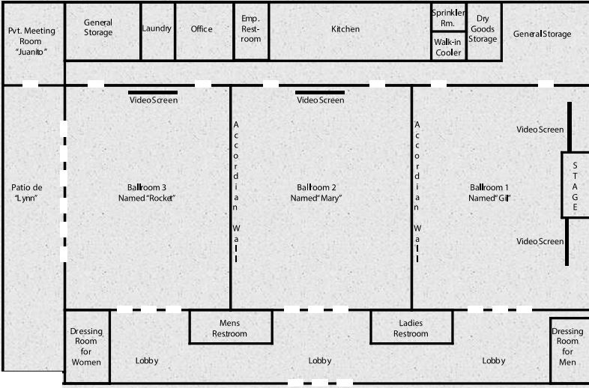

palacio maria – KATY’S event center

- BAR OPTIONS -

- BEER (DOMESTIC OR IMPORTED 24 PER CASE) $60.00 PER CASE

- KEG $ 150 .00

- MARGARITA MIX WITH TEQUILA $ 75.00 PER GALLON

- VODKA, RUM, GIN, BRANDY $ 75.00 PER .750 ML BOTTLE**

- TOPSHELF LIQUOR $ 100 PER .750 ML BOTTLE**

- ** INCLUDE THE MIXERS (CRANBERRY, ORANGE, PINEAPPLE JUICE, TONIC WATER, CLUB SODA, COKE DIER COKE, SPRITE ETC) AND BARTENDER

- OPEN BAR AVAILABLE

- CASH BAR AVAILABLE

PALACIO MARIA

PALACIO MARIA BANQUET HALL…….. THE PERFECT VENUE FOR YOU

21728 HIGHLAND KNOLL DR, KATY TX 774500

