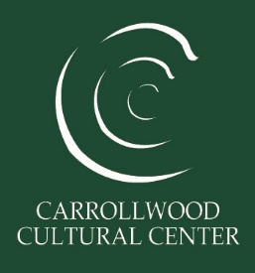

*Deposit - $300 (due at signing of Agreement) REFUNDABLE IF ALL REQUIREMENTS OF THE AGREEMENT ARE MET.

*Deposits ARE EXECUTED, CASHED/CHARGED, etc. Deposit is separate from rental balance.
*RENTAL BALANCE IS DUE (14) DAYS PRIOR TO EVENT.
*THE RENTAL FEE INCLUDES 30 MINUTES BEFORE THE MEETING/EVENT FOR SET-UP AND 30 MINUTES AFTER THE MEETING/EVENT FOR CLEAN-UP (at no additional charge).

Community Room- May be the perfect place for you. As a rectangular space at 815 sq. ft., it is perfect for meetings, baby showers, bridal showers and birthday parties, allowing plenty of floor space for your favorite indoor party games. (maximum of 50 guests) $75 per hour for members $85 per hour for non-members
The Carrollwood Village Room- The space has large ceiling-to-floor windows, which provide plenty of natural sunlight. At 630 sq. ft., the Carrollwood Village Room is perfect for any type of gathering, from discussion groups to board meetings. (maximum of 12 guests) $65 per hour for members $75 per hour for non-members
Meeting Room II- Like the Carrollwood Village Room, it also has large ceiling-to-floor windows and is 670 sq. ft. In addition, this room is next to a warming station with a mini-refrigerator and coffee maker – a convenient area to prepare small lunches and beverages for your event. (maximum of 30 guests)
$65 per hour for members $75 per hour for non-members

- Extra time is at a higher rate per hour.

*Additional fees available upon request.
*All rentals include tables and chairs.

For rental opportunities Please contact:
Rob Curry (Facility Director) 813.269.1310 ext.203 / Rob@CarrollwoodCenter.org
Or
Kimberly Rodriguez (Office Coordinator) 813.922.8167. ext.210 / Kimberly@carrollwoodcenter.org
**Rates are subject to Holiday Pricing **Rates are subject to change without notice.

