Venues
At Sherwood Forest Faire, we consider your wedding to be our special event of the day! Therefore, you are front and center, as our staff is dedicated to help make this the most special day of your lives. Sherwood Forest Faire wants to make your wedding a unique reflection of your relationship. We have three amazing Venues for our Wedding
Celebrations!
Maid Marian’s Chapel, a consecrated Christian church
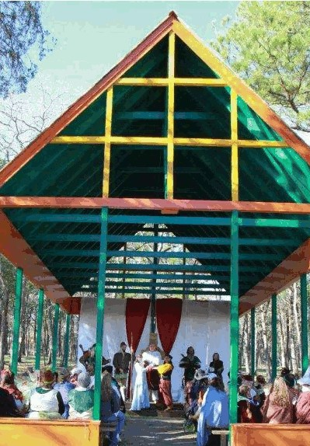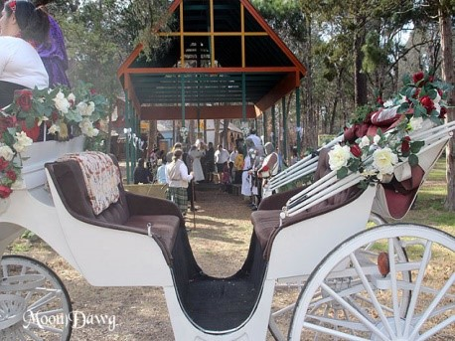

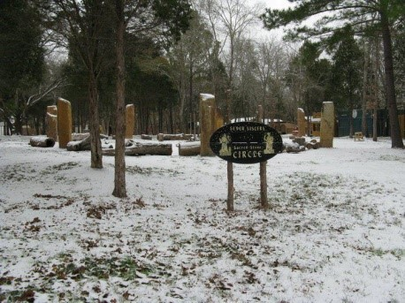
The Seven Sisters Sacred Stone Circle, a consecrated druidic sanctuary

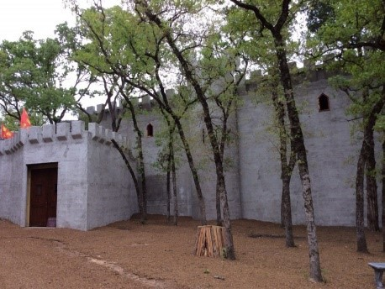
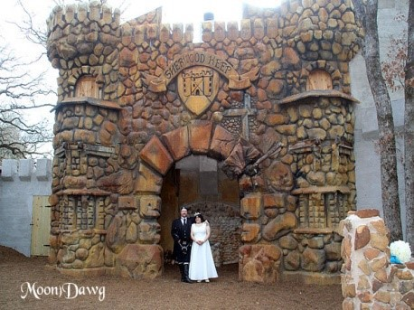
King Richard’s Great Hall in Sherwood Castle, an authentic (yet temperature controlled) medieval Great Hall

Several of our vendors will also provide our couples with special rates for products on their wedding day!

WEDDING PACKAGES

THE ROYAL WEDDING
This wedding is fit for a King and Queen, who may choose to have their wedding held at either location in our village and includes the following:
- Admission for the bride and Groom
- Admission for wedding guests
- Dressing room for the Bride & Groom
- An elegant bridal bouquet and Matching Boutonniere for the groom
- A carriage ride, to and from the castle
- An ordained minister dressed in period clothing
- Widget the Owl flying in the wedding rings
- Ceremony & reception musicians
- Reception in the Great Hall
- Traditionally decorated tables
- A spectacular reception menu
- Exclusive wedding chalices presented by a member of the Royal Court
- Wedding cake
- One night’s stay in the Castle

For 50 guests | $ 9,700
For 75 guests | $ 11,700
For 100 guests | $13,800

THE NOBLE WEDDING
This offering is for that Noble Bride and Groom, who would like their wedding held at either location in our village and includes the following:
- Admission for the bride and Groom
- Admission for wedding guests
- Dressing room for the Bride
- Ceremony musician
- A mixed bridal bouquet and Matching Boutonniere for the groom
- A carriage ride from and to the castle
- An ordained minister dressed in period clothing
- Widget the Owl flying in the wedding rings
- Reception in the Great Hall
- A delightful light reception menu
- Wedding cake
- Exclusive wedding chalices presented by a member of the Royal Court
- 1-night stay in the castle

For 50 guests | $9,300
For 75 guests | $11,100
For 100 guests | $13,000

THE REGAL WEDDING

This offering is for that Regal Bride and Groom, who would like their wedding held at either location in our village and includes the following:

  - Admission for the bride and Groom
  - Admission for wedding guests
  - Dressing room for the Bride
  - Ceremony and reception musician
  - A mixed bridal bouquet
  - A carriage ride from Castle and to Willow’s
  - An ordained minister dressed in period clothing
  - Reception at Willow’s
  - A delightful light reception menu
  - Exclusive wedding chalices presented by a member of the cast
  - Wedding cake
Duke menu

For 10 guests | $4,200
For 25 guests | $5,100
For 40 guests | $7,100
Countess Menu  For 10 guests  For 25 guests  For 40 guests | $4,200  $4,900  $6,900

VOW RENEWAL CEROMONIES
This package is for an intimate ceremony held at either location in our village and
includes the following:
- Admission for the bride and Groom & two guest
  - Dressing room for the Bride
- A mixed bridal bouquet
- An ordained minister dressed in period clothing
- Ceremony musician
- A traditional carriage ride processional to the ceremony
- A carriage ride for the two of you throughout the faire afterwards

Total Fare $1,500

CEREMONY ONLY

This package is for an intimate ceremony held at either location in our village and includes the following:

- Admission for the bride and Groom
- Dressing room for the Bride
- An ordained minister dressed in period clothing
- Ceremony musician
- A traditional carriage ride processional to the ceremony

Total Fare $1,400

Handfasting at 7 Sisters
- Admission for the bride and Groom
- Dressing room for the Bride
- An ordained minister dressed in period clothing
- Ceremony musician
- A carriage ride from the castle

Total Fare $1,100

SHERWOOD FOREST FAIRE A LA CARTE ITEMS
3106 E. HWY 290, PAIGE, TX. 78659
ITEM PRICE
Great Hall Rental Saturday (2 hours) or $ 2,000.00
Great Hall rental on Sunday (3 hours)
Extra flowers for the reception (per Table) $ 25.00
Additional reception musicians $ 275.00 and up
Additional mead or wine per bottle $ 24.00
Soft drinks (24 per case) $ 50.00
Water (48 per case) $ 6.00
Guest Suite (per night) $ 250.00
Keg of Coors Light ½ BBL $ 175.00
Keg of Coors Light ¼ BBL $ 120.00
Prosecco (12 per case) $ 204.00
Barefoot Pinot Grigio (12 per case) $ 200.00
Minister $ 200.00
Handfasting $ 300.00
Carriage Ride (Before & After) $ 200.00
Bartender $ 75.00
Linens $ 200.00
Willows Rental (3 hours) $ 1,000.00

If you desire anything else, all you must do is ask and we will try and make your dreams come
true.

