Bartlett Country Club
Hors D’Oeuvres

Hot Hors D ’Oeuvres
(Price listed Per Fifty Pieces)

Steamed Pot Sticker with Ginger Sauce $75

Boneless Buffalo Chicken with Bleu Cheese Dressing $75

Feta Cheese and Spinach Triangles in Phyllo Dough $75

Chicken Sate with Thai Peanut Sauce $85
Chicken Tenders with Spicy Honey Mustard $85

Seafood Stuffed Mushroom Caps $85

Rolled Black Bean and Cheese Quesadillas $85

Rolled Smoked Chicken Quesadillas $85

Vegetarian Spring Rolls with Sweet and Sour Sauce $85

Chicken Dijonnaise Brochette $100

Maryland Crab Cakes with Spicy Rémoulade $125

Teriyaki Beef Brochette $125

Clams Casino on the Half Shell $125

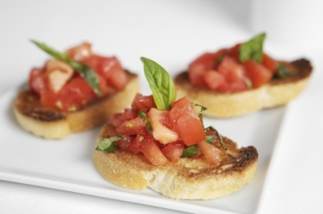
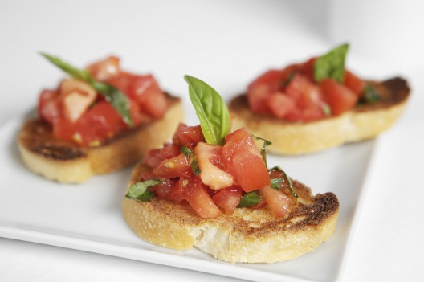
Jumbo Scallops wrapped in Bacon $175

