Exciting Line Dance Party

Looking for great way to relieve stress or are you a mom that needs a mental getaway? What better way to relieve tension and spend time with your friends than to Line Dance!
What to expect:
Have you ever heard of the Cha-Cha Slide? What about the Electric Slide or the Bus-Stop? Perfect Dancing specializes in teaching large groups of beginners the basic steps of Hip-Hop & RnB line dancing. Be ready to have lots of fun and TURN UP with friends and family as we dance and have a ton of excitement!

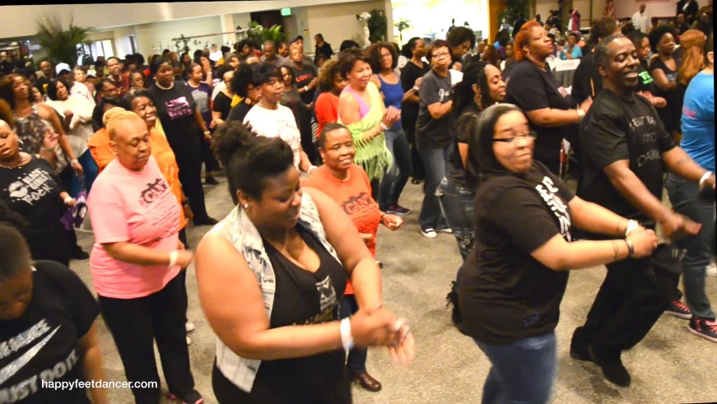
How much are lessons:
Group Class: $100 per hour

BENEFITS:
Dancing has the power to completely transform lives. It's great exercise, fun, builds self-confidence and improves physical coordination.

Where will we practice:
Due to our availability, we are able to travel to your location.
Option 2 we will discuss an enclosed location relatively close to both parties.

Present

Future

1
Instructor: Jesse Harris
Website: perfectdancing.wixsite.com/home
Perfectdancing1
@perfectdancing
@Perfectdancing
I look forward to teaching all levels, contact me today & schedule your 1st lesson!

