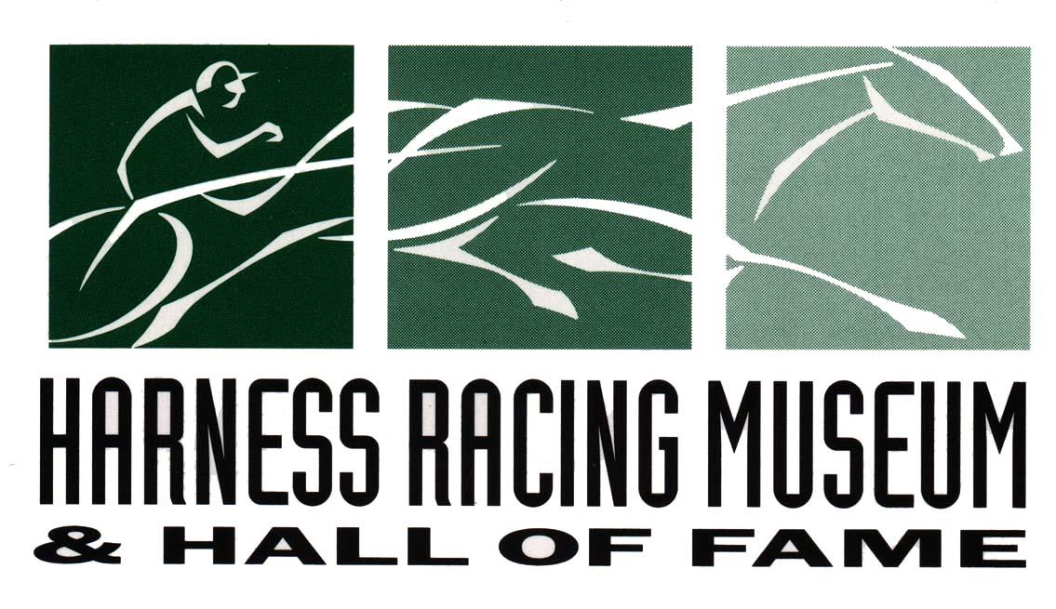

WILLIAM R. HAUGHTON MEMORIAL HALL RATES

Our facilities offer a state-of-the art meeting place for parties up to 120 people, seven days a week. The Museum’s dedicated staff specializes in planning and accommodating training seminars, corporate meetings, fundraisers, family parties, award ceremonies and retirement dinners. We are conveniently located just minutes off Route 17, near major hotels and airports.
OUR ROOM RENTAL PACKAGE INCLUDES:

- Five-hour Rental of Haughton Hall
- Use of adjacent patio and courtyard
- Weekday daytime events include FULL access to Museum exhibits until 3:45 P.M.
- Audio/Visual Equipment: Screen, Easel, Podium and Microphone
- Tables & chairs
- Two hours are given for setup; additional time must be arranged in advance.

WEEKDAY RATES

DAYTIME FIVE-HOUR PACKAGE HALF ROOM (50 guest max) FULL ROOM
BETWEEN 9:00 A.M. and 5:00 P.M. $400.00 $450.00
Monday – Friday
EVENING FIVE-HOUR PACKAGE
BETWEEN 5:00 P.M. and 11:00 P.M. $450.00 $550.00
Monday – Thursday

WEEKEND RATES

DAYTIME FIVE-HOUR PACKAGE HALF ROOM (50 guest max) FULL ROOM
BETWEEN 9:00 A.M. and 5:00 P.M. $450.00 $600.00
Saturday – Sunday
EVENING FIVE-HOUR PACKAGE
BETWEEN 5:00 P.M. and 11:00 P.M. $600.00 $750.00
Friday – Sunday

ADDITIONAL HOURS

Weekday $50/hr Weekend $100/hr
Additional hours must be arranged prior to the event.

SPECIAL EVENT RATES

Wedding Reception - Rental of Haughton Hall for 5 hours $3,000.00
Additional $300 if wedding ceremony is held at Museum

Sweet 16, Quinceañera, Bar mitzvah, Bat mitzvah, Communion,
Confirmation and Graduation Party $900.00

All events must conclude by 11:00 P.M.

Harness Racing Museum & Hall of Fame
240 Main St.
Goshen, NY 10924
845-294-6330; roomrentals@harnessmuseum.com
1/4/2023

