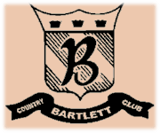
Bartlett Country Club
Hors D’Oeuvres

Chilled Hors D ’Oeuvres
(Price listed Per Fifty Pieces)

Plum Tomato, Fresh Mozzarella and Basil Bruschetta $75

Crabmeat Salad on Crostini $100

Dijon Beef and Asparagus Rolls $100

Shrimp Cocktail Shooters $150
Smoked Duck Breast with Grilled Strawberry and Balsamic Reduction $150

Rare Tenderloin of Beef on Toasted Baguette $150
with Horseradish Cream Sauce and Roasted Red Peppers

Lobster Salad on Tortillas Crisp $150

New Potato stuffed with Shrimp and Pesto Aioli $125

Smoked Salmon Pinwheel $100

Assorted Chef’s Canapés $100

