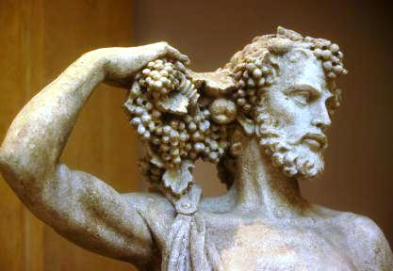
Greek Wine Dinner
Enjoy a selection of boutique wines
paired with a 4 course dinner
created by
German Master Chef, Michael Ober

greek salad
slice of feta
sitting on sliced peppers, cucumber,
sun warmed tomatoes & red onions
marinated in red wine vinegar & greek olive oil
PAPAGIANNAKOS SAVATIANO 2015
*

grilled octopus on creamy tomato sauce
w/ fresh herbs & roasted bread
KARAVITAKIS MERLOT KOTSIFALI KLIMA 2012
*
greek lamb casserole
in red wine & sage
w/ oven roasted potatoes
& baked garlic
PAVLIDIS AGIORGITIKO SYRA THEMA MACEDONIA RED 2013
*
baklava w/ fresh berries
& raspberry marshmallow
SAMOS MUSCAT VIN DOUX 2015

PO Box 8762 WPB FL 33407 PH: 561 339 2444
www.corksandforkscatering.com

