FOUNDATION FOR THE PRESERVATION OF 108 SOUTH JACKSON STREET (FP108SJ)
The Historic Janesville Woman’s Club Building
108 South Jackson Street, Janesville WI 53548 (608)754-4544
PRIVATE PARTY RENTAL AGREEMENT
The Foundation for the Preservation of 108 South Jackson Street (FP108SJ) is a non-profit organization. Rental fees go directly to the maintenance and preservation of the Historic Janesville Woman’s Club building that is on the state and national register of historic buildings.
MEMBER NON-MEMBER
(Member for minimum of 1 year
at date of this contract)
First Floor Rental $175 $300
Add Use of Second Floor $50 $100
Custodial Fee (minimum 3 hours) $20 per hour $20 per hour
Custodial Fee over 6 hours $30 per hour $30 per hour
Custodial Fee over 8 hours $60 per hour $60 per hour
Any Additional Hours Over Contract $100 per hour $100 per hour
June – September Air Conditioning Fee $30 $30
Security Deposit Waived $150
Deposit to Reserve Date and Time $100 $100
(Applied to total fees)
Credit Card Processing Fee 5% 5%

See optional ala carte rentals fees attached.

- Rental is confirmed upon receipt of a check for the deposit of $100 and security deposit (if applicable) of $150 made payable to FP108SJ. You may pay the full rental amount at this time.
- Full refund of fees if cancellation is 45 days or more prior to event date. Fees will be forfeited if cancellation is less than 45 days prior to the event.
- Final payment (rental fee + total custodial fees + AC fee + ala carte rental options) less $100 deposit is due 7 days prior to event. At this time, a walk-through of the building will be completed with the Building Manager and initialed and dated by the person who signed the rental agreement. (See attached). The building will be inspected after the rental. Repair costs of any damage or fees incurred due to the renter and/or their guests (in excess of security deposit for non-members), as well as any additional hours in excess of contract, will be billed within 30 days of the event. In the event that anything should happen as a result of renters use or misuse, they will be responsible for any service calls. (ie fire, police or alarm company and the like)
- Payment is due in full upon receipt of the bill. If there are no damages or additional fees, a refund check for the security deposit will be mailed to the person who signed the rental agreement within 30 days of the event.
- Food and beverages are not allowed in the upstairs art galleries. The upstairs piano must remain covered and may not be used.
- The elevator may be used only under the supervision of the Custodian or FP108SJ representative present during the event.
- Based on availability, early set up or delivery/drop-off of supplies, decorations, etc. may be scheduled with the Building Manager with a minimum of 1-hour custodial fee.
- Please notify the Building Manager of your caterer.
- Champagne, wine and bottled or canned beer/malt beverages are the only alcoholic beverages allowed on the premises. Beer kegs are not allowed.
- This is a non-smoking/vaping facility. A receptacle will be placed outside of the front door. No candles or flammable materials may be used in the building.
- FP108SJ is not responsible for the personal property of the renter and their guests. The property of FP108SJ may not be removed from the building for any reason.
- Please remain 5 feet away from artwork throughout the building.
- Decorations may not be attached to walls or chandeliers.
- NOTE: Security cameras are in use and monitored daily.
TABLES AND CHAIRS
Tables and chairs are included with the rental. Please complete the diagram(s) below and our custodian will have all tables and chairs set up before your event. 20 Card tables, 6 6” rectangular tables, 4 8” rectangular tables, 2 High Top Round tables available.
Due to Building Manager by ________________________.

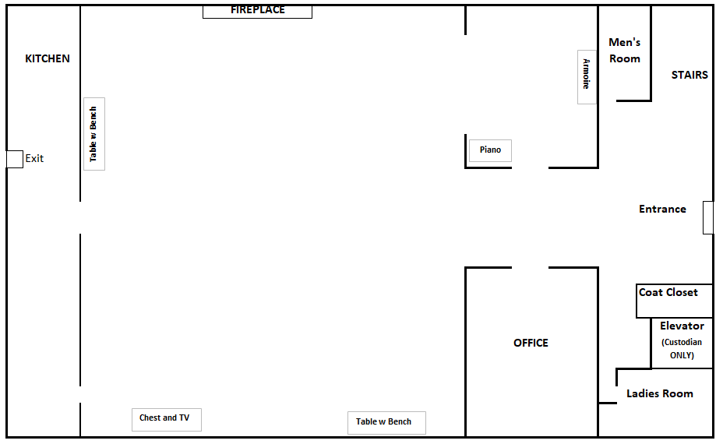

Second Floor (if applicable):
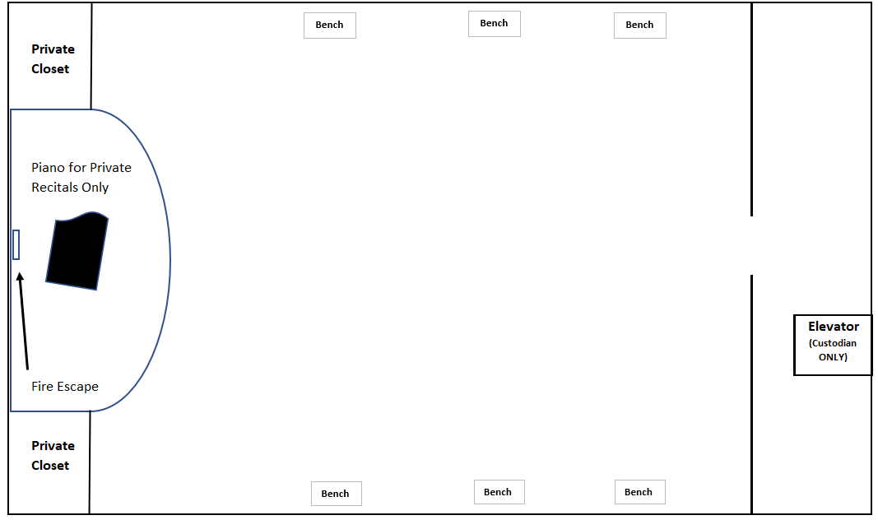

OPTIONAL ALA CARTE RENTAL OPTIONS
TABLECLOTHS High Top Round $15 each
6” or 8” $20
TABLE SETTINGS $100
(Plates, silverware, glasses, etc. regardless of if 1 item or many)

- Any FP108SJ kitchen items used during the event must be wiped clean into the garbage cans supplied in the kitchen and stacked on island. The custodian will wash these items after the event.
- Any FP108SJ tablecloths used during the event must be shaken out of debris, folded, and left stacked on one of the tables. FP108SJ staff will arrange for dry cleaning.
- Before leaving, remove the garbage and recycling from the kitchen and place in the appropriate wheeled bin to the left outside the back door. Extra garbage bags are located under the small sink in the kitchen.

FOUNDATION FOR THE PRESERVATION OF 108 SOUTH JACKSON STREET (FP108SJ)
The Historic Janesville Woman’s Club Building
108 South Jackson Street, Janesville WI 53548 (608)754-4544
PRIVATE PARTY RENTAL AGREEMENT
Client Name: ______________________________ Member of: ___________________
Address: ______________________________ Phone Number: ___________________
______________________________ Email: ___________________
Date of Event: ______________________________ Open Building Time: ___________________
Emergency Contact: Custodian (Ben): 608-208-3836 Event Time: ___________________
Building Manager (Ellen): 608-754-4544 Lock Up Time: ___________________
First Floor Rental ($175 or $300) _________________
Add Use of Second Floor ($50 or $100) _________________
Custodial Fee (minimum 3 hours, $20 per hour) _________________
Custodial Fee over 6 hours ($30 per hour) _________________
Custodial Fee over 8 hours ($60 per hour) _________________
Any Additional Hours Over Contract ($100 per hour) _________________
June – September Air Conditioning Fee ($30) _________________
Security Deposit ($0 or $150) _________________
Deposit to Reserve Date and Time ($100) _________________
(Applied to total fees)
TOTAL RENTAL: _________________

LESS Reservation Deposit and Security Deposit (if applicable): _________________ ______________
OR Check # & Date
5% Credit Card Processing Fee (if applicable) _________________
TOTAL CHARGED TO CREDIT CARD: _________________

BALANCE DUE: _________________ ______________
Due Date
(7 days before event)
_________________ ______________
OR Check # & Date Paid in Full
5% Credit Card Processing Fee (if applicable) _________________
TOTAL CHARGED TO CREDIT CARD: _________________

_________________________________________________ __________________________
Signature Date

_________________________________________________ __________________________
FP108SJ Office Manager Signature Date

Original to Client
Copy to FP108SJ

