Meeting Room | Seating Capacity
Square Footage | 707 sq. ft.
Theatre | 50 people
U-Shape | 20 people
Classroom Style, 2 per table | 40 people
Rounds of 6 | 40 people
Conference Style | 20 people
Hollow Square | 24 people

AC Hotel by Marriott Seattle Bellevue/Downtown
Meeting Space that provides you The Best Experience!
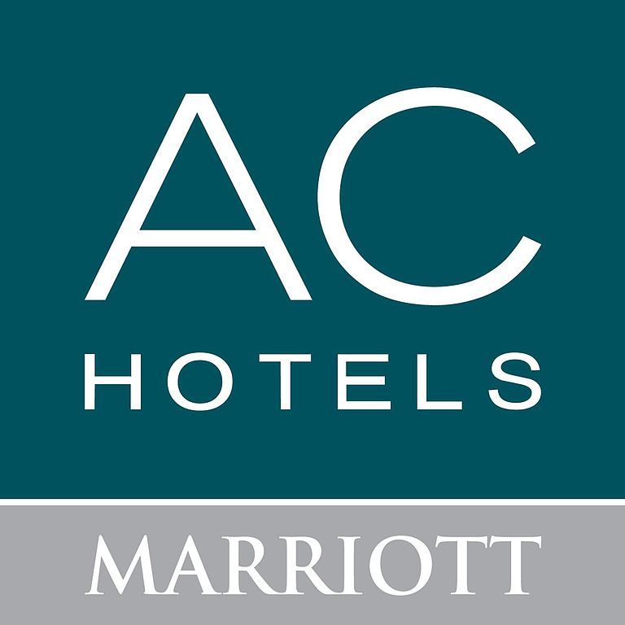
208 106th Pl NE, Bellevue, WA 98004

Sales Team Contact Information:
Maria Luna
Sales Manager
720-694-3733
Maria.luna@ldhg.com

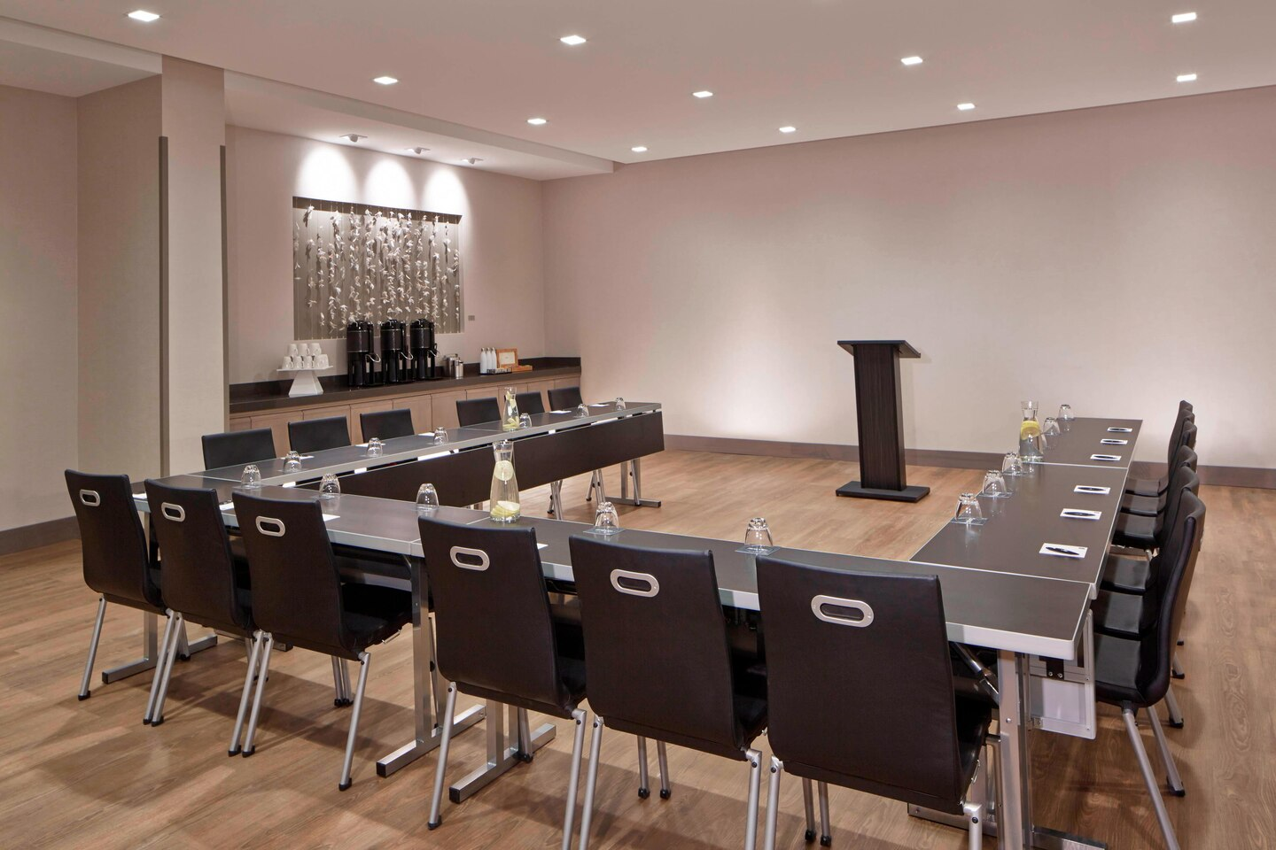
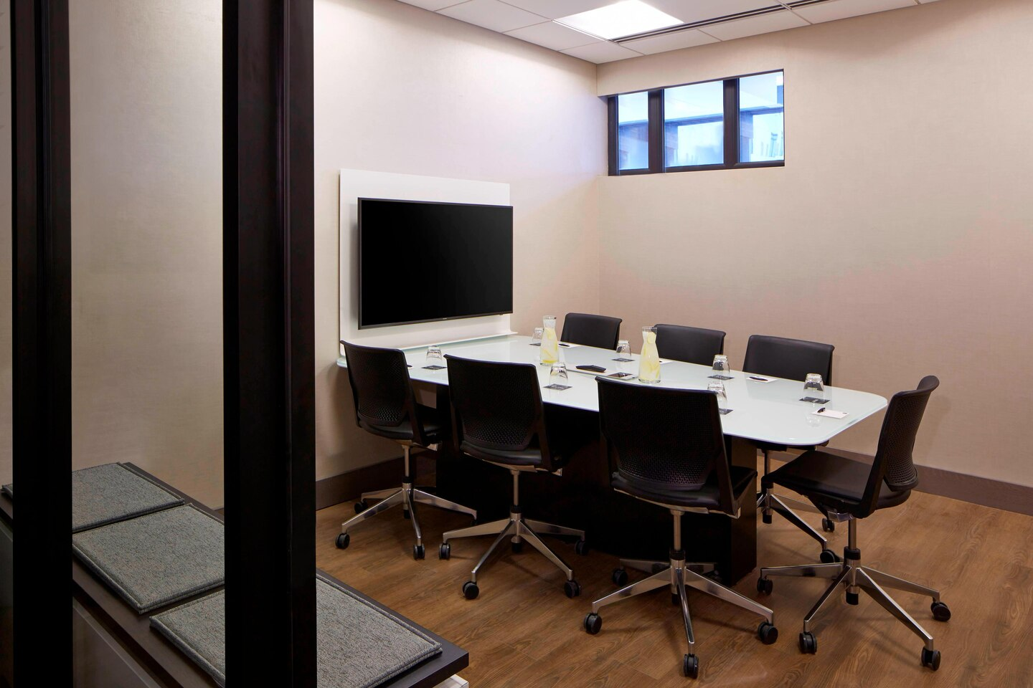
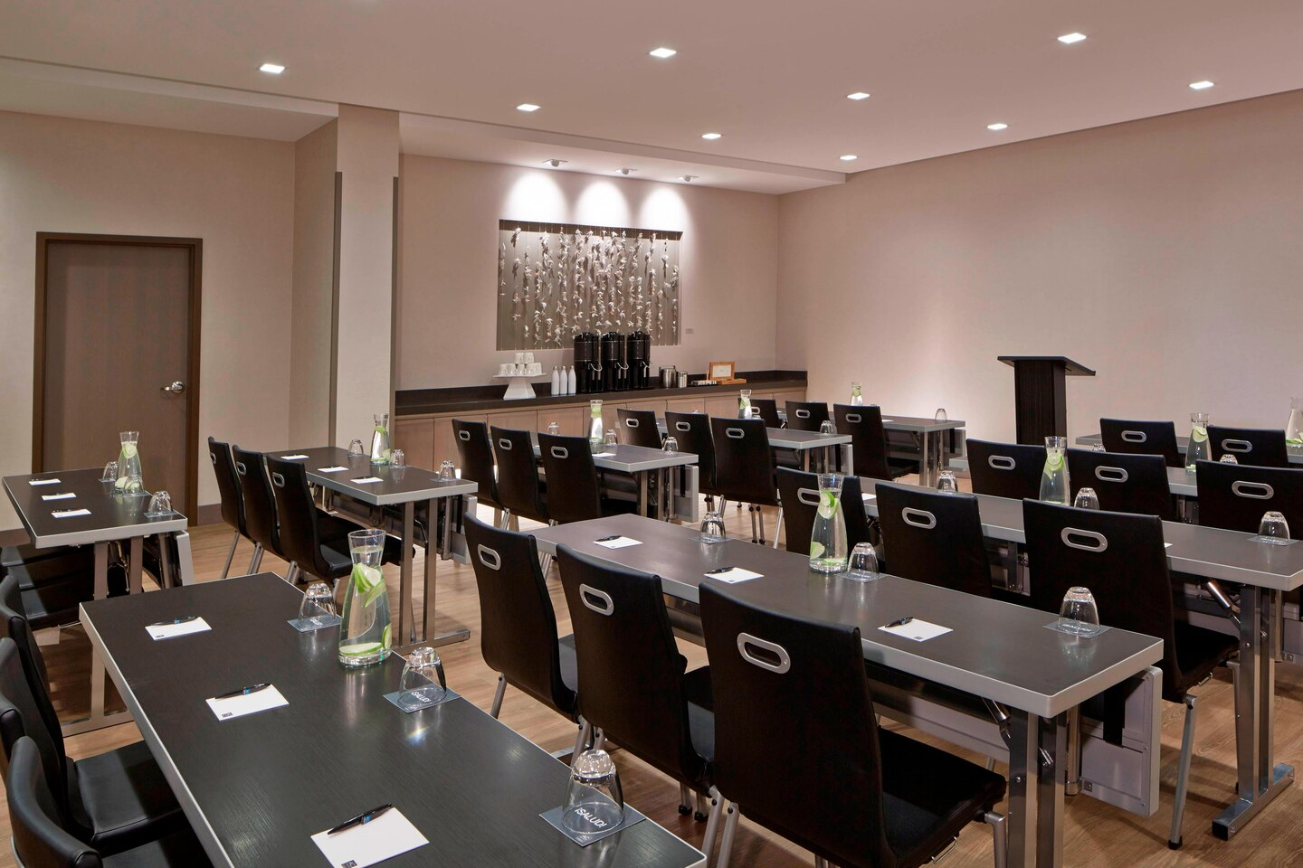
Flexible & Professional for:
- Small Corporate Workshops
- Seminars
- Speaking Engagements
- Meetings
- Strategy Meetings

