KCT Boardroom…… ……… ………………………………..$350
*Rental rates are not available by the hour.

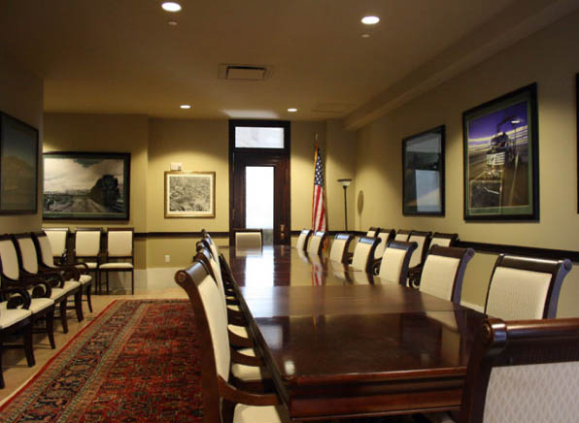
Theatre Seating Capacity: NA
Reception Capacity: NA
Banquet Capacity: NA
Classroom Capacity: NA
U-Shape Capacity: NA
Conference Table: 20

Room Rental Includes:
Furniture:
1 conference table w/ 18 chairs around table
10 additional tables set around perimeter of room.

Audio/Visual:
Room is equipped with 42” LED T.V for presentation.
*client must bring own laptop and cables.
Teleconference
Wifi

Other Amenities:
Balcony overlooking Grand Hall
Private Floor
Railroad Theme Décor

