Italian Wine Dinner
Enjoy a selection of boutique wines from Italy
with a 4 course dinner
created by German Master Chef Michael Ober

Menu
bonito tartare w sweet pea sprouts & hibiscus salt
tomato sorbet & mozzarella pearls
Argiolas Vermentino - Sardinia
*
chicken praline in nut crust
w/crispy pepper ranch bacon
fall vegetable & balsamic honey terrine
Tua Rita Rosso dei Notri – Tuscany
*
beef tenderloin
w/arugula vinaigrette & creamy porcini polenta
Falesco Cabernet Sauvignon – Umbria

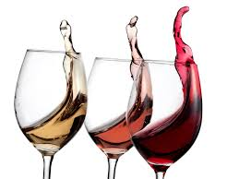
*
“Rosso & Nero”
dark berry ragout & chocolate mousse
w/candied rose petals
Bera Brachetto Sparkling Red – Piedmont

PO Box 8762 WPB FL 33407 PH: 561 339 2444
www.corksandforkscatering.com

