Bartlett Buffet

Artisan Bread Basket
Soup of the Moment

Choice of Any Two Salads:
Seasonal Greens with Gourmet Dressings
Classic Caesar Salad with Parmesan and Garlic Croutons
Greek Salad of Cucumbers, Tomatoes, Kalamata Olives and Feta Cheese
Homemade Potato Salad
Roasted Vegetable Couscous Salad
Marinated tomato, Cucumber, and Red Onion Salad
Penne Pasta Salad
Seasonal Fruit Salad

Entree Selection
Grilled Cider Basted Breast of Chicken
Mushroom Stuffed Breast of Chicken
Herb Chicken with Bourbon Peppercorn Sauce
Braised Beef Burgundy
Grilled Sirloin with Caramelized Shallot Port Glace
Roasted Rosemary Rubbed Pork Loin with Hard Cider Reduction
Grilled Mahi-Mahi with tropical mango Salsa
Ginger Glazed Salmon
Coastal Seafood Penne Pasta with Pesto Cream Sauce
Vegetarian Lasagna
Stuffed Manicotti

With Complimentary Starch and Seasonal Vegetable

Dessert
Chef’s Choice
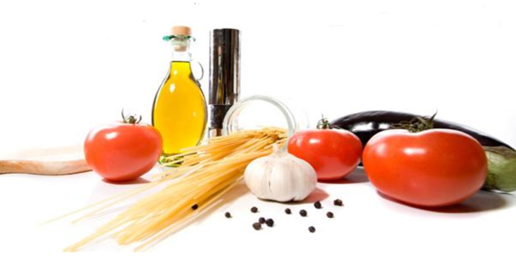
One Entrée: $24 Two Entrées: $26 Three Entrées: $28

