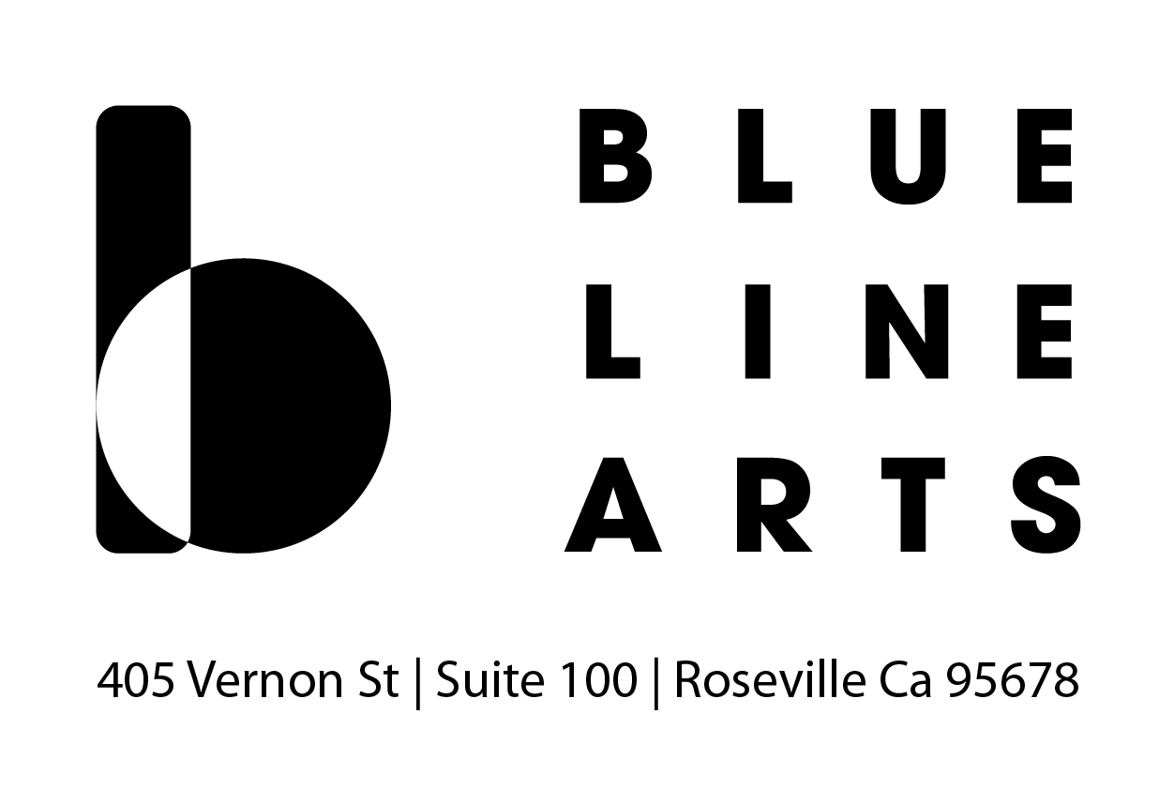
EVENT SPACE RENTAL AGREEMENT AND CONTRACT

Date of Event: | Event Attendance:
Name of Applicant:
Name of Organization:
Address: | City:
State: | Zip:
Primary Phone: | Secondary Phone:
Email Address:
Set-Up Time:
Event Start Time:
Event End Time:
Wrap- Up Time:
Event Description:

About your event:

 | Yes | No
Is your event open to the public?
Is there an admission charge?
Is this a fundraising event?
Will you need use of the kitchen?
Will you need to be serving food or refreshments?
Will you be using a caterer?
Are alcoholic beverages being served?
Are alcoholic beverages being sold?
Will there be a DJ, band, or amplified sound?

Gallery Rental Rates

Hourly Rates
*Education Gallery Max. Occupancy: 65*
*Entire Facility Max. Occupancy: 250*
Member rates based on Turquoise Level Membership or Above

 | Rates per Hour (up to 3 hours) |  | Rates per Hour (over 3 hours) |  | Hours Reserved | Total Amount
 | Non-  Members | Members | Non-  Members | Members
Education Gallery | $125 | $100 | $125 | $100
Entire Facility | $200 | $160 | $260 | $208

Wedding Packages
*Includes set up and clean up time*

Package | # Hours | Non-Members | Members | Package Selected
Full Day – Deluxe | 12 | $3,100 | $2,500
Full Day – Classic | 8 | $2,000 | $1,600
Half Day – Deluxe | 6 | $1,500 | $1,200
Half Day – Classic | 5 | $1,000 | $800
Half Day – Basic | 4 | $800 | $640

Subtotal: | $
Art Removal and Other Additional Fees | $
Grand Total: | $
Rental Deposit (25% of grand total): | $
Security deposit check (due prior to event): | $250 | Date Received
Amount due at time of event: | $ | Date Received

Rental Agreement

Blue Line Arts requires renters to book a free tour and consultation prior to booking a reservation. Our regular hours are Tuesday through Saturday 11am-5pm. Please call (916) 783-4117 or email info@bluelinearts.org to book a tour. To secure date: 25% down & $250 security deposit.

Deposit/Rental Fees:
The gallery is not considered secured until a signed contract has been received accompanied with the deposit of 25% of the total event price and a separate, refundable damage security deposit of $250. All three items must be received in order to reserve your events date(s) and time(s). The remaining balance is due prior to the start of your event. No terms are implied or granted and no work will be allowed to begin until full payment is received.
initial

Insurance and permits:
Special Event Liability Insurance is recommended for renters who would like to ensure peace of mind for themselves and guests concerning possible damage to work in the gallery during an event. Blue Line Arts should be named as an additional insured of any policy.
Applicant shall be responsible for determining and obtaining all necessary licenses and permits required for the event. A permit from the Alcoholic Beverage Control Department, approved by the Roseville Police Department is required for all public/ticketed events where alcohol is being sold.
initial

Catering, Cleaning, Trash and Equipment Removal:
Rental times must include all set up and take down/clean up time. All property of the renter must be removed from Blue Line Arts promptly, during the time specified on the application, and you are required to return the space to the same clean condition in which it was found. Renter is responsible for removing all possessions, garbage and to sweep/ mop if necessary. Events that require more time for breakdown will be charged an additional fee at an hourly rate. If extraordinary cleaning is required, the renter will not be refunded the $250 damage/cleaning deposit. Any garbage left at the end of the event will result in an additional $35 cleaning fee.

initial

Cancellations:
- Cancellations must be done in writing and received 31 days or more in advance of the event to receive a full refund.
- Cancellations received 2 weeks prior to the event will be charged 25% of the rental fee and the damage/cleaning deposit shall be returned.
- Cancellations received less than 2 weeks in advance of the event will be charged 25% of the rental fee and the $250 damage/cleaning deposit.
Cancellation of rental agreement by Blue Line Arts will occur if:
- The application is found to contain false or misleading information;
- Failure to make rental payment or deliver permits within minimum times provided;
- If applicant defaults on or has not completed all conditions and requirements for use of Blue Line Arts;
- Circumstances arise from natural disasters, power outage or other unusual situations;
initial

Equipment/Artwork:
Equipment, artwork, and/or fixtures at Blue Line Arts may not be removed or altered by Applicant under any circumstance.

- Any exhibit (artwork, pedestal, wall, etc.) within Blue Line Arts during the rental period will be left undisturbed and under no circumstances should be moved by anyone other than Blue Line Arts staff. Any moving or storage of artwork must be outlined and approved at time of booking.
- If renter requires removal of artwork, renter will be charged a $25/hour staffing fee for Blue Line Arts staff to remove, store and replace artwork.
initial

Policies and Restrictions:
- Blue Line Arts reserves the right to refuse service to anyone.
- Noise levels within the facility must be consistent with applicable City ordinances (not to exceed 45 decibels in any event).
- No animals, except service animals, are allowed in Blue Line Arts.
- Smoking is prohibited in the gallery, please use the side patio if necessary.
- Exit doors are to be free of tables, chairs, pull out walls, or any other furniture that obstructs entering or exiting the building.
- No open flames larger than a tea light, and no volatile or highly flammable substances are allowed in the gallery. Nothing may be adhered to gallery walls without prior approval by BLA staff.
- Blue Line Arts is not responsible for damage or claims for personal injury or death, or claims for damage or loss of property incurred in the facility;
- Blue Line Arts shall not be liable to applicant for damages in excess of rent agreed to for any cancellation or breach by Blue Line Arts for any reason.
initial

Covid-19 Safety Policies:
Blue Line Arts is required to observe state and local safety procedures related to public health. If the most up to date safety standards cannot be met within your event plan at the time of your event (e.g; restrictions on event attendance), Blue Line Arts reserves the right to cancel your event rental, at which time you will be issued a full refund of your deposit(s). Please keep state and local restrictions in mind when planning for your event.

The hours indicated are the applicant’s arrival and departure time. Unexpended time is not refundable. Blue Line Arts must be promptly vacated at the time specified in the application. Applicant will be liable for payment for the extra time at the rate set forth in the Blue Line Arts Agreement. All time is rounded up to the nearest full hour.

The applicant has inspected Blue Line Arts in order to know the capabilities and limitations of the facility and building before submitting an application. Without limitation, applicant is solely responsible for determining if the electrical capacity, access, restrooms and kitchen of Blue Line Arts are sufficient for the applicant’s needs. Nothing may be stored or left at Blue Line arts prior or following an event without prior authorization from an employee.

Signature of Applicant: Date:

Printed name of Applicant:

Signature of BLA Representative: Date:

Printed name of BLA Representative:

