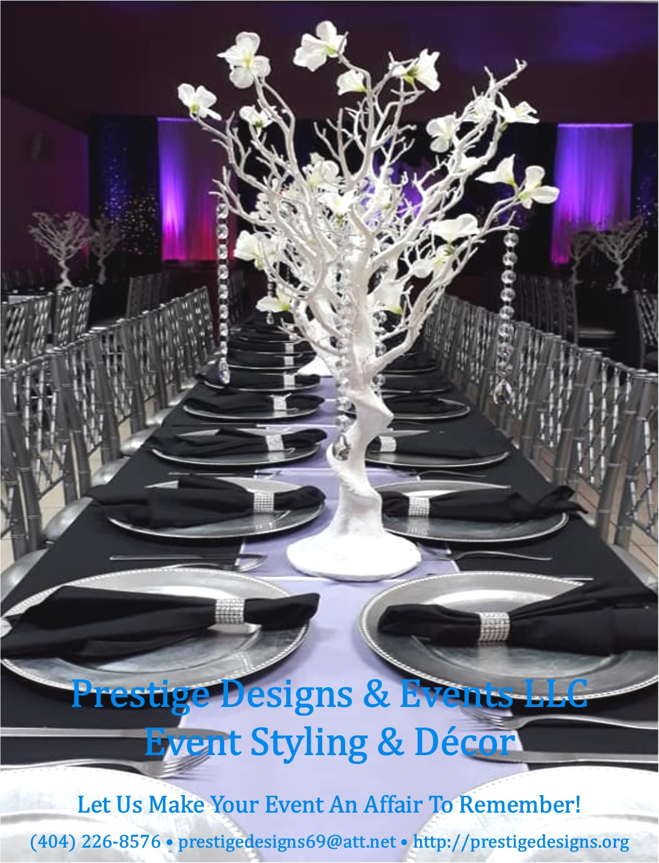

Creating

Unforgettable

Memories

One Event At a Time!

Prestige Designs & Events LLC is a full-service event planning and decorating company based in Decatur, GA. We specialize in weddings, corporate events, launch parties, social celebrations, religious and family gatherings, and much more!

Whether you’re planning a milestone or family celebration for 20 or 200 guests, with our Event Styling & Décor Services we create a design tailored to the unique style you envision for your momentous occasion.

Our Event Planning and Coordinator Services are designed to ensure you, your family and guests enjoy your special day while we handle all of the details. We will assist you with as much or as little as you desire, always working to make sure your dreams become reality.

Your Vision • Your Style • Your Day
We Make It Happen!

Event Planning, Coordination
& Décor Services

Planning events are whirlwind experiences, full of joy and excitement. Let Prestige Designs & Events handle all the arrangements so that you, your family, and friends can experience your special day without having to worry about the details. We will assist you with as much or as little as you desire, always working to make sure your dreams become reality.

Prestige Designs offers a wide range of event planning and coordination services, creative ideas, and advice on proper etiquette for all types and sizes of special events. We are sensitive to your individual needs, style, personality, and budget.

To create the celebration of your dream, we offer the finest in products, needs, and services that are essential for adding a special touch to your momentous occasion:
- Event Consultation & Planning
- Announcements, Invitations, and Programs
- Accessories, Favors, and Thank You Gifts
- Day-of-Coordination
- Recommendation and Onsite Management of Vendors
- Backdrops and Props for Photo Booths
- Decorations, and more.
Please contact us today to schedule a FREE consultation session!

Let Us Make Your Event An Affair To Remember
Denise Wilson
Event Planner & Creative Designer

Event Styling & Décor Services
Based on 50 guests
For clients who have planned everything for their event and need a creative design tailored to the unique style they envision
for their momentous occasion.

Silver Decoration Package: $1,250
• Standard Polyester or Satin Table Cloth
• Standard Chair Covers w/ Matching Sash
• Satin Table Runner or Overlay
• Guest Table Setting w/ Candlelight or Silk Floral Centerpiece
Charger, Dinner Napkin w/ Diamond Holder
• Head Table Decoration w/ Premium Linen,
Centerpiece, and Dinnerware & Setting
• Gift Table Decoration w/ Linen & Decor
• Dessert Table Set-Up with Linen & Décor
• Invitations w/ Envelope
• Customized Treats
• Entrance Signage/Display
• Photo Booth Backdrop w/ Props & Selfie Frame
Additional Guests: $10.00 per guest

Gold Decoration Package: $1,500
• Premium Table Linen
• Spandex Chair Covers w/ Matching Sash
• Sequin Table Runner or Overlay
• Napkins w/ Diamond Holders
• Guest Table Setting w/ Medium Centerpiece & Charger
• Head Table Decoration w/ Premium Linen
• Gift Table Decoration w/ Premium Linen
• Dessert Table Set-Up with Linen & Décor
• Invitations w/ Envelope
• Customized Treats
• Entrance Signage/Display
• Photo Booth Backdrop w/ Props & Selfie Frame
Additional Guests: $15.00 per guest

Pricing is variable and contingent upon customizations, type of linen (chair covers and sashes), centerpieces, backdrops, decorations, place setting (plastic or formal), number of guests, and more. However, we will create an incredible design that will please
your guest and make you smile.

Event Styling & Décor Services
Based on 100 guests
For clients who have planned everything for their event and need a creative design tailored to the unique style they envision
for their momentous occasion.

Silver Decoration Package: $2,500
• Standard Polyester of Satin Table Cloth
•Satin or Polyester Chair Covers w/ Matching Sash
• Satin or Polyester Table Runner or Overlay
• Guest Table Setting w/ Candlelight or Silk Floral Centerpiece
• Head Table Decoration w/ Standard Linen
• Gift Table Decoration w/ Standard Linen & Centerpiece
• Dessert Table Set-Up with Linen & Décor
• Invitations w/ Envelope
• Customized Treats
• Entrance Signage/Display
• Photo Booth Backdrop w/ Props & Selfie Frame
Additional Guests: $10.00 per guest

Gold Decoration Package: $3,000
• Premium Table Linen
• Premium Chair Covers w/ Matching Sash
• Premium Table Runner or Overlay
• Napkins w/ Diamond Holders
• Guest Table Setting w/ Medium Centerpiece & Charger
• Head Table Decoration w/ Premium Linen
• Gift Table Decoration w/ Premium Linen
• Dessert Table Set-Up with Linen & Décor
• Invitations w/ Envelope
• Customized Treats
• Entrance Signage/Display
• Photo Booth Backdrop w/ Props & Selfie Frame
Additional Guests: $15.00 per guest

Pricing is variable and contingent upon customizations, type of linen (chair covers and sashes), centerpieces, backdrops, decorations, place setting (plastic or formal), number of guests, and more. However, we will create an incredible design that will please
your guest and make you smile.

Premium Linen: (available in a variety of colors)
- Table Cloth: Pintuck, Spandex, Flocking Damask, Flocking Taffeta, Sequin, Flamingo Petals, and Rosette.
- Chair Covers: Universal, Spandex, or Chivari Chair Caps.
- Chair Sashes: Organza, Taffeta, Pintuck, Chiffon, Spandex, and Embroidered Organza.
- Table Skirts: Curly Willow Taffeta, Rosetta, and Satin Lamour Ruffle.
- Table Runner: Organza, Sequin, Taffeta, Grandiose Rosette, Shimmering Polyester, Artificial Grass, Couture Tulle, and Lace Netting.
- Overlays: Organza, Taffeta, Pintuck, Sequin, 3D Rosete, Lace, and Razzle-Dazzle Glitter.

Ala Carte Add-Ons:
- King or Queen Throne Chair $350.00

- King and Queen Throne Chair Set $700.00

- Formal Fine China Dinnerware (100 guests) $800.00
(includes dinner plate, dessert plate, salad plate, four-piece flatware, water/wine goblet, and champagne flute). Additional sets at $8.00 per guest.

- Premium Disposable Dinnerware (100 guests) $300.00
(includes dinner plate, dessert plate, salad plate, four-piece flatware, water/wine goblet, and champagne flute – high quality plastic). Additional sets at $3.00 per guest.

- Head Table Backdrop w/ Draping and Uplighting
- 8 ft x 20 ft (head table for up to 10 people) $300.00
- 10 ft x 24 ft (head table for up to 16 people) $400.00

To ensure your décor is set-up according to your vision, we would prefer to set-up the day before the event or three hours on the day-of,
and two hours for breakdown.

Our services only include set-up and breakdown of decorations that we provide. It does not include set-up, breakdown, and moving of tables and chairs provided by the facility or outside vendors.

Event Planning Services

Complimentary Consultation
The initial needs assessment and consultation consists of a meeting with you, your fiancé, family, friends, and any others who may be assisting you in planning your wedding. At this meeting we will explore the type of services available, offering budgeting guidance, answer any questions and get your planning started in the right direction.

Majestic Memories - Full service varies
Majestic Memories event planning is designed for people who “to busy” or “just not sure of what to do.” We will assist with handling all aspects of planning your special day from beginning to end. Services include assistance with:
- Location and selection of event venues (include site visit and price negotiation)
- Research, recommend and manage service vendors
- Schedule appointments and attend meetings with vendors
- Review and manage vendor contracts
- Assist with menu selection and attend food/cake tasking
- Provide list of hotels for out-of-town guests
- Create timeline and day-of itinerary
- Advice on etiquette, protocol and budgeting (cost saving tips and ideas)
- Ideas for event design and décor
- Ongoing and unlimited consultation and advice
- Assist with wording for Save-the-Date, Invitations, Programs and Menus
- Manage RSVP and Guest List
- Day of Coordination (Guests, Vendor, Facility, etc.)

Service Fees
Price | Event Size | Minimum Hours | # of Attendants
$750.00 | 50 - 100 guests | 6 hours included | 2
$900.00 | 100 - 150 guests | 6 hours included | 3
$1,100.00 | 150 – 200 guests | 6 hours included | 4
Includes six hours of service on the day of your event and unlimited consultation and preplanning services. Service fees and minimum hour requirement is based on size of the event.
Opulent Occasions – Day-of-Coordination Varies
Opulent Occasions is designed for couples that have planned all the details of their event, but need someone to coordinate Day-of-Services with their selected venue, vendors, and guests. Services include assistance with:

- Help welcome guests at reception
- Announce entrance of honorees
- MC reception activities (dinner, toasts, dances, and thank-you announcements)
- Serve as liaison to vendors to ensure delivery of contracted services
- Prepare worksheet of music selections
- Assist with menu and music selections
- Ensure enough food is served
- Supervise timelines of reception activities
- Collect and transport gifts
- Assist with event day logistics with vendors
- Facilitate clean-up of facility

Service Fees
There is a six-hour service minimum required for all Day-of-Coordination Services. Service fees and minimum hour requirement is based on size of the event. This includes two hours of early arrival and four hours during the actual reception.

Price | Event Size | Minimum Hours | # of Attendants
$500.00 | 50 - 100 guests | 6 hours included | 2
$600.00 | 100 - 150 guests | 6 hours included | 3
$700.00 | 150 – 200 guests | 6 hours included | 4

These services fees do not include set-up and breakdown of tables, chairs, and decorations provided by other vendors; and cost of vendor services. The only include delivery, set-up, arranging, and take down of all the décor that we provide.
Client is required to secure vendor service before the event.
Additional hours will incur a fee of $75.00 per hour.

