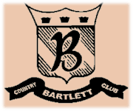
Bartlett Country Club
Dinner Buffet

New England Barbecue
Mixed Green Salad with Gourmet Dressings
Granny Smith Apple Cole Slaw
Sliced Seasonal Melon
Bread Basket with Cornbread and Honey Butter
New England Style Baked Beans
Chefs Selection of Pies
Selection of Two Entrees:
Barbeque Chicken
Spicy Italian Sausage
Brisket of Beef
Hamburgers
St Louis Ribs
Shrimp Skewers
$23 per Person

Tuscany Buffet
Italian Wedding Soup
Classic Caesar Salad with Parmesan and Garlic Croutons
Fresh Garlic Bread
Antipasto Display
Shrimp and Scallops with a Creamy Sun Dried tomato Pesto over Penne Pasta
Seared Breast of Chicken with Marsala Wine Sauce
Polenta Napolitano
Ratatouille of Eggplant, Squash, Tomatoes and Fresh Herbs
Italian Dessert Display
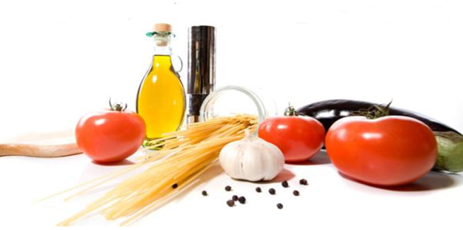
$23 per Person

