LINEN RENTAL

Round Table Linen 85x85 $5.00 each

8ft Table Linen 52x96 $8.00 each

(Table linen comes in Black, White, or Ivory)

Napkin Rental $15.00 per 50 napkins

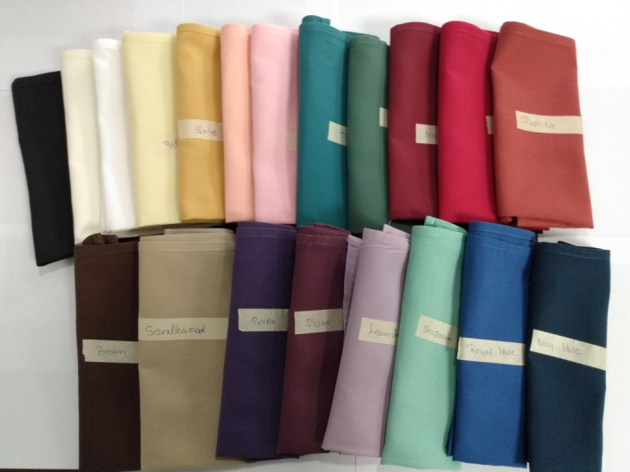

Napkin colors come in; White, Black, Ivory, yellow, gold, pink, peach, teal, green, maroon, red, paprika, brown, sandalwood, purple, plum, lavender, sea foam green, royal blue, navy blue

