Innovation Conference Center ………………………………..$1,200
NEWLY RENOVATED, OPENING JUNE 2017.
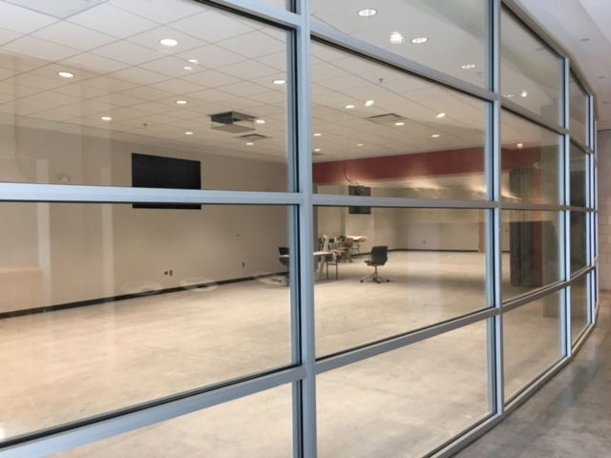
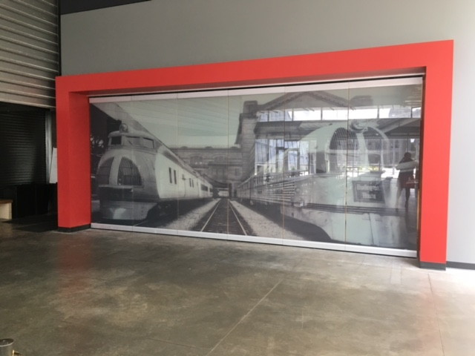

Theatre Seating Capacity: 120
Reception Capacity: 200
Banquet Capacity: 150 (rounds of 10)
Classroom Capacity: 66
U-Shape Capacity: 44

Room Rental Includes:
Furniture:
15- 60” rounds (seat 10) for banquet seating (linens provided)
25-6ft tables for classroom seating (linens are not provided for these tables)
14- 6ft tables for U shape seating (linens are not provided for these tables)
1 6ft registration table w/ black linen
*additional tables/chairs quoted upon request

Audio/Visual: State of the Art upgrades
90" flat screen
2- 75” flat screens
House Sound System (with Bluetooth wireless patching)
Wireless handheld microphone
Medical Imaging Projector
Wifi
Teleconferencing

