Arthur Stilwell.. ….… ……… ………………………………..$1,000
*Rental rates are not available by the hour.
*Max of 8 hour rental time frame.
*Access to the room 1 hour prior to event start time. (extra time may be requested)
*Non-Profit Rates are 20% off standard rate listed above.

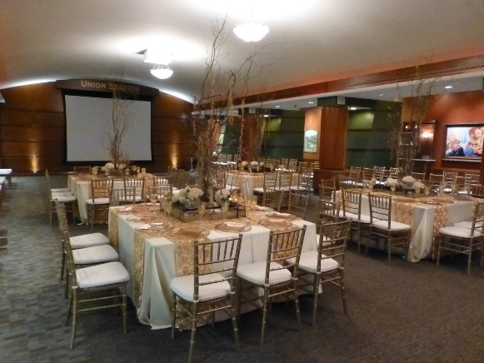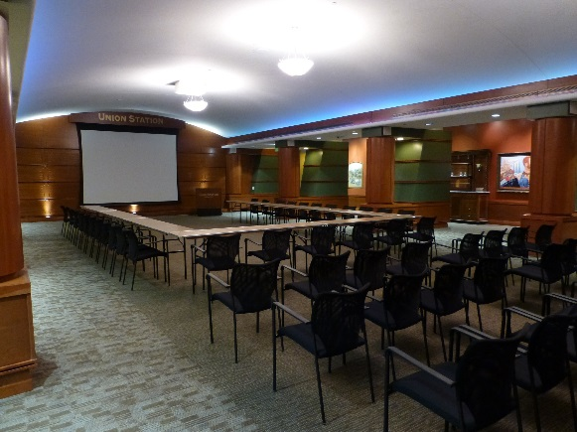

Theatre Seating Capacity: 126
Reception Capacity: 200
Banquet Capacity: 140
Classroom Capacity: 72
U-Shape Capacity: 48

Room Rental Includes:
Furniture:
14- 66” rounds (seat 10) for banquet seating (linens are not provided for these tables)
24-6ft tables for classroom seating up to 72 people (linens are not provided for these tables)
14- 6ft tables for U shape seating of up to 38 (linens are not provided for these tables)
1 6ft registration table w/ black linen

Audio/Visual:
LCD Projector
9’ x 12’ Front projection screen
Built in Sound System
Wireless handheld microphone (up to 4)
Power Point capabilities
*client must provide own laptop, MAC computers require a VGA adapter.
Wi-Fi
Teleconferencing
LED up lighting

