Meetings
Meeting Rooms

Vista Room | Up to 150 Guests

The Main Dining Room provides a
commanding view of the Golf Course.

Room Rental
Daily Rental: $500
Weekend: $1000

Concho Room | Up to 55 Guests

Room Rental

Daily Rental: $200
Weekend: $400

Pinion Room | Up to 225 Guests

Room Rental

Daily Rental: $1000
Weekend: $2000

Breakfast
Buffets
Priced per person unless otherwise noted
Ranchland Hills Continental | $10
Sliced Seasonal Fresh Fruits
Assorted Danish and Scones with Butter and Jams
Orange Juice
Regular and Decaffeinated Coffee
California Continental | $11
Sliced Seasonal Fresh Fruits and Berries
Assorted Yogurts and Granola
Sliced Breakfast Breads
Orange Juice
Regular and Decaffeinated Coffee
Fairway | $12
Scrambled Eggs
Crisp Bacon, & Sausage
Potatoes O’Brien
Fluffy Biscuits with Butter and Jam
Orange Juice
Regular and Decaffeinated Coffee
Enhance your Buffet with:
Honey Butter Fried Chicken Biscuits | $4.95
Egg and Sausage Biscuit | $4.75
Chef Inspired Yogurt Parfaits | $4
Breakfast Tacos and Salsa |$3.75 each (Choice of Bacon, sausage, or potato)
Whole Fruit | $2.50 each

Break Time
Priced per person unless otherwise noted

Beverage Station
Iced Tea | $40 gallon
Regular or Decaffeinated Coffee $50 gallon

Available to add:
Bottled Water | $2.00 each
Sodas | $2.00 each
Gatorade | $2.50
Assorted Juices | $25 gallon
Orange, Apple or Cranberry
Assorted Candy Bars | $2 each
Assorted Bagged Chips | $2 each
Assorted Granola Bars | $2.50 each
Fresh Baked Cookies | $20 a dozen
Chocolate chip, oatmeal, or sugar
Assorted Danish Pastries | $20 dozen
Assorted Muffins | $22 dozen

Sweet and Salty | $5
Assorted Fresh Baked Cookies and Brownies
Pretzels and Snack Mix
Par 3 | $8
Creamy Queso, Fresh Guacamole, and Salsa
Crispy Tortilla Chips
Health Nut | $6
Sliced Fruit with Chef’s Dip
Vegetable Crudites with Ranch Dip
Mixed Nuts

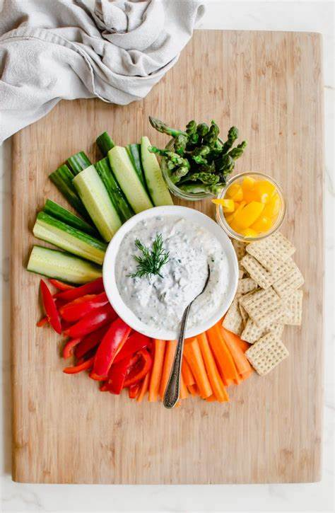
A Bit of Dip | $8
Creamy Artichoke Dip
Hummus
Crispy Tortilla Chips and Pita Bread

Lunch Buffets
Served with iced tea, priced per person
Front Nine | $17
Assorted Garden Salad with Dressings
Sliced Black Forest Ham,
Smoked turkey Breast, and Roast Beef
Assorted Sliced Cheeses
Artisan Breads and Brioche Rolls
Tomatoes, Red Onions, Lettuce, Pickles
Mustard, Mayonnaise, Ketchup
Potato Chips

Back Nine | $19
Seasonal Fresh Fruit Display
Garden Salad with Ranch Dressing
Smoked Turkey and Avocado Wrap
Tomato and Fresh Mozzarella Flat Bread
Grilled Chicken and Roasted Corn Flat Bread

Tuscany | $26
Caesar Salad
Select 2 of the Following Entrees:
Chicken Fettucine Alfredo
Penne Pasta with Marinara Sauce
Beef Lasagna
Sauteed Vegetables
Garlic Bread

Fajitas | $28
Chips and Salsa
Grilled Beef and Chicken Fajitas
With Peppers and Onions
Flour Tortillas
Sour Cream, Shredded Cheese, Lettuce
Borracho Beans
Spanish Rice

Craving Something Sweet?
Add one or more of these
Assorted Cookies and Brownies | $20 dozen
Fresh Fruit Cobbler | $5 per person
Pecan Pie | $5 per person
New York Cheesecake | $5 per person

All prices are subject to change without notice. Prices do not include %20 service charge or current sales tax.
The Happy Hour
Priced per person.
Mini Grilled Cheese and Mini Tomato Soup | $3.25
Mini Pork Tenderloin Sliders | $4.50
Mini Beef and Cheddar Sliders |$4.50
Breakfast Tacos | $4
Select Two (2): Bacon, Egg, and Cheese; Sausage, Egg and Cheese; Potato, Egg and Cheese served with
Fresh garden salsa
Fresh Baked Cookies | $3
Build your own Smores | $5.50
Graham crackers, Hershey’s Chocolate bars, marshmallows
Assorted Mini Dessert Display |$7

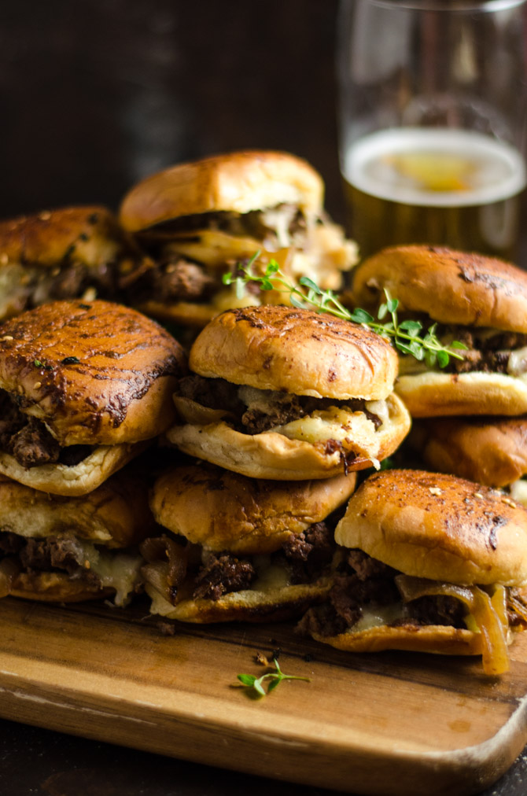

Ranchland Hills Bar Packages
Host Hourly
Beer & Wine
2 Hours | $18
3 Hours | $24
4 Hours | $28
Call
2 Hours | $22
3 Hours | $27
4 Hours | $32
Premium
2 Hours | $32
3 Hours | $37
4 Hours | $42
Super
2 Hours | $40
3 Hours | $45
4 Hours | $50

Domestic and Premium Beer* | C $5.50-$6.50
Bud Light, Miller Lite, Michelob Ultra, Coors Light
Dos XX, Shiner Bock, Corona, Corona Premier, White Claw

Call Brands* | C $7.75
Enchanted Rock, Tanqueray Gin, Jack Daniel's Whiskey, Jose Cuervo Gold Tequila Dewar's Scotch, Bacardi Silver Rum

Premium Brands* | C $9
Ketel One Vodka, Beefeater Gin, Maker's Mark Whiskey, Patron Silver Tequila,
Johnny Walker Red Scotch, Captain Morgan Spiced Rum

Super Premium Brands* | C $12
Grey Goose Vodka, Bombay Sapphire Gin, Crown Royal Canadian Whiskey, Flecha Azul Blanco Tequila,
Chivas Regal Scotch, Flor de Cana 7yr Rum, Grand Marnier

Host Bar prices subject to service charge and tax. Cash Bar prices include tax.

*brands subject to change without notice
All prices are subject to change without notice. Prices do not include 20% service charge or current sales tax.

Alcohol and Beverages
Beverage Add-Ons
Sparkling Champagne Greeting | $7 pp
Tray passed club champagne
Hand Poured Wine Service with Dinner | $25 bottle
Choice of club red or white
1 Hour Mimosa Bar | $14 pp
Choice of three (3) juices: orange, cranberry, & pineapple
Bloody Mary Bar | $14 pp
Vodka, bloody Mary mix, celery, and assorted garnishes
Keg of Beer
Domestic $300 | Imported $375
By the Gallon
Margaritas $75 | mimosas $65 | sangria $65 | fruit juices $25
Sodas and Bottled Water | $2.50 each
Wines by the Bottle
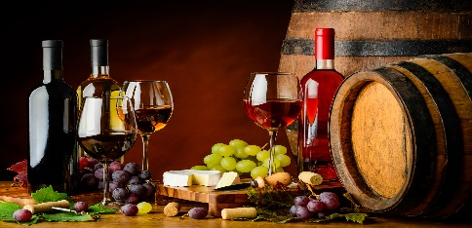
Chardonnay Interesting Reds
Canyon Road | $25 Corazon Del Sol Malbec | $18
Avarean | $48 Skeleton Key | $58
Sauvignon Blanc
Canyon Road | $25
Astrolabe | $38
Pinot Grigio
Canyon Road | $25 Limited Time Offerings
Cabernet Sauvignon Ask about our current specials
Canyon Road | $25
True Myth | $36
Merlot
Canyon Road | $25
Pinot Noir
Canyon Road | $25
Cannonball | $42

Equipment
LCD Projector | $50
Tripod Screen | $25
Microphone and In-house Speakers | $50
Whiteboard with Four Markers | $25
Standing Podium | no charge

Club Policies and Procedures
All events have a time limit of five (5) hours. If additional time is needed, please make arrangements with the Events Director. Additional charges may apply. All events must end no later than 12:00 am. If a client goes over the agreed rental time, a $500 minimum charge will be applied.
Final menu selections, room arrangements, and other details are due 45 days prior to the event. Menu pricing is guaranteed up to 90 days prior to the event.
Final guaranteed attendance count is due seven (7) days prior to the event.
All food and beverage must be provided bu the Club, unless otherwise approved with the Events Director. We offer a variety of menu selections and packages designed to accommodate any event. Custom menus can be created for an event.
All food and beverage is subject to the current tax of 8.25% and service charge of 20%.
A signed contract and non-refundable deposit is required to confirm a date. Payments may be made by check, Visa, or Mastercard. Payment schedule is as follows:
- At contract signing – 25% of the estimated event total.
- 90 days prior to the event- 50% of the remaining event charges.
- 7 days prior to the event-remaining balance is due
A valid credit card may be required to be on file for payment of any additiional charges incurred at the event and for cancellation purposes.
In the event a Member or Client cancels a function for any reason, the Club will be entitled to a cancellation fee as liquidated damages (plus service charges and applicable taxes) at the time of cancellation as follows:
- 14 days prior to the event- 50% of the Estimated Cost
- 72 hours prior to the event- 75% of the Estimated Cost
- Less than 48 hrs will incur 100% of the Estimated Cost
Given the Club’s capacity to prepare and serve food and beverages, the parties acknowledge that it is highly unlikely that the Club would be able to mitigate any losses caused by cancellation of the function. The parties agree that prospectively calculating the damages that the Club would suffer as a result of the cancellation of the would be exceptionally difficult or impossible. For this reason, the parties have agreed that the cancellations set forth above are a reasonable forecast of just compensation in the event of the cancellation of the function. The amounts due for cancellation set forth herein are intended as liquidated damages and not as a penalty.
Club Usage Fee: A benefit of Membership is that Members are allowed usage of our facilities without a rental fee. Non-member Club rental fees range from about $200-$2,000. If interested in becoming a Member, speak with the Events Director.

Christa Brown
Director of Events and Catering
1600 E. Wadley Avenue; Midland, Tx 79705
Club (432)682-3729
www.ranchlandhills.com
events@ranchlandhills.com

