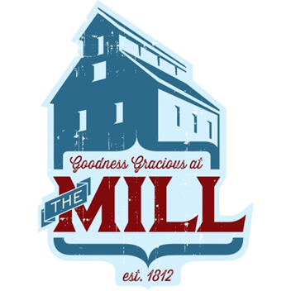
Dinner Parties at the Mill
All parties include: venue rental for 3 hours (time starts when you arrive to set up and ends when you and last guest leave), buffet or plate served* dinner service, servers, tax, tables and chairs, tea, soda and coffee service
Bronze Menu: *includes dessert choice* $29 per person
Silver Menu: $35 per person
Gold Menu: $40 per person

30 ADULT GUEST MINIMUM. Kids 5-10 years old ½ price- 4 and under free
* For plate service, another server may need to be added depending on final number ($75)
$75 per hour for each additional venue rental hour needed beyond 3 hours
Final guest count is due 7 days before event date. Guest add ons can be made up to 2 days before event.

