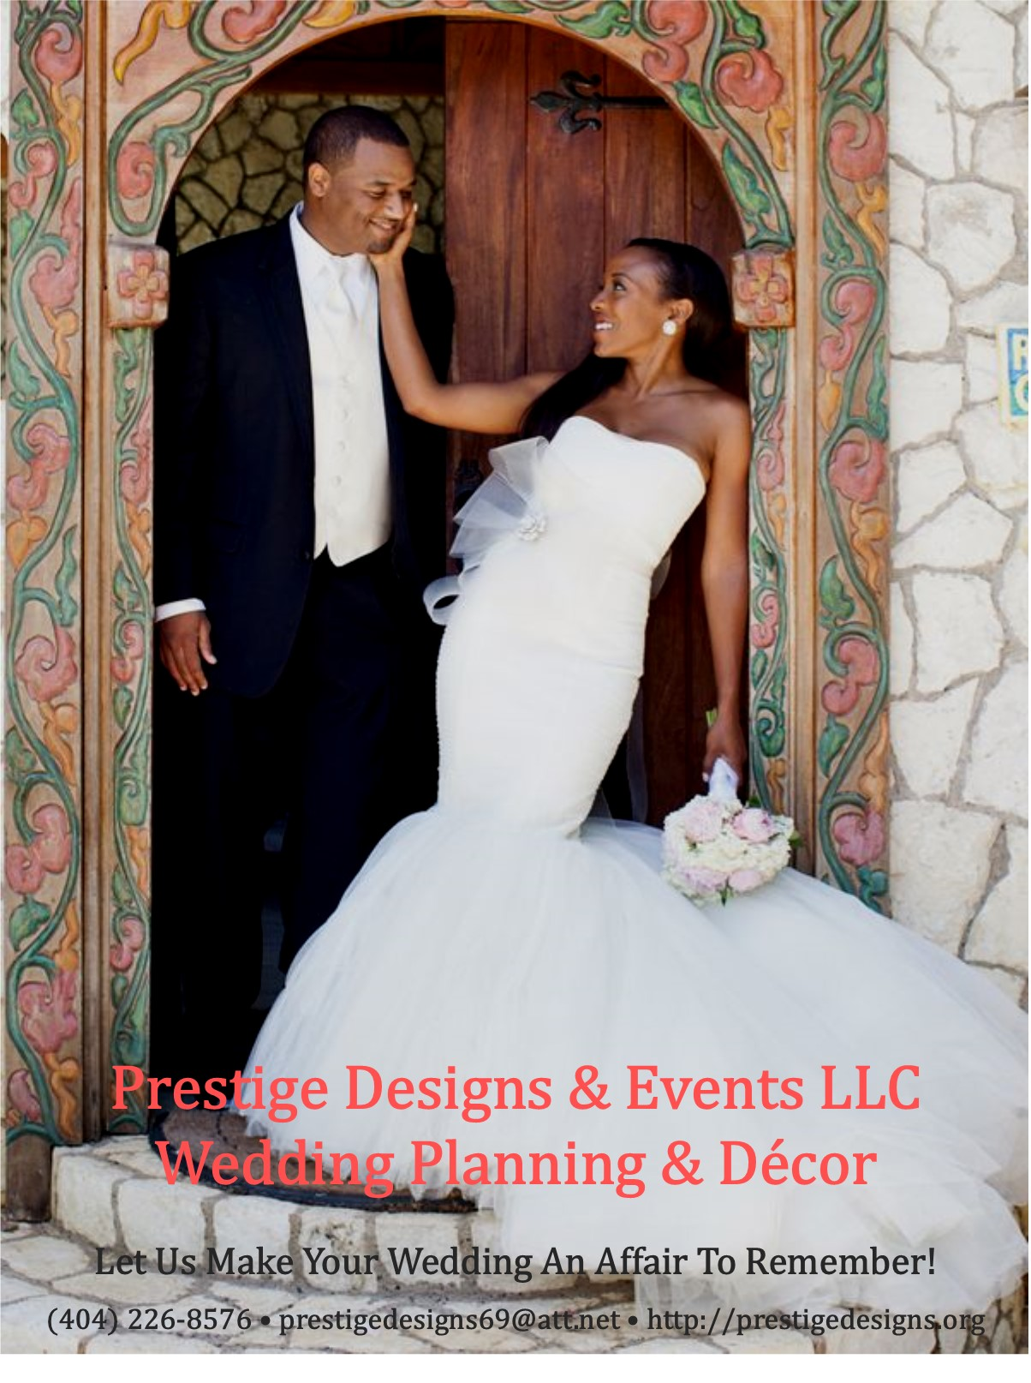

Creating Unforgettable Memories One Wedding
At a Time!

Prestige Designs & Events LLC is a full-service event planning and decorating company based in Decatur, GA. We specialize in weddings, corporate events, launch parties, social celebrations, religious gatherings, and much more!

Whether you’re planning a wedding for 20 or 200 guests, with our Event Styling & Décor Services we will create a design tailored to the unique style you envision for your momentous occasion.

Our Wedding Planning and Coordinator Services are designed to ensure you, your family and guests enjoy your special day while we handle all of the details. We will assist you with as much or as little as you desire, always working to make sure your dreams become reality.

Your Vision • Your Style • Your Day
We Make It Happen!

Wedding Planning, Coordination
& Décor Services

Weddings are whirlwind experiences, full of joy and excitement. Let Prestige Designs & Events handle all the arrangements so that you, your family, and friends can experience the day without having to worry about the details. We will assist you with as much or as little as you desire, always working to make sure your dreams become reality.

Prestige Designs offers a wide range of wedding planning and coordination services, creative ideas, and advice on proper etiquette for all types and sizes of weddings and special events. We are sensitive to your individual needs, style, personality, and budget.

To create the wedding of your dream, we offer the finest in wedding products, needs, and services that are essential for adding a special touch to your wedding festivities:
- Wedding Consultation & Planning
- Announcements, Invitations, and Programs
- Accessories, Favors, and Thank You Gifts
- Wedding Party Florals
- Ceremony and Reception Décor & Essentials
- Day-of-Coordination of Rehearsal, Ceremony, and Reception
- Recommendation and Onsite Management of Vendors
- Backdrops and Props for Photo Booths
- Decorations, and more.
Please contact us today to schedule a FREE consultation session!

Let Us Make Your Event An Affair To Remember
Denise Wilson
Event Planner & Creative Designer

Wedding Planning Services

Complimentary Consultation
The initial needs assessment and consultation consists of a meeting with you, your fiancé, family, friends, and any others who may be assisting you in planning your wedding. At this meeting we will explore the type of services available, offering budgeting guidance, answer any questions and get your planning started in the right direction.

Majestic Memories - Full service varies
Majestic Memories wedding planning is designed for the couple that is “to busy” or “just not sure of what to do.” We will assist with handling all aspects of planning your special day from beginning to end. Services include assistance with:
- Location and selection of event venues (include site visit and price negotiation)
- Selection of attire for wedding party
- Rehearsal dinner arrangements
- Research, recommend and manage service vendors
- Schedule appointments and attend meetings with vendors
- Review and manage vendor contracts
- Assist with menu selection and attend food/cake tasking
- Provide list of hotels for out-of-town guests
- Create timeline and wedding day itinerary
- Advice on etiquette, protocol and budgeting (cost saving tips and ideas)
- Ideas for wedding design and décor
- Ongoing and unlimited consultation and advice
- Assist with wording for Save-the-Date, Invitations, Programs and Menus
- Manage RSVP and Guest List
- Coordinate Wedding Rehearsal and Rehearsal Dinner
- Day of Coordination (Wedding Party & Vendor Logistics, Ceremony & Reception)

Service Fees

Price | Event Size | Minimum Hours | # of Attendants
$1,000.00 | 50 - 100 guests | 10 hours included | 2
$1,200.00 | 100 - 150 guests | 10 hours included | 3
$1,400.00 | 150 – 200 guests | 10 hours included | 4
$1,600.00 | 200 - 300 guests | 10 hours included | 5

Includes ten hours of service on the day of your event (3 hours for rehearsal, 3 hours for ceremony, and 4 hours for the reception) and unlimited consultation and preplanning services.
Opulent Occasions – Day-of-Coordination Varies
Opulent Occasions is designed for couples that have planned all the details of their event, but need someone to coordinate Day-of-Services with their selected venue, vendors, and guests. Services include assistance with:

Coordinate Rehearsal & Ceremony
- Ceremony details and needs with officiant
- Roles, processional, and recessional of wedding party
- Music arrangements with musicians and soloists
- Ensure ceremony site is clean and orderly
- Pin corsages and boutonnieres on attendants
- Assist with rehearsal dinner arrangements

Coordinate Reception
- Direct guests to location of reception
- Announce entrance of wedding party
- MC reception activities (dinner, toasts, dances, and thank-you announcements)
- Serve as liaison to vendors to ensure delivery of contracted services
- Prepare worksheet of music selections
- Assist with menu and music selections
- Ensure enough food is served
- Supervise timelines of reception activities
- Collect and transport gifts
- Assist with event day logistics with vendors
- Facilitate clean-up of facility

Service Fees
There is a ten-hour service minimum required for all Day-of-Coordination Services. Service fees are based on the size of the event and include ten hours of service (2 hours for the rehearsal, 2 hours for ceremony, and four hours for the reception, and 2 hours of early arrival).

Price | Event Size | Minimum Hours | # of Attendants
$750.00 | 50 - 100 guests | 10 hours included | 2
$900.00 | 100 - 150 guests | 10 hours included | 3
$1,050.00 | 150 – 200 guests | 10 hours included | 4
$1,200.00 | 200 - 300 guests | 10 hours included | 5

Beautiful Beginnings – Ceremony Only $350.00-$900.00
Beautiful Beginnings provides coordination of the wedding rehearsal and ceremony that allows you to enjoy your special day worry and stress free. Services include assistance with:
- Ceremony details with officials and officiant
- Roles, processional and recessional of wedding party
- Arrange music with musicians and soloists
- Ensure ceremony site is clean and orderly
- Pin corsages and boutonnieres on attendants

Romantic Royale – Reception Only $350.00-$900.00
Romantic Royale is designed for couples that are already married, but just need someone to assist with coordinating their reception. It allows you to wine, dine, and be merry at your reception, while I handle all the details. Services include assistance with:
- Announcement of bridal party
- Serve as liaison to reception vendors
- Prepare worksheet of music selections
- Assist with menu selection
- Work with caterer to ensure enough food is being served
- Supervise timelines of reception activities
- Coordinate collection and transportation of gifts

Service Fees
There is a six-hour service minimum required for all Ceremony Only and Reception Only services. Service fees and minimum hour requirement is based on the event size, and includes two hours of early arrival before each event and four hours of services during the actual event.

Price | Event Size | Minimum Hours | # of Attendants
$350.00 | 75 to 100 guests | 6 hours included | 2
$500.00 | 100 – 150 guests | 6 hours included | 3
$650.00 | 150 – 200 guests | 6 hours included | 4
$900.00 | 200 - 300 guests | 6 hours included | 5

These services fees do not include set-up and breakdown of tables, chairs, and decorations provided by other vendors; and cost of vendor services. The only include delivery, set-up, arranging, and take down of all the décor that we provide.
Client is required to secure vendor service before the event.
Additional hours will incur a fee of $75.00 per hour.

Event Styling & Décor Services
Based on 50 guests
For clients who have planned everything for their event and need a creative design tailored to the unique style they envision
for their momentous occasion.

Silver Decoration Package: $1,250
• Standard Polyester or Satin Table Cloth
• Standard Chair Covers w/ Matching Sash
• Satin Table Runner or Overlay
• Guest Table Setting w/ Candlelight or Silk Floral Centerpiece
Charger, Dinner Napkin w/ Diamond Holder
• Head Table Decoration w/ Premium Linen,
Centerpiece, and Dinnerware & Setting
• Gift Table Decoration w/ Linen & Decor
• Dessert Table Set-Up with Linen & Décor
• Customized Treats
• Entrance Signage/Display
• Photo Booth Backdrop w/ Props
• Selfie-Frame
Additional Guests: $10.00 per guest

Gold Decoration Package: $1,500
• Premium Table Linen
• Spandex Chair Covers w/ Matching Sash
• Sequin Table Runner or Overlay
• Napkins w/ Diamond Holders
• Guest Table Setting w/ Medium Centerpiece & Charger
• Head Table Decoration w/ Premium Linen
• Gift Table Decoration w/ Premium Linen
• Dessert Table Set-Up with Linen & Décor
• Customized Treats
• Entrance Signage/Display
• Photo Booth Backdrop w/ Props
• Selfie-Frame
Additional Guests: $15.00 per guest

Pricing is variable and contingent upon customizations, type of linen (chair covers and sashes), centerpieces, backdrops, decorations, place setting (plastic or formal), number of guests, and more. However, we will create an incredible design that will wow
your guest and make you smile.

Event Styling & Décor Services
Based on 100 guests
For clients who have planned everything for their event and need a creative design tailored to the unique style they envision
for their momentous occasion.

Silver Decoration Package: $2,500
• Standard Polyester of Satin Table Cloth
•Satin or Polyester Chair Covers w/ Matching Sash
• Satin or Polyester Table Runner or Overlay
• Guest Table Setting w/ Candlelight or Silk Floral Centerpiece
• Head Table Decoration w/ Standard Linen
• Gift Table Decoration w/ Standard Linen & Centerpiece
• Dessert Table Set-Up with Linen & Décor
• Customized Treats
• Entrance Signage/Display
• Photo Booth Backdrop w/ Props
• Selfie-Frame
Additional Guests: $10.00 per guest

Gold Decoration Package: $3,000
• Premium Table Linen
• Premium Chair Covers w/ Matching Sash
• Premium Table Runner or Overlay
• Napkins w/ Diamond Holders
• Guest Table Setting w/ Medium Centerpiece & Charger
• Head Table Decoration w/ Premium Linen
• Gift Table Decoration w/ Premium Linen
• Dessert Table Set-Up with Linen & Décor
• Customized Treats
• Entrance Signage/Display
• Photo Booth Backdrop w/ Props
• Selfie-Frame
Additional Guests: $15.00 per guest

Pricing is variable and contingent upon customizations, type of linen (chair covers and sashes), centerpieces, backdrops, decorations, place setting (plastic or formal), number of guests, and more. However, we will create an incredible design that will please
your guest and make you smile.

Premium Linen: (available in a variety of colors)
- Table Cloth: Pintuck, Spandex, Flocking Damask, Flocking Taffeta, Sequin, Flamingo Petals, and Rosette.
- Chair Covers: Universal, Spandex, or Chivari Chair Caps.
- Chair Sashes: Organza, Taffeta, Pintuck, Chiffon, Spandex, and Embroidered Organza.
- Table Skirts: Curly Willow Taffeta, Rosetta, and Satin Lamour Ruffle.
- Table Runner: Organza, Sequin, Taffeta, Grandiose Rosette, Shimmering Polyester, Artificial Grass, Couture Tulle, and Lace Netting.
- Overlays: Organza, Taffeta, Pintuck, Sequin, 3D Rosete, Lace, and Razzle-Dazzle Glitter.

Ala Carte Add-Ons:
- King or Queen Throne Chair $350.00

- King and Queen Throne Chairs Set $700.00

- Formal Fine China Dinnerware (100 guests) $800.00
(includes dinner plate, dessert plate, salad plate, four-piece flatware, water/wine goblet, and champagne flute). Additional sets at $8.00 per guest.

- Premium Disposable Dinnerware (100 guests) $300.00
(includes dinner plate, dessert plate, salad plate, four-piece flatware, water/wine goblet, and champagne flute – high quality plastic). Additional sets at $3.00 per guest.

- Head Table Backdrop w/ Draping and Uplighting
- 8 ft x 20 ft (head table for up to 10 people) $300.00
- 10 ft x 24 ft (head table for up to 16 people) $400.00

Ceremony Decoration Package: $500 - $1,500
Let us create a customized package for you consisting of the following.

- Decorated Arc or Backdrop w/ Draping
- 10 Pew Bows or Aisle Marker
- Aisle Runner
- Unity Candlebra
- Guest Book Registry

To ensure your décor is set-up according to your vision, we would prefer to set-up the day before the event or three hours on the day-of,
and two hours for breakdown.
Lady-in-Waiting Personal Assistance
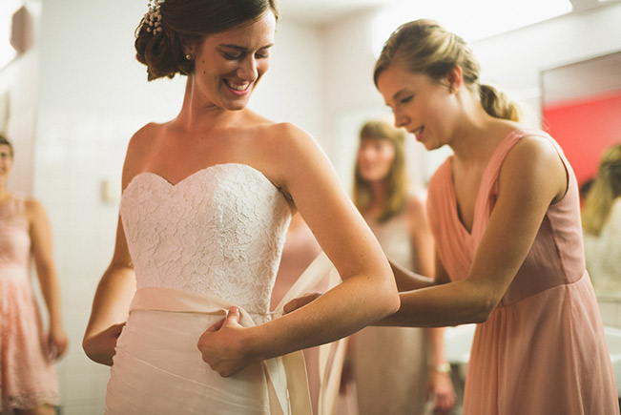
Your wedding day is stressful enough. With our Lady-in-Waiting Personal Assistance service, we will take care of your every need and ensure you are treated like royalty! These services include:
- Catering to the bride’s every need!
- Being the liaison between family, bridal party, guests, wedding coordinator, and vendor
- Keeping track of time and ensuring that everything is on schedule
- Assisting the bridge into her bridal attire and change of clothes
- Remaining with the bridge until her all-important walk down the aisle
- “Fluffing” the bridal train before she makes her entrance into the ceremony and beyond
- Touching up make-up, hair, and dresses to ensure that everyone look perfect throughout the day.
- Keeping track of the bride and bridal party’s personal belongings.
- Have a fully-stocked, handy-dandy emergency kit
- Ensure bride and groom receive enough food and drink during the reception
- Clean and prepare the bridal suite before the honeymoon night (when the reception is held in close proximity to the reception venue)
$250.00 for four hours • $500.00 for eight hours
$50.00 per Hour (minimum of four hours)
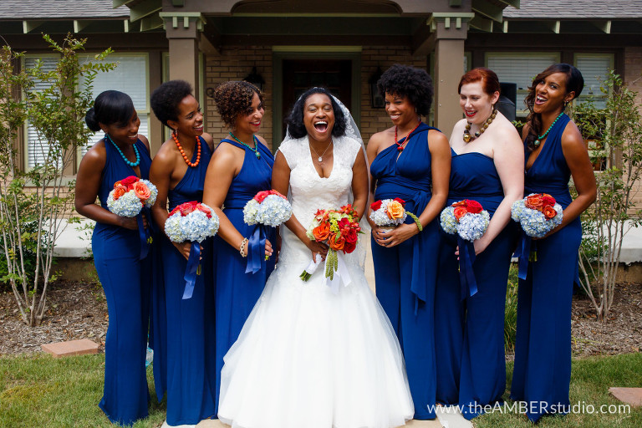
Wedding Party Floral Packages
Bridal Bouquet
$50.00—$75.00 Silk
$75.00—$100.00 Fresh

Bride Maid Bouquet
$25.00—$50.00 Silk
$50.00—$75.00 Fresh

Corsages
$8.00—$10.00 Silk
$10.00—$15.00 Fresh

Boutonnieres
$5.00—$8.00 Silk
$8.00—$10.00 Fresh

Complimentary
Bride’s Throw-Away Bouquet
Rental of Flower Girl Basket w/ Petals
Ringer Bearer Pillow or Bell

Please
Call Us
To Schedule a
FREE
Consultation Session!

Denise Wilson
(404) 226-8576

We Look Forward to Making Your Wedding
An Affair to Remember!

