Home2 Suite by Hilton Temecula
28400 Rancho California Road
Temecula, CA 92590
951-331-3622

OLD TOWN BOARDROOM
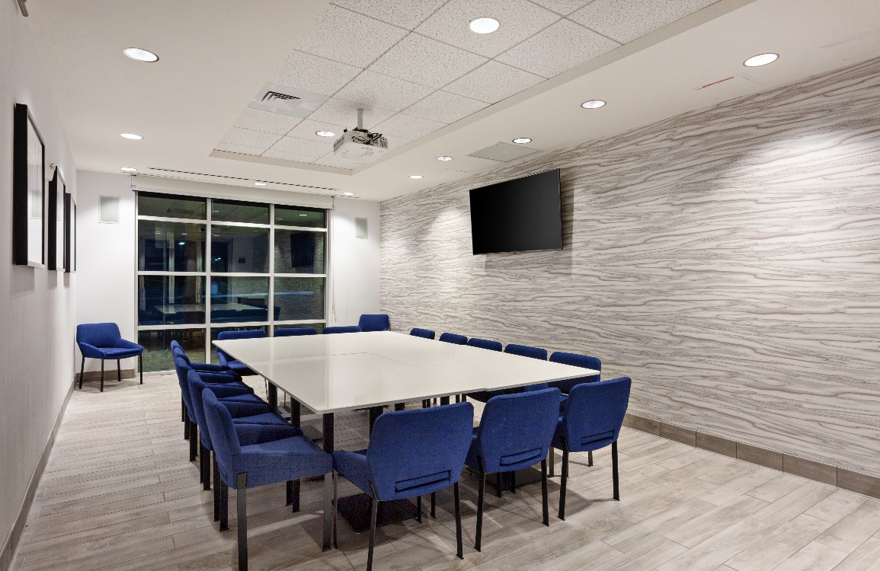

392 sq. ft.

Room Rental
4 hours | $225
8 hours | $450

Room Rental Includes
Overhead LCD Projector
8’ Drop Down Remote Screen
65” LG TV-HDMI Compatible
1 HDMI Cable
1 Extension Cord
Wi-Fi Access
Access to complimentary 24/7 Coffee Station in Hotel Lobby

Room Set Up & Max Occupancy
Conference | 16 people

