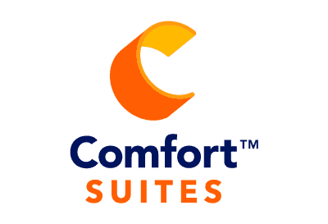

Comfort Suites Downtown Carlisle
10 South Hanover Street Carlisle, PA 17013 717-960-1000

Meeting Room Rental Costs
Heritage Ballroom (4039 square ft) $500-$1000
Dickinson/Thorpe (2544 square ft) $350-$500
Wilson/Blaine (1495 square ft) $250-$400
Boardroom (up to 12ppl) $150-$200

A/V Equipment
Flipchart Paper $15.00
With Markers $20.00
Dry Erase Board $10.00
LCD Projector $95.00
Tradeshow Vendor Tables $10.00 each
Screen Complimentary
Easel Complimentary
A/V Cart, Power Strip, Extension Cord Complimentary
Podium with Microphone Complimentary

Please add 6% sales tax
Prices are subject to change and cannot be guaranteed more than 6 months in advance.
Outside food & beverage is not permitted*

