BOA Gallery ……..…… ……… ………$1,200 (Sun-Thurs) $2,000 (Fri-Sat)
*Rental rates are not available by the hour.
*Max of 4 hours event time frame.
*Events start time varies depending upon the day of the week and exhibit hours, and must conclude by 10 p.m.

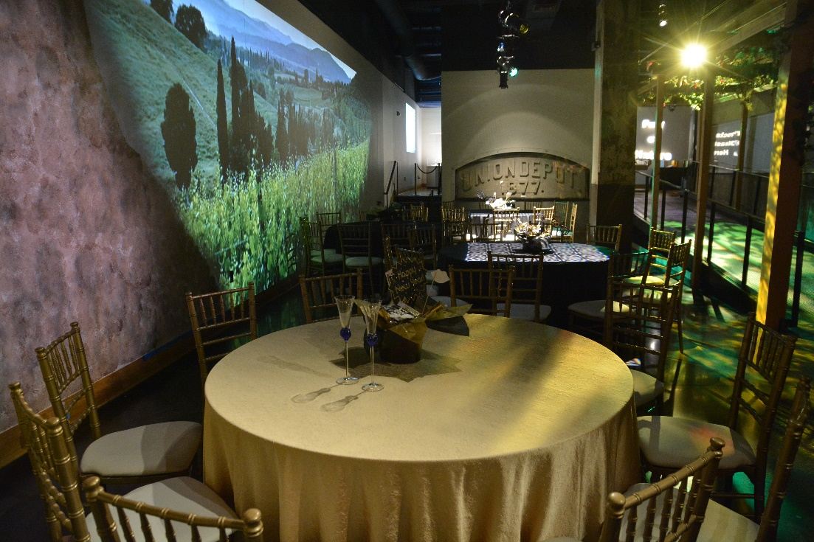
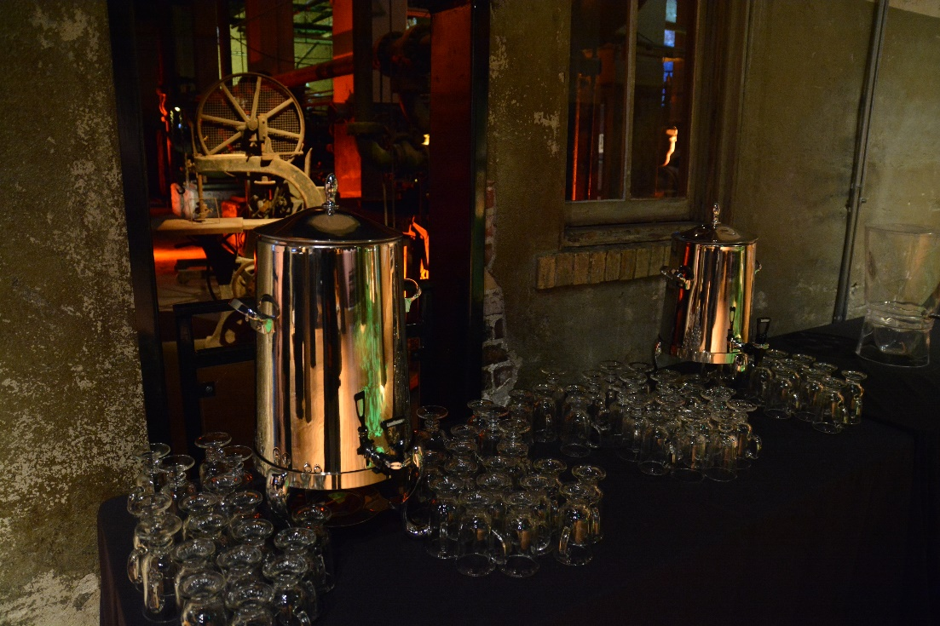

Reception Capacity: 400 (standing only)
Banquet Capacity: 120

Room Rental Includes:
Furniture:
10 Bar High Tables
10- 66” rounds (seat 10) w/ black table linens
2- 6ft tables for registration w/ black table linens and 2 chairs

Audio/Visual:
House sound system for background music.

Other Amenities:
Historic architecture.
Exposed ceilings
View of original pump room.
Private restrooms during event
*can add private access into the traveling exhibition (ask for details, additional cost

Catering:
Approved Caterers:
- Pierpont’s at Union Station- Robbie McGowan,Catering Director rmcgowan@pierponts.com
- Brancato’s Catering- Jennifer Fuentes, Catering Manager, jfuentes@brancatoscatering.com
- Q39 BBQ- Michael Naegele, Catering Manager, michael@q39.com
- Lon Lane Inspired Occasions, Jeff French, Catering Manager, jeff@inspiredoccasionskc.com
- Sheraton/ Westin Crown Center, Chrissy Frazier, Chrissy.Frazier@starwoodhotels.com
*if you have special traditional menu requirements please let us know so we can discuss options.

Bar Service: (no other vendors permitted to provide this service)
- Pierpont’s at Union Station
- Brancato’s Catering

Rentals: (exclusive provider)
- All Season’s Event Rental, Jennifer Fuentes, jfuentes@allseasonstentrental.com

Entertainment/ DJ Services:
- Any vendor of choice can be used for these services.

Cake, Cupcakes, Desserts:
- Any vendor of choice can be used for this service.

Floral/ Photography:
- Any vendor of choice can be used for these services.

Valet:
- In-house contracted vendor, quotes can be provided upon request.

Décor Policies:
- No open flame candles (LED/ battery operated)
- No helium balloons
- No Confetti/ Glitter
- No taping to walls or surfaces

Considerations:
- Union Station does not provide carts or dollies for vendors.
- Union Station does not provide power/extension cords.
- No carts or dollies permitted on the marble floors that do not have non-marking white or grey wheels.

Parking:
Union Station visitor garage rates- $5-$8
Front surface lots- $12-$20

Booking Process:
Contract to confirmation-
- 7 days from the receipt of the contract signed copy is due.
- 50% non-refundable deposit is due when contract is returned.
- Checks (payable to Union Station), Cash, Credit Card or Debit Card accepted.
  - *if paying by check or cash, Union Station still requires a CC on file.
- Final balance due 30 days prior to the event date.

Cancellation Process:
- Deposit is non-refundable, date is transferrable with the deposit within the same calendar year.
- 31 days or more before the event date, no additional monies due.
30 days or less, full payment

