Bartlett Country Club
Stations

Fresh Inspirations $6
An Assortment of Fresh Spring Greens, And Romaine Lettuce, with various Salad Toppings, Gourmet Dressing and Grilled Chicken.

Potato Bar $5
Mash Potatoess and Sweet Mash Potato with Various toppings of Cheeses, Fresh Herbs, Pesto's, Bacon, Pea's, Brown Sugar, Honey and Gravy.

Pasta Station $6
Bowtie Pasta with Broccoli and Grilled Chicken in Pesto Alfredo Sauce. Penne Pasta with Peppers and Onions in Marinara Sauce with Italian Sausage.

Vegetable Station $4
Chef selections of two Seasonal Vegetables

Seafood Station $15
Raw Clams and Oysters, King Crab, Shrimp Cocktail, Mussel Marinara, Lemons, Coctkail Sauce.

Asian Station $7
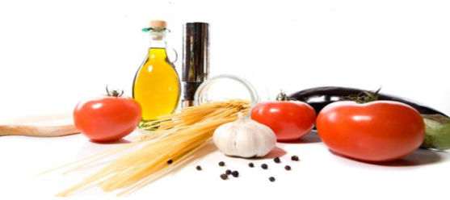
Shrimp and Chicken Stir Fry with Asian Vegetables and Sauces accompanied by Fried Rice and Lo Mein
Southwestern Fajita Station $7
Flour Tortillas with Shreded Lettuce, Cheddar Jack Cheese, Jalapenos, Black Olives, Red Onion, Guacamole, Sour Cream and Grilled Chicken with Peppers and Onions. And Spanish rice

Curry Station $6
Sauteed Chicken in a Red Curry Sauce, Sauteed Lamb in a Garam Masala Sauce, Basmati Rice, Pita Bread, and Flat Bread

Sushi Station $7
An assortment of Shrimp, Ahi Tuna, and Vegetarian Rolls with traditional accompiantments of wasabi, pickled ginger, and soy sauce.

Fruit Fondu Station $6
Fresh Strawberries, Pineapple, Melon, Pretzels, Marshmellows, and Chopped Nuts with Melted Chocolate.

Carving Stations
Prime Rib $7
Beef Tenderloin $9
Montreal Porkloin $5
Peppercrusted Round of Beef $6
Roast Turkey $5
Pit Smoked Ham $5
*All stations are based on appetizer portions for your guest
a minimum of four stations are required*

