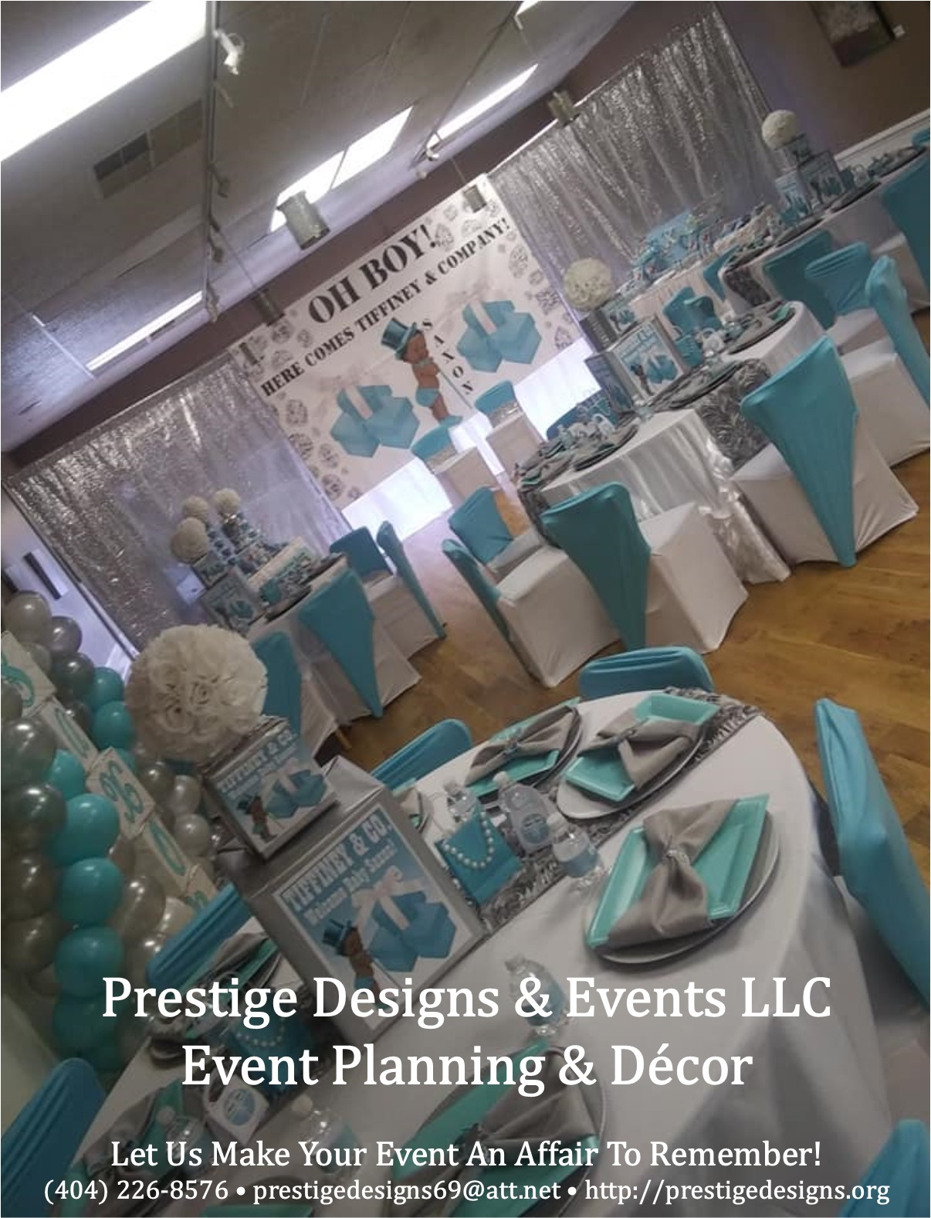

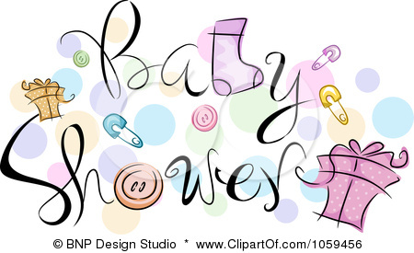
Creating Unforgettable
Memories One Event
At a Time!

Prestige Designs & Events LLC is a full-service event planning and decorating company based in Decatur, GA. We specializes in weddings, corporate events, launch parties, social celebrations, religious gatherings, and much more!

Our Event Planning and Coordinator Services are designed to ensure you, your family and guests enjoy your special day while we handle all of the details. We will assist you with as much or as little as you desire, always working to make sure your dreams become reality.

Whether you’re planning a baby shower for 20 or 50 guests, with our Event Styling & Décor Services we will create a design tailored to the unique style you envision for your momentous occasion.

Your Vision • Your Style • Your Day
We Make It Happen!
Event Planning, Coordination
& Décor Services

Planning events are whirlwind experiences, full of joy and excitement. Let Prestige Designs & Events handle all the arrangements so that you, your family, and friends can experience your special day without having to worry about the details. We will assist you with as much or as little as you desire, always working to make sure your dreams become reality.

Prestige Designs offers a wide range of event planning and coordination services, creative ideas, and advice on proper etiquette for all types and sizes of special events. We are sensitive to your individual needs, style, personality, and budget.

To create the celebration of your dream, we offer the finest in products, needs, and services that are essential for adding a special touch to your momentous occasion:
- Event Consultation & Planning
- Announcements, Invitations, and Programs
- Accessories, Favors, and Thank You Gifts
- Day-of-Coordination
- Recommendation and Onsite Management of Vendors
- Backdrops and Props for Photo Booths
- Decorations, and more.
Please contact us today to schedule a FREE consultation session!

Let Us Make Your Event An Affair To Remember
Denise Wilson
Event Planner & Creative Designer

Precious Moments: Baby Shower
Skip the simple things and aim for a glamorous Mother-to-Be Celebration
with Prestige Designs and Events. Our signature theme design is sure to make her smile!

Package A: $1,000+ (up to 50 people)
• Standard Linen (polyester or satin table cloth and runner)
• Chair Covers w/ Matching Sash
• Guest Table Setting
(with centerpiece, charger, and customized face setting)
• Head Table Decoration w/ Premium Linen
• Gift Table Decoration w/ Premium Linen
• Entrance Signage/Display
• 25 Invitations w/ Envelope
• Customized Treats
• Photo Booth Backdrop w/ props
• Selfie-Frame

Package B: $1,500+ (up to 50 people)
• Linen (standard & premium table cloth)
• Chair Covers w/ Matching Sash
• Guest Table Setting
(with centerpiece, charger, and customized face setting)
• Head Table Decoration w/ Premium Linen
• Special Honoree Seating Area w/Princess Throne Chair
• Gift Table Decoration w/ Premium Linen
• Entrance Signage/Display
• 25 Invitations w/ Envelope
• Customized Treats
• Photo Booth Backdrop w/ props
• Selfie-Frame

Pricing is variable and contingent upon customizations, type of linen (chair covers and sashes), centerpieces, backdrops, decorations, place setting (plastic or formal), number of guests, and more. However, we will create an incredible design that will please your guest and meet your needs.

… Every “Mom-to-Be” is as unique as the baby born to her …

Premium Linen: (available in a variety of colors)
- Table Cloth: Pintuck, Spandex, Flocking Damask, Flocking Taffeta, Sequin, Flamingo Petals, and Rosette.
- Chair Covers: Universal, Spandex, or Chivari Chair Caps.
- Chair Sashes: Organza, Taffeta, Pintuck, Chiffon, Spandex, and Embroidered Organza.
- Table Skirts: Curly Willow Taffeta, Rosetta, and Satin Lamour Ruffle.
- Table Runner: Organza, Sequin, Taffeta, Grandiose Rosette, Shimmering Polyester, Artificial Grass, Couture Tulle, and Lace Netting.
- Overlays: Organza, Taffeta, Pintuck, Sequin, 3D Rosete, Lace, and Razzle-Dazzle Glitter.

Ala Carte Add-Ons:
- Princess Throne Chair $350.00

- Prince & Princess Throne Chairs $700.00

- Formal Fine China Dinnerware (100 guests) $800.00
(includes dinner plate, dessert plate, salad plate, four-piece flatware, water/wine goblet, and champagne flute). Additional sets at $8.00 per guest.

- Premium Disposable Dinnerware (100 guests) $300.00
(includes dinner plate, dessert plate, salad plate, four-piece flatware, water/wine goblet, and champagne flute – high quality plastic). Additional sets at $3.00 per guest.

- Head Table Backdrop w/ Draping and Uplighting
- 8 ft x 20 ft (head table for up to 10 people) $300.00
- 10 ft x 24 ft (head table for up to 16 people) $400.00

Day-of-Coordination $500.00
- Coordinate and host party activities
- Coordinate set-up and take-down of decorations
- Plan and facilitate games, door prizes, and more.
- Assist with music and menu selections
- Onsite coordinator with vendor to ensure delivery of contract services
- Gather gifts and transport to “Mom’s to Be” Car

Our services only include set-up and breakdown of decorations that we provide. It does not include set-up, breakdown, and moving of tables and chairs provided by the facility or outside vendors.

Please
Call Us
To Schedule a
FREE
Consultation Session!

Denise Wilson
(404) 226-8576

We Look Forward to Making Your Baby Shower
An Affair to Remember!

