Wedding Packages

By Hilton Garden Inn Raleigh/Crabtree Valley

These menus are only the beginning of what the talented culinary staff at the Hilton Garden Inn can provide for your celebration. We welcome your thoughts and ideas to create the perfect epicurean experience for you and your guests.

Whether you’re planning an intimate ceremony for twenty or an elaborate affair for 350, we look forward to making this day what your dreams are made of.

We would be happy to arrange a block of rooms for your guests. We can arrange a negotiated rate for 10 rooms or more.

For additional information and to arrange an appointment please contact our Director of Catering, Christine Nthiga, at (919) 703-2518 or by email at christine.nthiga@hilton.com

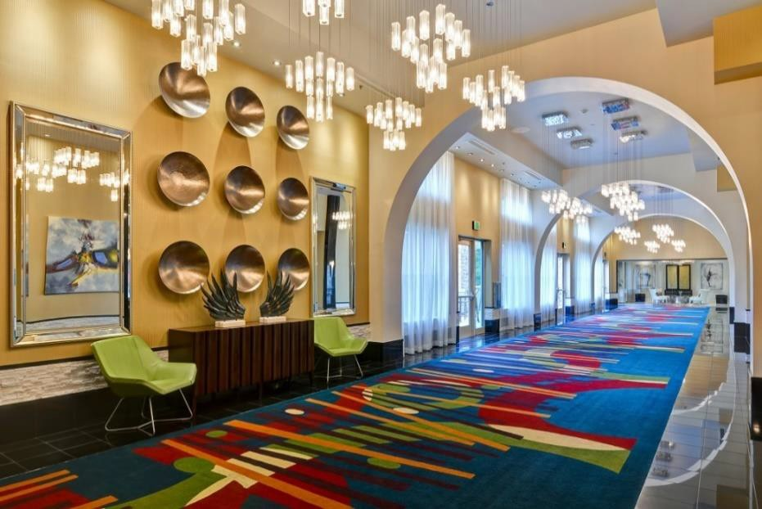

Prices listed are subject to applicable NC Sales Tax & 23% Service Charge. Prices subject to change.

The Wedding Ceremony

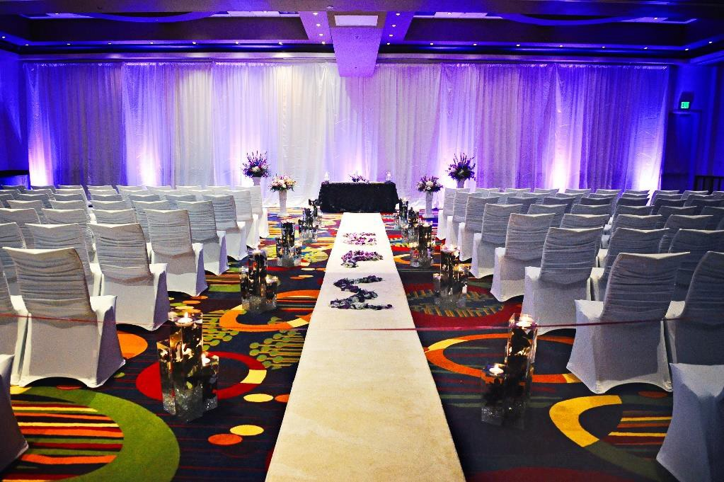
It’s time to say “I Do”
Ceremony fees begin at $1,500 and include the following:

- Hour Ceremony Rehearsal the Week of
- Hour Room Rental for Ceremony & Decor Hotel Banquet Chairs with White Chair Covers Wireless Lavaliere Microphone for the Officiant 12 ft. of Backdrop & Drapery Enhancement Uplights
Ceremony Arch White Aisle Runner Ceremony Tables
Use of the Bridal Studio

The Hilton Garden Inn Catering Team will be on-site during your Wedding Ceremony. Our attention will be dedicated to ensuring no details are overlooked while making your Special Day is unforgettable. Therefore, we recommend you hire a ceremony coordinator. Please see our Vendor List for suggestions of creative partners who work with our hotel to ensure the very best service for your Wedding Ceremony and/or Reception.

Prices listed are subject to applicable NC Sales Tax & 23% Service Charge. Prices subject to change.

The Wedding Reception

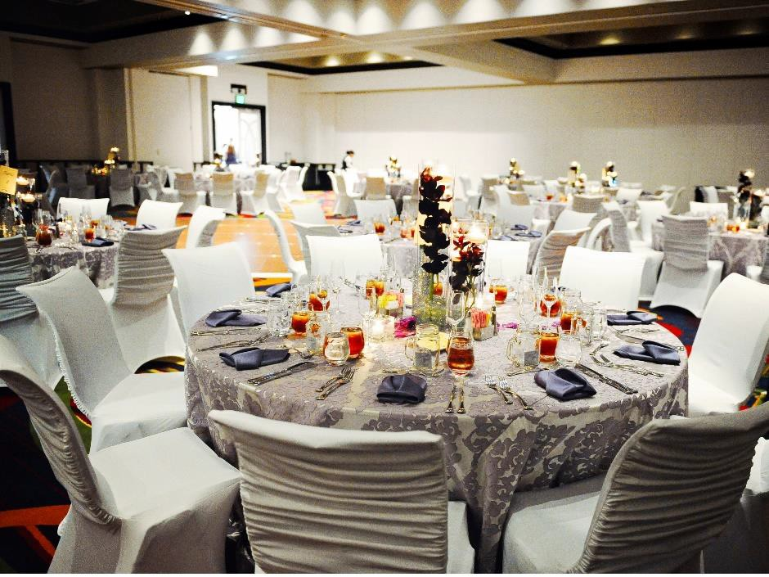
Each Reception Package Includes:
Event Space with Uplights Cake Cutting & Service
Cake, Gift & Guest Book Tables With House Linens Complimentary 12x12 Dance Floor
Complimentary Wedding Menu Tasting For up to 2 People Floor-Length White or Ivory Linen
Linen Napkin in your choice of color Standard Candlelight Centerpieces Banquet Captain for Your Special Event Ballroom Screen & Projector
Use of the Bridal Studio & Boardroom for Wedding Party Complimentary Guest Room on Your Wedding Night Complimentary Breakfast for the Wedding Couple Discounted Room Rates for your Guests
Hilton Honor Event Planner Points

Prices listed are subject to applicable NC Sales Tax & 23% Service Charge. Prices subject to change.

The Classic Reception Package

Dinner Service is Accompanied by a Choice of Salad, Market Fresh Vegetable & Starch, Fresh Baked Rolls & Butter,
Sweet Tea, Freshly Brewed Regular & Decaffeinated Coffee
BUFFET DINNER SERVICE - $60  2 Entrees, 1 Salad, 1 Starch & 1 Vegetable | PLATED DINNER SERVICE - $65  Choice of 2 Entrée Options, 1 Salad, 1 Starch & 1 Vegetable
COCKTAIL HOUR
Charcuterie Board
Enhance your Cheese Display with: Assorted Smoked & Cured Meats and Sausages,
Cornichons, Coarse and Dijon Mustard; Served with French Bread Baguette
SALAD SELECTIONS
Please Select One:
- House Salad Spring Mix, Tomato, Cucumber, Carrot, Red Onion & Croutons
- Caesar Salad Homemade Croutons, Shaved Locatelli & Classic Caesar Dressing
- Baby Spinach Salad Toasted Pine Nuts & Blood Orange Vinaigrette
ENTRÉE SELECTIONS
May Select up to Two:

- Herb & Parmesan Crusted Chicken Tomato and Warm Relish
- Five Spice Pork Tenderloin Brandy Hoisin Reduction
- Tri- Color Tortellini Pancetta and Sweet Peas in a Panna Romano Sauce
- Roasted Sirloin
- Fire Grilled Flank Steak
- Maryland Crab cakes with Remoulade Sauce
- Roasted Salmon Cilantro, Caper & Parsley Pesto
STARCH SELECTIONS  Please Select One:  - Wild Rice Pilaf  - Roasted Red Bliss Potatoes  - Mashed Yukon Gold Potatoes  - Parmesan Herb Polenta  - Jasmine Rice | VEGETABLE SELECTIONS  Please Select One:  - Roasted Asparagus  - Garlic and Parmesan Green Beans  - Seasonal Roasted Vegetables  - Seasoned Broccoli with Olive Oil & Lemon  - Roasted Carrots in a Honey Glaze

Prices listed are subject to applicable NC Sales Tax & 23% Service Charge. Prices subject to change.

The Premier Reception Package

Dinner Service is Accompanied by a Choice of Salad, Market Fresh Vegetable & Starch, Fresh Baked Rolls & Butter,
Sweet Tea, Freshly Brewed Regular & Decaffeinated Coffee
BUFFET DINNER SERVICE - $70  2 Entrees, 1 Salad, 1 Starch & 1 Vegetable | PLATED DINNER SERVICE - $75  Choice of 2 Entrees, 1 Salad, 1 Starch & 1 Vegetable
COCKTAIL HOUR
*Includes Charcuterie Board & Choice of 2 Passed Hors d’oeuvres*
Charcuterie Board  Enhance your Cheese Display with: Assorted Smoked & Cured Meats and Sausages,  Cornichons, Coarse and Dijon Mustard; Served with French Bread Baguette | Passed Hors d’ oeuvres  Brie & Raspberry Tartlets, Thai Shrimp & Corn Fritters, Honey Siracha Chicken Skewers, Fried Vegetable Spring Rolls, Bacon  Bourbon Spicy Cocktail Meatballs, Black & Blue Sliders and Cajun Sausage Wrapped in Puff Pastry
CHAMPAGNE TOAST
Champagne or Sparking Cider Toast Served tableside
SALAD SELECTIONS
Please Select One:
- Baby Kale, Spinach & Strawberry Toasted Hazelnut, Radish & Lemon Vinaigrette
- Greek Salad Cherry Tomato, Cucumber, Kalamata Olives, Feta & Red Onion with Lemon Vinaigrette
- Field Green Salad Sliced Pears, Gorgonzola, Toasted Pecans & Balsamic Vinaigrette
- Spinach Salad Bacon, Tomato, Hard Boiled Egg & Sliced Mushroom Drizzled with Honey Dijon Dressing
ENTRÉE SELECTIONS
May Select up to Two:
- New York Strip with Caramelized Onion Bordelaise (10oz)
- Filet Mignon with a Cabernet Reduction (6oz)
- Maple Mustard Glazed Salmon
- Boneless Leg of Lamb Pistachio & Green Olive Tapenade
- Pecan Chicken Cranberry & Apple Relish
- Blackened Flounder Chile Lime Butter
- Chicken Provencal Sundried Tomatoes, Artichoke Hearts, Roasted Peppers and Black Olives
- Pasta Primavera Penne Pasta Tossed with Garden Vegetables with Creamy Parmesan Sauce
STARCH SELECTIONS - Please Select One  - Lemon Basmati Rice  - Oven Roasted Fingerling Potatoes  - Parmesan & Basil Mashed Potatoes  - Israeli Couscous  - Roasted Sweet Potatoes with Cranberries & Apples  - Pecan- Rice with Sun- Dried Cherries | VEGETABLE SELECTIONS- Please Select One  - Roasted Brussels Sprouts with Bacon  - Harissa Roasted Butternut Squash with Carrots  - Zucchini, Carrots & Summer Squash  - Broccoli with Olive Oil, Garlic & Red Pepper Flakes  - Corn, Edamame & Asparagus Stir Sauté  - Spicy Roasted Cauliflower
Prices listed are subject to applicable NC Sales Tax & 23% Service Charge. Prices subject to change.

Cocktail Packages
Prices are per person, per hour, for guests ages 21 & over

House Brands Prestige Brands
$14 First Hour / $10 Each Additional Hour $18 First Hour / $12 Each Additional Hour Smirnoff Vodka, Gordon’s Gin, Ancient Age Grey Goose Vodka, Bombay Sapphire Gin Whiskey, Grant’s Scotch, Montezuma Tequila Woodford Bourbon, Johnny Walker Black
Castillo Gold Rum, Christian Brother’s Brandy Scotch, Patron Tequila, Myers Rum, Courvoisier

Premium Brands Beer & Wine Package
$16 First Hour / $11 Each Additional Hour $12 First Hour / $8 Each Additional Hour Absolut Vodka, Tanqueray Gin, Jack Daniel’s Selection of House Sparkling, Red & White Whiskey, Dewar’s Scotch, Jose Cuervo Gold
Tequila, Bacardi Rum, Hennessey Cognac

Domestic
Beer & Wine Selections

Bud Light, Budweiser, Michelob Ultra, Miller Lite

Specialty
Heineken, Corona, New Castle, Red Oak, Sam Adams, Carolina IPA

White & Sparkling
Tunnel of Elms Pinot Grigio & Chardonnay, Coastal Vines White Zinfandel, Douglass Hill Moscato, J Christoph Riesling

Red
Tunnel of Elms Cabernet Sauvignon & Merlot, Coastal Vines Pinot Noir
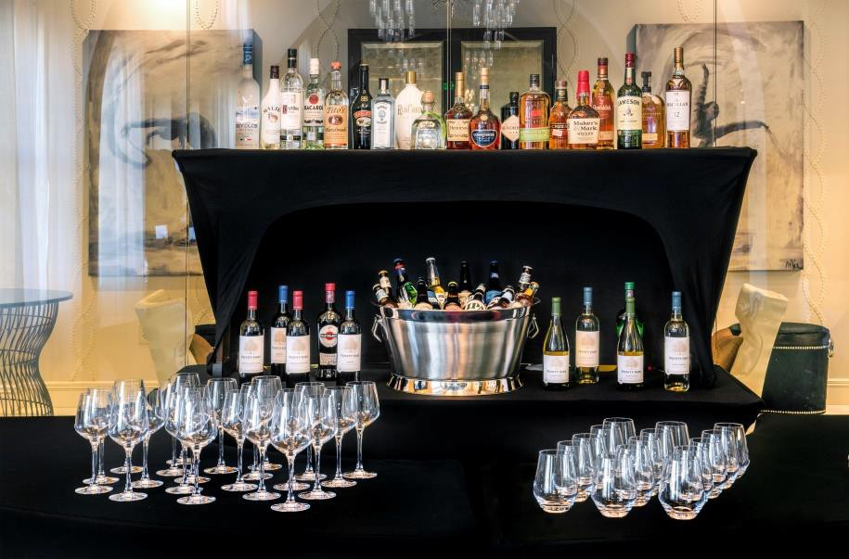
Prices listed are subject to applicable NC Sales Tax & 23% Service Charge. Prices subject to change.

Bar Pricing

Beverage | Cash | Host
House Brands | $8 | $6.50
Premium Brands | $9 | $7.50
Prestige Brands | $11 | $9.50
House Wine | $7 | glass | $6.50 | glass
Domestic Beer | $6 | $5.50
Imported / Specialty Beer | $7 | $6.50
Cordials / Liquors | $11 | $9.50
Sparkling / Still Water | $3 | $3.00
Regular & Diet Sodas | $3 | each | $3.00 | each

Toast Selections
House Champagne or Sparkling Cider Service | $3 per person

Bar Policies
Bartenders are required for all bars. The bartender fee is $50.00 per bartender per hour. The hotel requires one bartender for every 100 guests. The Hotel reserves the right to staff the appropriate number of bartenders based on your final head count, to provide accurate and efficient service at the client’s expense.
There will be a $300.00 minimum for all cash bars. The group / host will be responsible for 100% of the difference if the minimum is not met.
No alcoholic beverages will be sold to persons under 21 years of age. Hotel staff can deny alcoholic beverage to any guest or patron not able to provide a valid form of identification.

The sale and service of all alcoholic beverages is regulated by the State of North Carolina. As a license holder, the Hilton Garden Inn Raleigh / Crabtree Valley is responsible for the administration of all applicable regulations. All beverages containing alcohol must be arranged through the hotel.

Package Enhancements

Menu Enhancements
To add an additional starch or vegetable to either the Classic or Premier Reception Package, the additional option is $3/per person, per item. Additional entrees can be added at an additional cost- Please let your Director of Catering know if you would like to add any items to upgrade your package.

Hors d’oeuvre Enhancements
Create an upscale cocktail hour by adding display stations, platters, and more. Ask your Director of Catering for pricing and menu options.

Classic Chiavari Ballroom Chairs
Please ask for pricing; delivery fees apply

Specialty Linen Packages & Upgraded Linen
Enhance your table settings by adding fabulous linens or colored overlays at each guest table. Please inquire with your event specialist for samples and cost. Level one tier colored napkins included in package.

Audio Visual Arrangements
Our in-house AV department is happy to assist with up-lighting, slideshows and the perfect vendor for monogrammed lighting. Please inquire directly for costs.

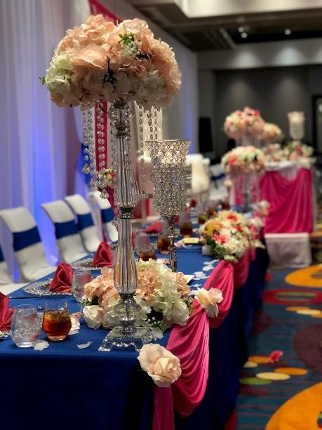

Additional Information

Deposit & Payment
A 25% non-refundable deposit is required at the time of signing your contract to secure your event date. A second deposit (1/2 of the remaining balance) is due 30 days prior to your event date. Full payment is required 10 days prior to your event by certified
check, cashier’s check or credit card. No personal checks accepted.

Guaranteed Guest Count
Guest count guarantees are due by 5:00pm, ten days prior to your event. Guarantees are not subject to reduction.

Minimum Revenue Requirement
Food & beverage minimum revenue requirements will apply to your event based on the function space your event requires. Please inquire directly.

Children’s Meals
Children 12 and under are welcome to eat from the buffet selection chosen by the client at the discounted rate of $24.95. Plated options may also be arranged. Please let your Director of Catering know how many children will be in attendance.

Vendor Meals
It is customary to provide meals to the professionals that you engage for your event. Please arrange this with your Director of Catering prior to your event.

Place Card Service
Hilton Garden Inn or host provided place cards may be required (based on your desired menu package), or if you simply want to add formality or assign seats for your reception. Consult your Catering Sales Manager/Director of Catering for more details.
*HILTON GARDEN INN PROVIDED PLACE CARDS | $2.50/ card

Package Pricing
Minimum of 75 (adults) guests for package pricing.

Music
A DJ/ Band is permitted to play at an appropriate level for the duration of your event. The hotel reserves the right to decide what sound level is appropriate. All music and noise must conclude by 11:00pm.

Event Parking
Complimentary parking is available onsite for your guests.

Group’s Property
All items that do not belong to the hotel and are not contracted through the hotel, such as rentals, must be removed from the room at the conclusion of the event. Hotel is not liable for any items left behind.

Ceremony Rehearsal
Rehearsal time/space is dependent upon availability the day prior to your wedding. Rehearsals are typically scheduled two months prior to event date. Please discuss available times for rehearsal with your Director of Catering.

Decorations Policy
All outside décor must be set up by the event host or vendors the day of the event. Hilton Garden Inn banquets team is not permitted to set up outside décor. Decorations NOT permitted include, but are not limited to: Open flame/ taper candles, table glitter/ confetti, streamers, any hanging items, vinyl decals, banners*, pins, hooks, nails, party poppers/ noisemakers, sparklers, bubbles, fog machines, rice or confetti. Hotel reserves the right to exclude any decoration on the day of the event if they do not meet the safety needs and decoration requirements set forth by the hotel.

Day of Changes
Substantial changes to the event set up, timeline or meal times are subject to additional charges at the discretion of the onsite events team.

Frequently Asked Questions

Q: We are expecting many out of town guests. Is it possible to reserve a group of hotel rooms to accommodate them and what is the cost? Do our guests receive a discount? How does this work?
Yes. A courtesy room block may be arranged through our sales office. The discounted hotel room rates for your block vary; depending on the size of the block and the time of year. After we have received your contract, you will receive instructions to send to your out of town guests detailing their discounted hotel room rate and how to make reservations.

Q: What type of room is included within the wedding package on the night of my wedding? Are there upgraded options?
A complimentary standard King Room is included on the night of your wedding with complimentary breakfast for the wedding couple. You are welcome to upgrade to the Executive Suite at a discounted rate, talk to your Director of Catering about pricing and availability.

Q: Does the hotel provide complimentary shuttle service?
Yes. Our complimentary local hotel shuttle is available to guests who are staying at the hotel and is available to take your guests to the destination of their choice within a 3-mile radius of the hotel. Hired, professional transportation companies are required for groups larger than 20 people.

Q: May we bring our own food or use an outside caterer?
As a full service operation, all food items must be supplied and prepared by the hotel. In accordance with NC Health Department regulations and the risk of food borne illness, food may not be brought in from outside the hotel nor taken/boxed up from the hotel premises after it has been served. Specialty cakes are the exception, provided they are prepared by a licensed bakery.

Q: May we bring in our own alcoholic beverages?
As a full service operation and in compliance with the NC State Alcohol Beverage regulations, the hotel must provide, as well as serve, all alcoholic beverages. Uncorked Wine Bottles are the exception at a $15/bottle corkage fee.
Q: How much does my wedding reception cost? Is there a minimum we must pay to host our event? Minimum Food & Beverage requirements and/or room rentals will be assessed by the Catering & Sales Department and are determined by the anticipated size of your group, date, and duration of time the event is scheduled.

Q: Will there be someone onsite, day of, to ensure we adhere to our timeline and help with various tasks such as sending people down the aisle, announcements, and other items needed?
You will have a Banquet Captain dedicated to your event who will assist with set-up items, AV needs, and the Food & Beverage Portion of your time with us. If you need additional day-of-assistance, we highly suggest getting a day of coordinator.

Q: When will we get access to the room on the day of the wedding?
You will be able to access the room 4-hours prior to your Ceremony start time. Earlier arrival will be solely based on availability, which can be determined the week of your special day. Guaranteed times prior to the week of the event are subject to additional room rental.

