Welcome and Enjoy your Special Event
here with us at the
Holiday Inn Hotel & Suites Phoenix Airport
All foods and beverages must be provided by the hotel-
-Special Event Packages include complimentary-
Beautiful Ballroom with Fichus trees with lights
centerpieces for all guest tables, Various colored table linens
Wooden dance floor, decorations on the Guestbook table, the appetizer station, and bar and punch stations, podium and microphone
Various menu packages to select from-
Professional experienced banquet staff to assist with your event
Alcohol and non-alcohol packages available-
Professional and licensed bartenders to verify age and monitor drinking throughout the evening
Abundant and decorated buffet and dessert stations
Hotel accommodations discounted for your attendees to enjoy the evening worry free
20 % Service charge and 9.6 % Sales tax is already added in with stated inclusive price listed

Special Event Package # 1
Fresh Fruit Punch in decorative bowl for Social hour
- Cold Hors D’oeuvre for Social hour
Dinner Buffet with three salads, two entrees, two side dishes, fresh rolls and butter, Assorted Beautiful Desserts, Coffee, Decaf, Tea, Milk
( Uniformed Chef Carver if needed )
@ $ 33.95++ per person, or $ 45.00 inclusive

Special Event Package # 2
Fresh Fruit Punch in decorative bowl for Social hour
Cash Bar with Licensed Bartender
2- Cold Hors D’oeuvres for Social hour
Dinner Buffet with three salads, two entrees, two side dishes, fresh rolls and butter, Assorted Beautiful Desserts, Coffee, Decaf, Tea, Milk
( Uniformed Chef Carver if needed )
@ $ 37.95++ per person, or $ 50.00 inclusive

Special Event Package # 3
Fresh Fruit Punch in decorative bowl for Social hour
Hosted Bar with one Alcohol Drink ticket per person
2- Cold Hors D’oeuvres for Social hour
Dinner Buffet with three salads, two entrees, two side dishes, fresh rolls and butter, Assorted Beautiful Desserts, Coffee, Decaf, Tea, Milk
( Uniformed Chef Carver if needed )
@ $ 41.95++ per person, or $ 56.00 inclusive

Special Event Package # 4
Fresh Fruit Punch in decorative bowl for Social hour
Hosted Bar with two Alcohol Drink tickets per person
1- Cold and 1- Hot Hors D’oeuvre for Social hour
Dinner Buffet with three salads, two entrees, two side dishes, fresh rolls and butter, Assorted Beautiful Desserts, Coffee, Decaf, Tea, Milk
( Uniformed Chef Carver if needed )

@ $ 47.95++ per person, or $ 63.00 inclusive

Special Event Package # 5
Fresh Fruit Punch in decorative bowl for Social hour
Hosted Bar with two Alcohol Drink tickets per person
1- Cold and 1- Hot Hors D’oeuvre for Social hour
Dinner Buffet with three salads, three entrees, two side dishes, fresh rolls and butter, Assorted Beautiful Desserts, Coffee, Decaf, Tea, Milk
( Uniformed Chef Carver if needed )

@ $ 50.95++ per person, or $ 67.00 inclusive

Additional Hors D’oeuvres and additional hosted bar tickets can be added to any package, just ask and we will provide you with pricing-

Cash Bar continues after tickets used at no additional cost
Ice carvings available - Inquire for pricing

Ask about weekday specials

Buffet Meals:
Minimum 25 people for buffet service
All meals include: Premium roasted regular and decaf coffee, iced tea,
low fat milk, lemon ice water and fresh rolls & butter
~Chef’s Assorted Dessert Selection~

Salad Choices:
(Choice of two for up to 30 people, Choice of three for 30+ people)
Garden salad with 2 choices of dressings, Strawberry salad, Traditional Caesar, Creamy Cucumber salad with dill, Caprese salad, Seafood Pasta salad, Greek Pasta salad, Fresh Fruit salad with seasonal berries, Ambrosia Salad, Marinated Mushroom and Artichoke salad, California Waldorf salad

_______________________________________________

Entrée Selections:
Homemade Meatloaf with natural gravy
Cheese tortellini or ravioli with pesto cream sauce
- Can add Grilled Chicken breast –

Slow roasted turkey with gravy and cranberry mayo
Breaded pork chops with apple chutney
Roasted eggplant parmesan
Chicken Marsala- or -Chicken Cordon bleu- or -Grilled citrus Chicken
Chicken Piccata
Lemon Salmon
Sliced Sirloin of Beef with Au jus
Roasted Pork tenderloin with peppercorn
demi glaze or rasberry chipotle sauce

Carver Station:
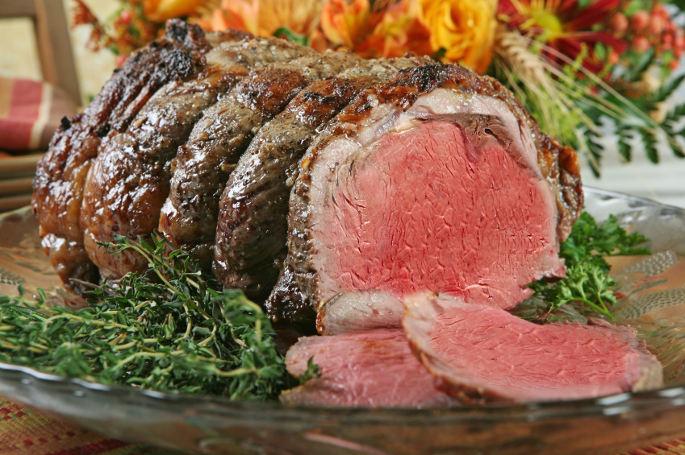
Roasted prime rib of beef with au jus and creamed horseradish
Honey glazed ham

_______________________________________________

Starch Selections:
(Choice of One)

Wild rice
Rice pilaf
Risotto
Cous Cous
Quinoa
Steamed white or brown rice
Red skin mashed potatoes
Seasoned baby potatoes
Baked sweet potato
Homemade stuffing
Au Gratin potatoes
Twice baked potatoes

Baked potato with
sour cream & chives on the side

_______________________________________________
Vegetable Selections:
(Choice of One)
Steamed green beans with roasted red pepper
Sautéed zucchini and yellow squash
Buttered or grilled asparagus spears
Steamed vegetable medley
Roasted whole kernel corn
Broccoli

Themed Menus
Minimum 20 people for buffet service
All meals include: Premium roasted regular and decaf coffee, iced tea, low fat milk and lemon ice water

Western Buffet
Garden salad with sliced bell pepper,
corn kernels and black beans
Coleslaw
Mustard potato salad
Sautéed corn
Ranch style beans
Choice of 2:
Grilled chicken
Pulled pork
Ribs
Biscuits and cornbread with
butter on the side
Cherry and apple pie

Oriental Buffet
Baby spinach salad with mushrooms, sprouts, radishes, water chestnuts
and jicama with ginger sesame dressing
Crudités of vegetables with dip
Beef and broccoli
Teriyaki chicken and vegetable stir fry
Egg rolls
Fried rice and brown rice
Fortune cookies

____________________________________________________________

Italian Buffet
Traditional Caeser salad with shredded parmesan, croutons and dressing on the side
Caprese salad with sliced tomatoes, mozzarella cheese, basil and
balsamic vinaigrette dressing, Pasta salad
Choice of 2:
Chicken parmesan over spaghetti noodles
Meat or vegetarian lasagna
Baked penne pasta
Meatballs in red or alfredo sauce
Garlic bread
Cannolis and tiramisu

Mexican Buffet
Garden salad with diced bell peppers, onions and tortilla strips with chipotle ranch dressing
Fresh fruit salad with mangoes, Mexican black bean and corn salad,
Spanish rice and refried beans, Flour tortillas
Guacamole, sour cream and cheese,
Homemade salsa and tortilla chips
Choice of 2:
Cheese enchiladas, Chicken or beef fajitas, Chile relleno,
Chicken or Beef Street tacos
Tres Leche

Crosby Rigging Trainer Development
Meetings with Breaks
March 22 & 23, 2017
Thank you for choosing the Holiday Inn Hotel & Suites Phoenix Airport to serve your organization. Although we constantly strive to provide the highest quality of facilities and services, you are, the ultimate judge of our success.

 | Excellent | Good | Fair | Poor
Staff Courtesy / Friendliness | X
Banquet Service | X
Banquet Food | X
Ballroom Presentation | X
Telephone / Message Service | X
Meeting Services | X

Other Comments: This was the absolute best service I have ever received on these type of meeting programs – and I have been doing these for 25 years. Joe is organized and extremely thorough. I was able to focus on my meetings instead of being concerned with the service.
______________________________________________________________________________________

How did you hear about the Holiday Inn Hotel & Suites Phoenix Airport? Website meeting icon.
______________________________________________________________________________________

Why did you select the Holiday Inn Hotel & Suites Phoenix Airport? Pricing was attractive.
______________________________________________________________________________________

Do you have any future events planned? Nothing in the immediate future. But if something comes up, I will come back.
______________________________________________________________________________________

How can we improve our service to you? Don’t change anything! Just keep doing what you are already doing.

______________________________________
Joe Vojacek, Catering and Conference Services

