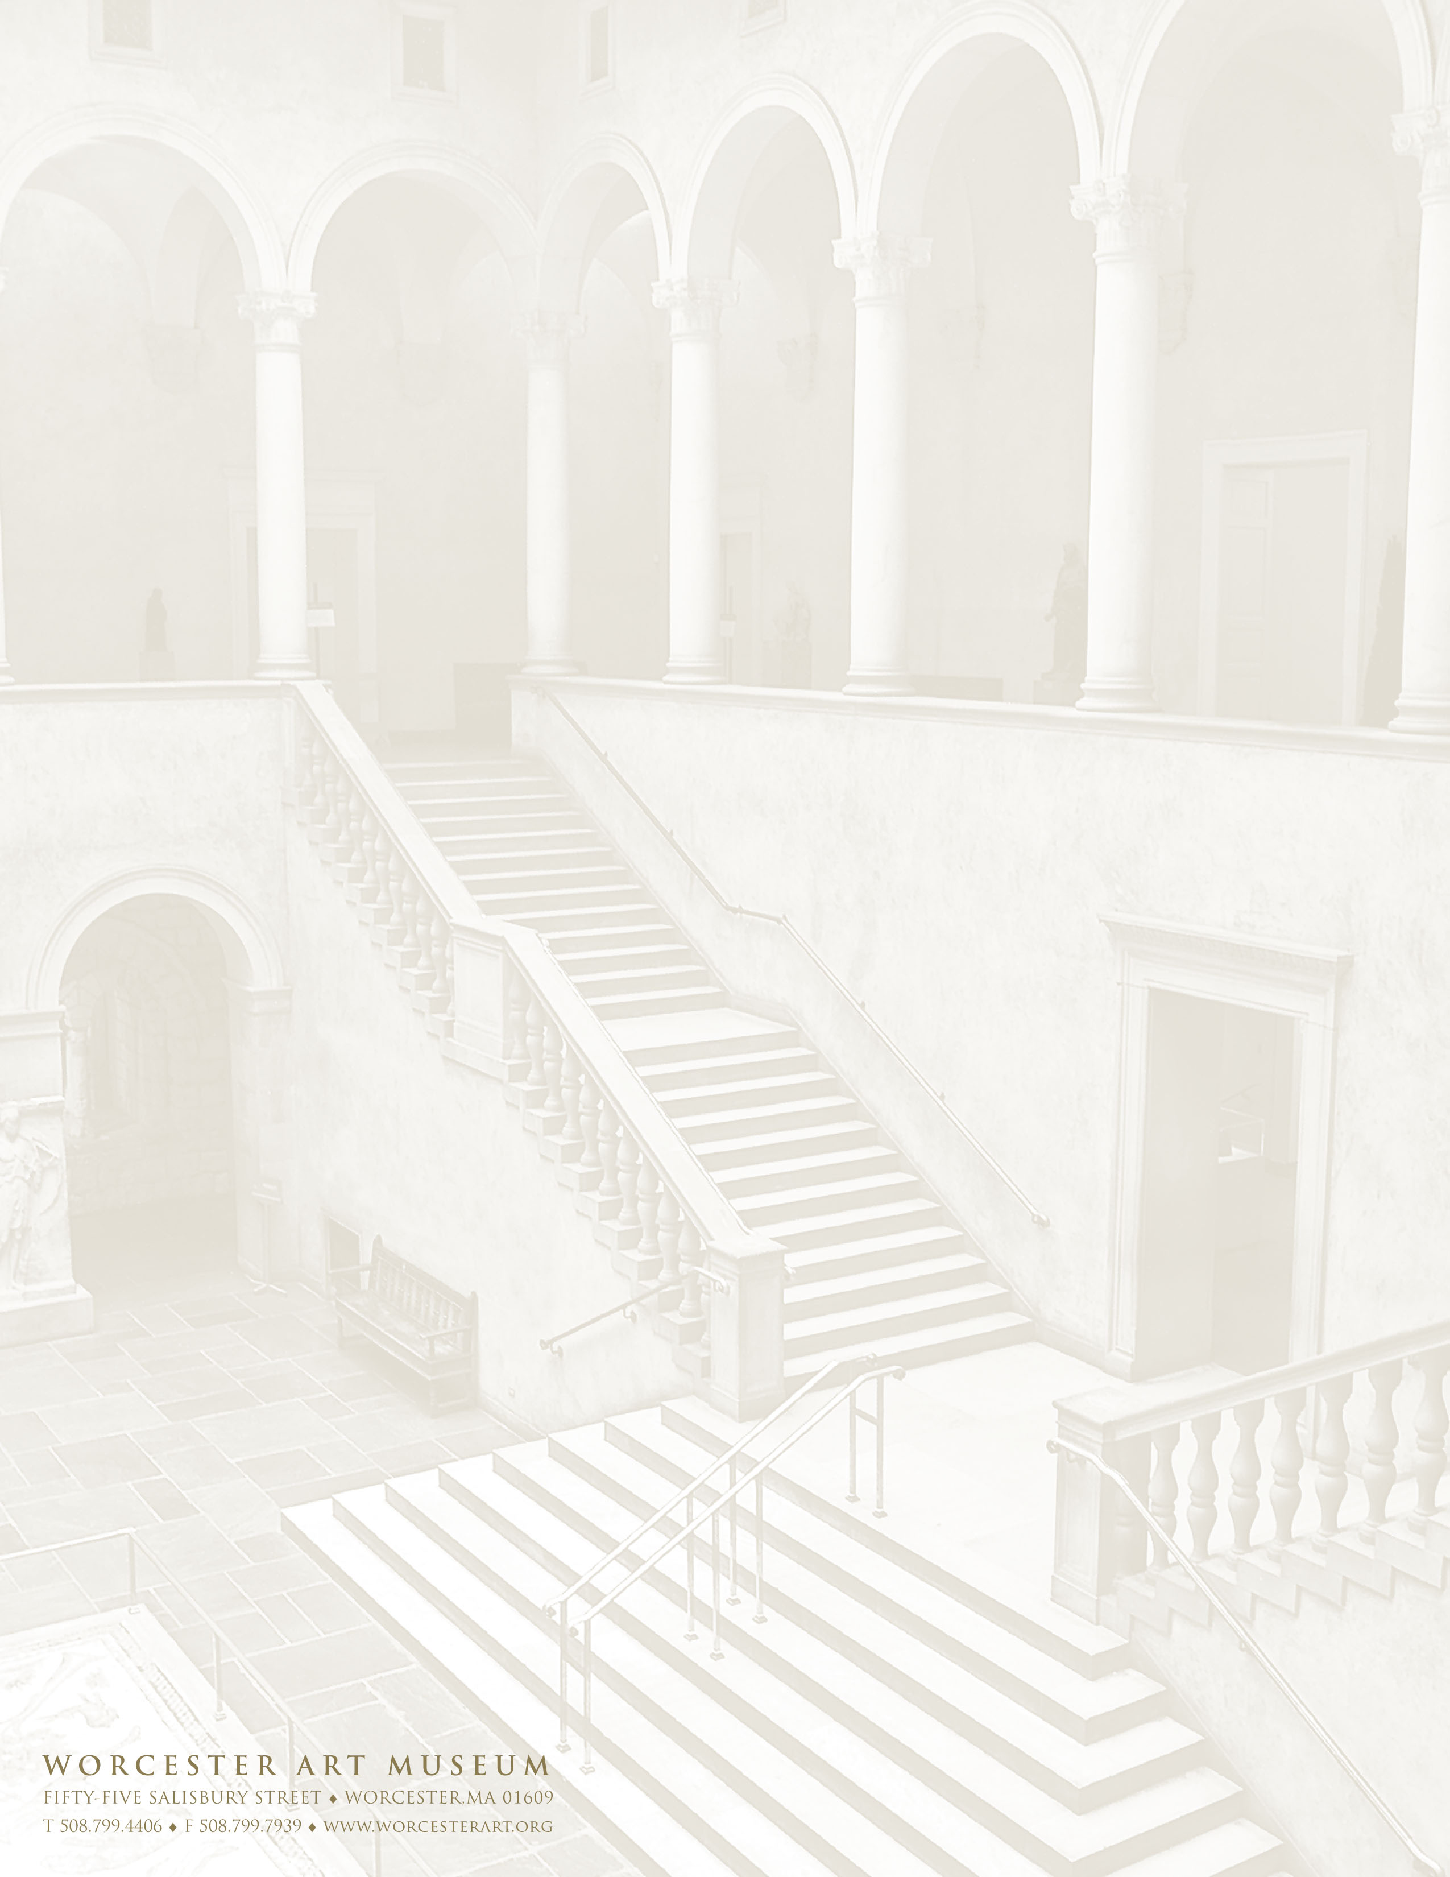

VENUE FEES

The Museum makes available, on a rental basis, the use of its unique architectural spaces and galleries for groups or individuals to host Cocktail Receptions, Bridal Showers, Holiday Parties and Corporate events including Dinners, Meetings, and Client Appreciation events. To schedule a personal tour or request information, contact Kristen Kirk at 508.793.4330 or by e-mail at facilityrentals@worcesterart.org
Venue Capacity Rate
Renaissance Court/Balcony Cocktail Style Reception: 250 $3800 for up to 3 hours
(Includes access to Museum Galleries on first level) Seated Dinner & Dancing: 120 $500 per additional hour
Dinner only w/up & downstairs seating:160

Renaissance Court 1st level 30-100 guests; Depending on set up $3400 for up to 3 hours
(Includes access to Museum Galleries on first level) $500 per additional hour

The Museum Café Cocktail Reception: 150 $1000 for up to 3 hours &
(Includes the Stoddard Garden Courtyard) Dinner: 70-90 $400 per additional hour

Conference Room Meeting space: 30-100 $400 for up to 4 hours &
(Basic Audio Visual Included) Depending on set up $600 for up to 8 hours
((Prices applicable Weekdays only 9-5))

For events held on Sunday through Thursday a 10% discount off the Venue Fee is applicable. (Conference Room excluded) Non-profit discounts available, only one discount is applicable.
VENUE Availability
Monday and Tuesday – All Venues available anytime
The Conference Room is available without time restriction
Renaissance Court is available Wednesday through Sunday – from 6:00pm on; all events must conclude by midnight
The Museum Café/Stoddard Garden Court - daily 5pm on and all day Sunday

Rental fees include Museum Protective Services, set up of Museum and or rental furniture and a Museum Facilitator. Rental of the Renaissance Court/Balcony includes 140 chairs for indoor usage and standard tables within Museum inventory. The Museum Café includes existing tables (no high tops) and chairs for up to 90 guests. The Conference Room includes chairs and classroom style tables for standard set ups.
Complimentary parking is available at the visitor parking lots and on the street.

Additional Fees
Any rental furniture needs will be provided by the Museum and set up by same. Delivery charge of $45 is applicable for rental furniture. Venue fees and any rental furniture are subject to 7% State and local tax.

2016

