HOST YOUR NEXT MICRO-EVENT HERE!

Hair BNB GA of Dryer Enterprises Inc.
presents
Creative Space Micro-Event Rental Space
What is a micro-event? They are traditional events condensed in size and scope, sometimes in an untraditional setting which adds to the character of your event and makes it creative!
What can the space be used for? Classes, workshops, trainings, socials, mini-seminars, pop-up shops, business launches, photo shoots, even small weddings! ...and more!
What is the size of the usable space? There are two sections in our main space. The measurement for the main area is 36x14’8. The adjoining annex is 11’2x10’5.
Capacity:
- 60-75 Theater style
- Table seating capacity depends on style/set-up but usually cuts theater style attendance in half
- A cocktail event with a mixture of hi-tops, some chairs, and a few standard tables can be an option.
There is also a private room/space available for one-on-one trainings, a dressing room, or office use. While here, you can have access to the following:
- 4- 50 inch TV’s with internet connection and viewing from your personal laptop or device with hdmi.
- WIFI
- Tables and Chairs if needed*
- Handicapped Accessible
- Some outdoor function area
- We can arrange catering according to any budget if desired*
- Outside Catering Allowed
- Plentiful Parking
- Private/Semi-private Meeting Options
- Decoration Packages Available Based on Budget*
*Additional fees will be added to space fee.
What are the rates? Rates can be hourly or daily depending on availability. Special weekday discount rates.
Am I allowed to bring food? Yes, but food must already be prepared. If food must be warmed, you are responsible for doing so with your own equipment (pans and sternos for bigger dishes). A list of preferred caterers can be provided for you to explore or outside catering is allowed.
For more information, text inquiries to LaDonna at 912-844-4837. Scan the code to be directed to the website.
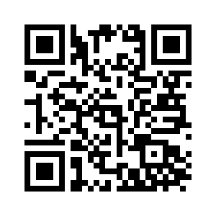
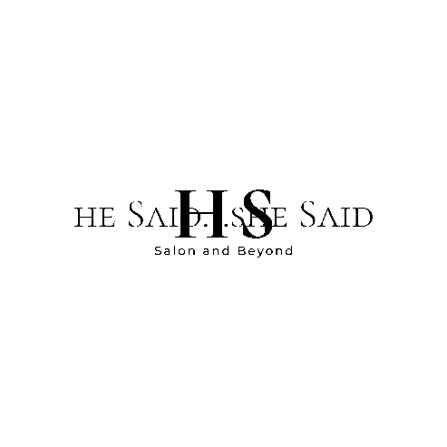
Event Request Profile
We appreciate your interest in renting our creative space for your micro-event! We can simply rent a space only or we can work with you to create an unforgettable experience that your attendees will cherish! Please fill out the following information and we will get back to you very shortly with a proposal including pricing based on your needs!
Name:
Company Name:
Contact Number:
Contact Email:
Function Requested:

Date or Dates Requested:
Hours needed – ½ day minimum required (5 hours) (Daily/1/2 Day):
Amount of People Expected:
Space(s) Requested: Main Space/Annex/Private Room
Catering Requested? Total Budget?
Chairs/Tables/Equipment Needed? (Please be specific)

What can we do to make your event/workshop special and unique?

Would you like a decorating quote for your event?
Do you have a specific theme or colors that you would enjoy?
What is your maximum budget for decorating services?

Will you need the use of televisions for PowerPoint or video viewing?
Do you prefer a more intimate and private environment?

What other information should we know to set your event up to win?

Thank you for providing insight for your event! You can email your completed profile to hesaidshesaidsalon@gmail.com or text a clear picture of the form to 912-844-4837. After analyzing your responses, we can put together a proposal for you!

