Weddings With A Blessing

By: The Honorable Reverend Steve Whitters, D. Th.
5408 Fern Valley Way
Elk Grove, California 95757-3306
Cell Phone: (916) 214-3980
E-Mail: whitters9570@yahoo.com

Price Listing
Weddings, Anniversaries And Commitment Ceremonies

(Simple Wedding): 10 - 15 Minutes Long, Which Includes All Of The Following:

Free First Meeting Consultation With The Couple (Approximately 1 Hour)
Free 2nd Meeting (Usually Short and Sweet, And If Needed) Presentation Of The Bride
Angelology Welcome
In Memory Of:
Opening Remarks Declaration Of Support Negative Questioning Declaration Of Intent/Consent
Marriage Vows Exchanged (Either Personal Or Traditional) Ring Exchange
Pronouncement Of Marriage Couple’s Kiss
Presentation Of Mr. And Mrs.
Signing Of The Marriage Documentation
Free Marriage Keepsake Certificate For The Bride & Groom Free 500 Page Printed Main Wedding Manual
Free DVD Of 40,000 Pages Of Additional Wedding Material. 140 Total Manuals!
Free 5 Copies Of The Wedding Script (Reverend’s Booklet) 1 For Each Parent, And 1 For You.
Free Certificate Of Appreciation To All Flower Girls; Ring Bearers; Readers, Coin & Bible Presenters.

$200.00 Yes

================================================================
(Average Wedding): 16 - 30 Minutes’ Long

All The Above,

Plus Opening Prayer and 2 Scripture Readings
Two Unity Ceremonies
Anointing Of The Couple With Either Holy Water Or Oils Blessing Of The Bridal Ring Set

$250.00 Yes
================================================================
(Full Wedding): 31 Minutes Or Longer.

All The Above Plus

Gospel Readings Reaffirmation Of Faith Prayer For Bride And Groom
Blessing Of The Food At The Reception, If Requested Ruth’s Passage Read
Unlimited Unity Ceremonies Such As Coins, Communion, Lasso, Hand Blessing, Sand Ceremony, Etc. (See Page 17 Below And Manuals 55 - 59 For All The Available Unity Ceremonies – Over 300 different ones).

$300.00 Yes:

=====================================================

Please Note: The following are about the only extra charges that you might incur other than Comfort Items discussed in the next section.

Rehearsals Within Sacramento County = +$50.00
Rehearsals for Out of Sacramento County = +$75.00 (+$75.00 Per County from outside Sacramento)
Out of Sacramento County Weddings = +$50.00 Use of 280 Amp PA System = +$35.00 (Very Loud)!

Note: Delivering (and filing) of your documents to your County Recorder’s Office, is all that I can do. I can NOT get a copy of your Wedding Certificate as California Law forbids it. If you want a “Certified Copy” of your marriage certificate, you must fill out the application and submit it directly to your County Recorder’s Office with a payment of $16.00.

Please see the below URL.

http://www.cdph.ca.gov/certlic/birthdeathmar/Pages/AthorizedCopyvsInformationalCopy. aspx
The actual PDF application form is available at the below listed URL:
http://www.cdph.ca.gov/pubsforms/forms/CtrldForms/vs113a.pdf

=====================================================

Sample:

Simple Wedding = $200.00 Wedding In Solano County = 50.00 Out of Sacramento County Rehearsal = $75.00 Total: $325.00

Comfort Items

Turtle Dove Releases. Releasing up to 24 Doves as an expression of Love, Devotion, Peace and Unity.

Pricing is based on contacting Whitebird Ceremonial Dove Releases. Anna’s phone number is: (916) 443-2165 and her Web Address is: http://www.whitebird.com/index.php.
Serving the Sacramento, California foothills towns of Auburn, Grass Valley, Lincoln, Roseville and the surrounding communities.

Yes: No:

===============================================================

Butterfly Releases. Pricing is based on contacting one of the nearby butterfly farms in either Woodland or El Dorado. Normal pricing is approximately $100.00 per dozen butterflies. PRICES VARY depending on type of butterfly ordering, the season and availability. I have their complete address and phone numbers if you want to contact them. You can either pick them up, or have them delivered. This is an ohhhhhh, wowwwww ceremony!

Yes: No:

WHERE CAN I PURCHASE BUTTERFLIES

There are two places in which you, can get butterflies.

One is called: Utterback Farms, (530) 661-3009, Woodland, CA. http://www.utterbackfarms.com/

The other place is called: Swallowtail Farms, 989 Governor Drive, #103, El Dorado, CA (916) 939-3752.
http://www.swallowtailfarms.com/

===============================================================

One Long Stem Rose w/greens presented to each Mother.

Yes: No:

$20.00

===============================================================

House Blessing with Certificate.

Yes: No:

$50.00

===============================================================

Horse And Buggy/Carriages, etc.

Vintage Carriage Company
395 Hwy. 65, Ste. A,
Box 157
Lincoln, CA 95648
(800) 426-3321
www.vintagecarriage.com

OR AT:

Top Hand Ranch
P.O. Box 183 Elverta, CA 95626
Cell: (916) 496-0102
Home: (530) 677-2871
(916) 655-3444
Fax: (916) 655-1516
tophandranch@aol.com

Yes: _ No:

Pricing is based on contacting one of the nearby Horse And Buggy Ranches in either

Use This Price Sheet As A Guide

Traditional $ Wedding Type: Semi-Formal $
Full Wedding $ Sacramento Rehearsal $
Out Of Sacrament County Wedding $ Out of Sacramento Rehearsal $ Use of Public Address System $
Comfort Items $ Unity Ceremonies $
One Or The Other Military Discount - $ But NOT Both Pinoy/Pinay Discount - $

GRAND TOTAL: $

= = = = = = = = = = == = = = = = = = = = = = = = = = = = = = = = = = = = = = = = = = = =
Please note:

- Any travel beyond the Sacramento County Line will be an additional $50.00 due to time and travel.

- Any rehearsals within Sacramento County will be an additional $50.00 due to time and travel but is very highly suggested.

- Any travel beyond the Sacramento County Line for a rehearsal will be $75.00 due to time and travel, but is very highly suggested.

- Payment is due immediately after the wedding ceremony. It is normally attended to by the Best Man. Please ensure that the Best Man, the two witnesses, the Flower Girls and the Ring Bearer are available after the wedding.

- Unfortunately, because of previous scenarios, without payment, I may have to refuse to sign the marriage certificate until payment is received in full. The other option for me is to NOT submit your wedding license to the County Recorder’s Office with extenuating circumstances.

- PLEASE DO NOT HOLD THE WEDDING LICENSE FOR RANSOM! I require that the license be presented to me, prior to the start of the wedding! Do NOT tell me you don’t have one; you have it in the car; or it’s in your hotel room; or

that your parents have it! I’ve heard all those stories before, and it takes times away from my other weddings that I may have to attend to.

- Please note that these are donations. I have receipts with me that I can issue to you for your tax records.

Military And Pinoy Discounts
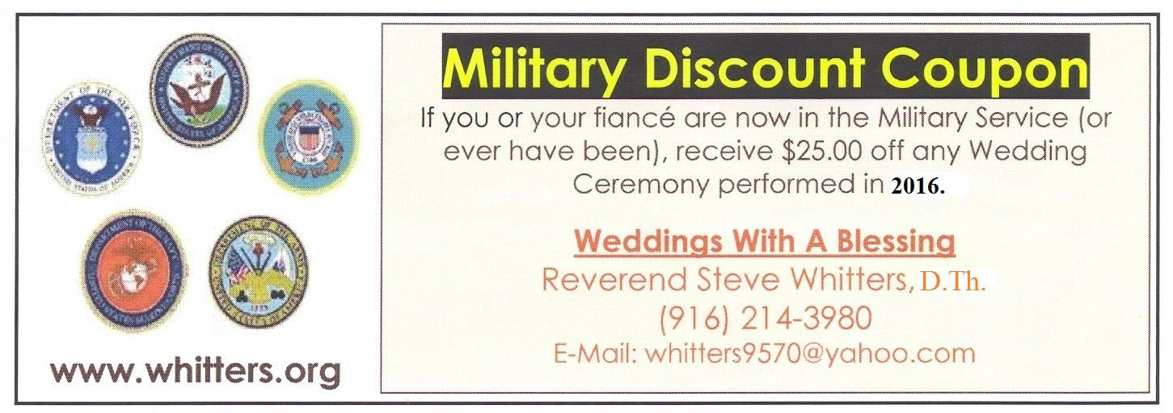
Guess What? The above coupon NEVER expires!!!! It is good FOREVER.

Due to the fact that I am a retired U.S. Marine with over 21 years of service; and that our military service personnel have been coming home from overseas since December 2011, I will give any couple who will be married in the calendar year 2011 and beyond; a $25.00 discount, if either of you have served, or still serving in any of the U.S. military services.
NOW: The above coupon is good for any member of your family who has ever been in the military service. Soooo, if your Uncle Ned was in Vietnam, I’ll give you $25.00 off your wedding ceremony.
If your Aunt Martha was a Nurse in WWII, I’ll still give you $25.00 off. If your Grandpa was in the Civil War at Bull Run, Gettysburg, or Antioch; I’ll still honor this offer.
If your Great Grandpa served in the American Revolution and fought against the British at Fort McKinley or Bunker Hill, I’ll donate the $25.00 back to you.
I’ll tell you what; if your Dad’s dad wore a coon’s skins hat and fought at the Alamo, I’ll take $25.00 off of your wedding.
You’ll still get the $25.00 off even if your Great, Great, Grandpa was thrown off the Mayflower, the Santa Maria or the Pina coming to America.
No proof required! Your say-so is good enough for me.

OTHER DISCOUNTS:

- If you are a Pinoy/Pinay; my wife would kill me if I didn’t give you a $25.00 discount. Since she’s from Bayombong (Very Northern Philippines), she demands Pinoy/Pinay discounts.

- If you refer a couple, and I conduct their wedding, you will be sent a check for $25.00.

Questionnaire To Be Filled Out

Please hand PRINT neatly or type it. Fill it out as much as possible. If you don’t know an answer, please leave it blank for now.

- Grooms Full Name: _ (Please Include Full Middle Name)

Date Of Birth & Age On Wedding Date:

Address: _ Phone Number(s): _ E-mail Address: _ Father Of The Groom: _ Mother Of The Groom:
Parent’s Phone Number:

- Brides Full Name: (Please Include Full Middle Name)

Date Of Birth & Age On Wedding Date:

Address: _ Phone Number(s): _ E-mail Address: _ Name Of Father Of The Bride:
Does Your Father Want to Give You Away? Yes: No:

If Not Your Father, Who Else Will? Please provide full Name and Relationship.
_

_

Name Of Mother Of The Bride:

Parent’s Phone Number:

- Day, Date And Time Of Wedding:
Also, if you know the specific day such as Sun, Mon., Tue., Wed., etc., please enter it.

- Approximate Number Of Wedding Attendees?

- Place Where Wedding Will Be Performed: _

Address Of Wedding: _

_ Wedding Place Phone Number(s):
- Are There Any Gated Property Codes, Specific Directions Or Routes, Wedding Signs, Etc., That I Must Know Of?
_

- Is The Wedding Ceremony Going To Be Conducted Indoors Or Outdoors? (Please Circle One)

- Do You Have A Contention Plan For Any Inconceivable Weather? Yes: No: _

- Do you know of Anything That Could Detract From The Ceremony? Traffic, Waterfalls, Trains, Airplanes, Construction, Road Repair, Volcano’s, Any Loud Noises, Etc.?
_

_

- Is There Going To Be A Rehearsal? Yes: _ No:

Date And Time Of rehearsal?

Location Of Rehearsal? (If Different Then Wedding Location)

Address: _ Phone Number(s):
- Is The Reverend To Attend The Rehearsal? Yes: _ No:

Please Note: There will be an extra charge of $50.00 for Sacramento Rehearsals due to Reserving the date and time). Other Counties are $75.00 per county from Sacramento.

- Will You Be Having A DJ Or A Live Band At Your Wedding Ceremony?

Yes: _ No:

- Will The DJ Be Providing Me, You Or Us, With A Mic For The Wedding Ceremony?

No DJ: Officiant:
Groom:
Bride:

- Should The Officiant Bring His Own 280 Amp With 2 Lapel Mics With Him For
An Additional $35.00? Yes: No:

- Do you have an independent full-service Wedding Planner or a Day of Coordinator? Yes: No: _

If yes, please include their name and contact information below.

Contact Name: _. Contact Phone Number: _. Contact E-Mail Address (If Known): _.
(Note: Most planners and Day Of Coordinators over-see your rehearsal, and many “venue provided” coordinators do so as well).

- Does your venue include a coordinator with their services? Yes: No:

If any of those options are available to you, you might want to forgo contracting me for your rehearsal, saving you $$$).

- Has The Marriage License Been Obtained And Available For Reviewing? Yes: _ No: _

If No, When Are You Planning To Apply For The License?

- What Is The Appropriate Attire For The Reverend?

Dark Colored Suit & Tie: (This Is The Normal Attire)

Cotton Tweed White Suit Coat, Pants And Tie (Shell White): _ Cowboy Attire: _ Attire #1: Attire #2:
Vestments (Alb & Vestments/Stole): _ (For Christian Weddings)

Black Shirt With White Collar, Black Pants: (Priest Uniform) Dressed Up As Your Wedding Theme As Discussed Below?
Yes: _ No:

No Preference:

- Do Either Of You Have A Wedding Web Site That You’re Using?

Yes: No:
If you do, what is the URL (Web Address)?

- Do You Have A Theme Or Specific Colors For Your Wedding?

Yes: _ No: _ What is it? _ (Or Please Circle Below)

1920's
1950's
1960's and Disco Alice Cooper
Alice In Wonderland Angel
Asian
Autumn/Fall Beach
Beach Party Black And White Bluez Brotherz Bond
Butterfly

Calla Lily Camelot Celtic
Cherry Blossom Christmas
Colors:

Cruise Ship Daisy Disney Dolphin Dreamsicles Egyptian
Elvis Blue Hawaii Elvis
Fairy Tale Fall
Feather/Maribou Fleur De Lis Flower Girl Items Gangster
Golf Gothic
Gothic Rock Graveyard Halloween Harley Hawaiian Heart
Irish
Hollywood Starlet Intergalactic Italian
Kim Anderson Las Vegas Lavender Floral Liberace
Lily of the Valley
Linked at the Heart Love Bird
Mardi Gras Marry My Friend Medieval Monogram Moroccan Motorcycle November Outdoor
Perfect Pair s Pirate Phantom Pink Caddy Pirate
Red Rose Rock And Roll Red
Rock-a-Billy Rocky's Horror Rose
Royalty Rustic/Barn Seashell Shower Spring
Star Wars Star Summer
Swan And Heart Sweethearts Tiffany
The Tomb
The Viva Tango Tulips Valentine's Victorian
Viva du Cirque Wass-up Pussycat Western Western/Cowboy

When Vampire's Fly Wine
Wings of Love
Winter
Winter Wonder Land Woodstock

Please Describe If Not Listed Above:
_
_
_

- Do you want to perform Any Unity Ceremonies?

Yes: _ No:

Please circle which one(s) or add it here: _

13 Coins Balloon Releases
Bell Ringing Ceremony Blessing of Children Blessing Of The Hands Blessing With Holy Oils Blessing With Holy Water
Blessing Of The Engagement and or Bridal Rings
Box Ceremony
Breaking the Glass Ceremony Broom/Sword Jumping Butterfly Release
Candle Ceremony
Celtic Loving Cup Ceremony Child Acknowledgement
Children’s Ceremony Chocolate
Circling
Clay Ceremony Cleansing Of The Hands Communion
Double Sided Cup Dove Release Goldfish
Hand Ceremony Hand-Fasting Padlock Ceremony
Roses To Both Mothers Salt
Sand Water

- Is Their A Specific Tone To The Ceremony That You’re Wanting? (Please Circle) I.e.; Traditional, Spiritual, Formal, Religious, Casual, Interfaith, Shotgun Wedding, Beach Wedding, Fun, Exciting, etc.

- Do You Want An Opening Prayer (First Reading)? Yes: No: (Our Father, We Come Before You This Holy Occasion With Our Hearts Filled…

- Do You Want An Opening Scriptures Read? (Old Testament Scriptures) Yes: _ No:
Usually Taken From: (1) Genesis 1:27-28, So God created man in his own image
  - Genesis 2:21-25, So the Lord God caused a deep sleep
  - Ecclesiastes 4:9-12, Two are better than one because they have a good return for their labor.

- Do You Want A Closing Scriptures Read? (Old Testament Scriptures) Yes: _ No:

Usually Taken From: (1) 1 Corinthians 13: 1-13, If I speak in the tongues of men
  - Ephesians 5:23-33, Wives, submit yourselves to your
  - Ruth 1:16-17, Do not urge me to leave you or turn back

- Filipino Weddings:

Do You Want To Perform The Candle Ceremony? Yes: _ No:

Do You Want To Perform The Vail Ceremony? Yes: Do You Want To Perform The Cord Ceremony? Yes: Do You Want To Perform The 13 Coin Ceremony? Yes: Do You Want To Receive Communion? Yes: Do You Want To Perform The Wine Ceremony? Yes:
No: No: _ No: _ No: No:

- Will You Be Reading Your Own Vows, Or Will The Standard Vows Be Stated?
Standard: Personal Vows:
(Personal Vows are very highly recommended).

- Do You Have A Wedding Program Available? Yes: If you do, please provide the Reverend Whitters with one.
No:

- Who Will Provide The Bridal Ring set? _

Age
- Will There Be A Flower Girl? (Full Name): _ (I Will Need Their Age, Middle Initial and
Gender also).

Age
- Will There Be A /Ring Bearer? (Full Name): (I Will Need Their Age, Middle Initial and
Gender also).

_

- Other than the Flower Girl and Ring Bearers, will there be any other young specialty people that you would recommend that Reverend Whitters present a Certificate to that helped with your wedding? (Bible Readers, Train Bearers, Coin Bearers, etc.) Please list their First Name, Middle Initial, Last Name, Gender and What Position They Will Be Holding.

_

_

_

- Who Will Be The Best Man? (Full Name And Please Include Middle Initial).
_

- Who Will Be The Maid Of Honor? (Full Name And Please Include Middle Initial).
_

- Please Provide The Names Who Shall Be The 2 Witnesses For Signing The Marriage License? (May Be Of Any Age, But Must Know What They Witnessed).
If They Are The Best Man And Maid Of Honor, Please So State. Also, Please Include Any Middle Initial.
1.

2.

- Will The Reverend Give A “Blessing Of The Food” At The Reception? Yes: No:

- Will There Be A Mentioning Or Prayer For Any Deceased Member Of The Family Prior To The Wedding? (Mother, Father, Sister, Brother, Aunt, Etc.) If Yes, Please Provide Their Name And Relationship To You.

Also, If There Are Other Members Who Could Not Make It Here Today Due To Sickness, Location, Etc., I’ll Also Include Them Into The “In Memory Of” portion.

Please Remember “This Is NOT An Obituary Or A Eulogy, IT’S YOUR WEDDING! Please Print Exact Name To Be Read: Please Circle Relationship
Bride/Groom

Bride/Groom

Bride/Groom

Bride/Groom

Bride/Groom

- Do Either Of You Have Children?

a. Groom: Yes: No: _

Please Print Names: Age Gender

_

_

_

_

_

b. Bride: Yes:  Please Print Names: | No:  Age | Gender
 |  | _
 |  | _
_ _

_

_

- Are There Others Who Would Like To Be Part Of, Or Mentioned In The Ceremony? (Being Blessed; In Sand or Medallion Ceremony; Etc.). If There Are,
Please List Their Information Below. Yes: No:

If Yes, Please Give The Full Names Of Each Person With Their Age And Relationship (Or Role (Sand Ceremony, Rock Ceremony, Blessing Of Holy Water Or Oils, Bible Readings, Train Bearer, Page Boys, Etc.).

Please Print Exact Name To Be Read: Age Relationship/Role

Additional Notes

(Any Concerns Or Questions?)

_
_
_
_
_
_
_
_
_
_
_
_
_
_
_
_
_
_
_
_
_
_
_
_
_
_
_
_
_
_
_
_
_
_
_
. Whitters 1080 Form (Rev 6/05)

Are You Looking For Insurance?
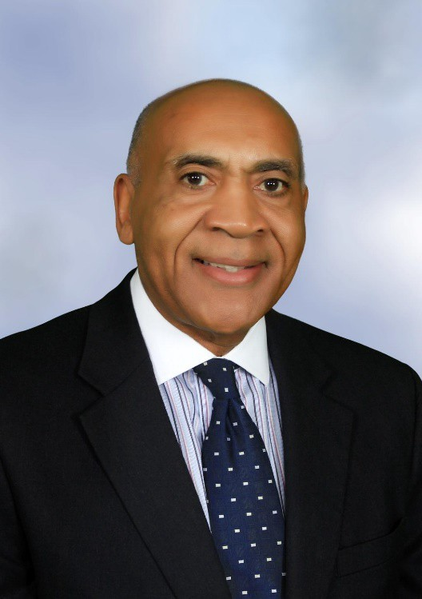
Janssen

D.

Jansen D. Brooks Agent-Broker

Brooks

California License #0B87882 8209 Wooded Brook Drive Elk Grove, California 95758
Cell Phone: (916) 667-4974 Home Phone: (916) 683-8160
Did you just get married, or have children? Would you like a policy review?
Do you require a policy changes?
As a Professional Licensed Agent-Broker, I instill an atmosphere of relaxation and honesty, with unique experiences for you you and your loved ones.
Retirement Income Planning Burial Insurance
Heath Insurance
While I’m based in Sacramento, I am more than happy to travel to wherever my services may be needed.
If you have specific insurance needs, as an
Independent Insurance Broker, I’m able to select the best policies for you.

Whatever your insurance needs are, we can definitely make a custom package just for you!
Janssen D. Brooks

