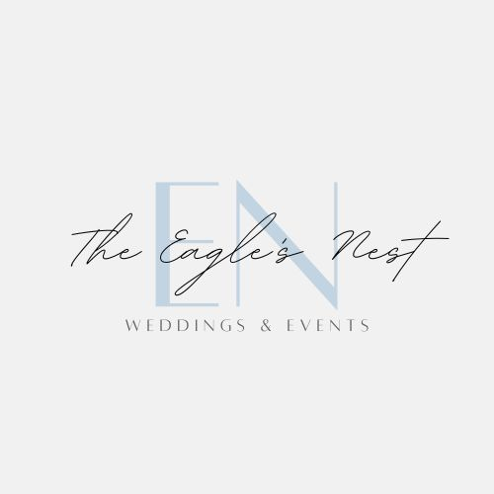

Eagle’s Nest Intimate (100 guest max) Wedding Venue Package
BASIC
$2,999.00
5.5% sales tax is not included in the pricing above.

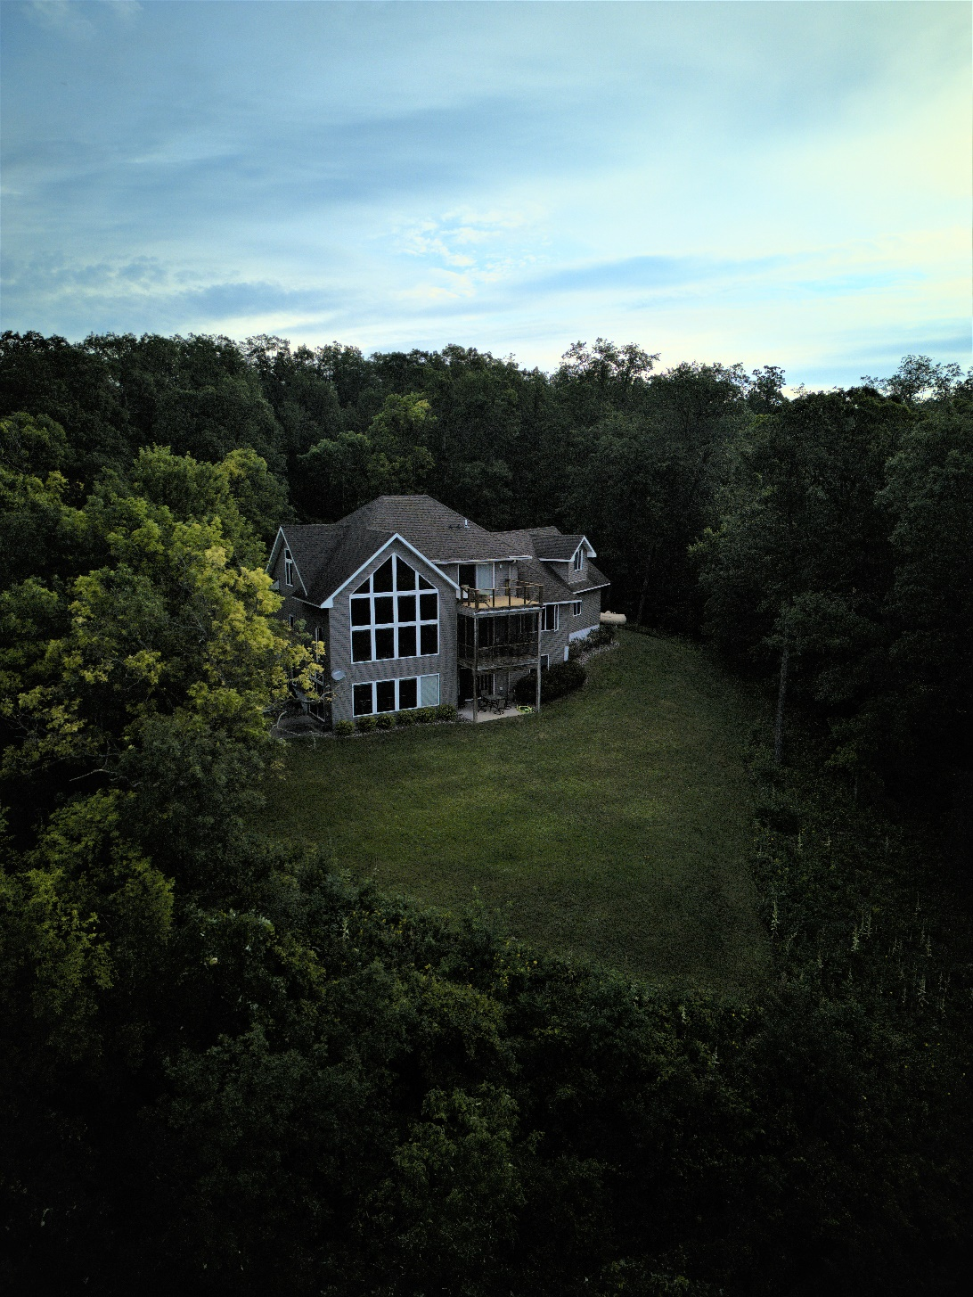

Includes:
* Afternoon before the day of the event - noon the day after the event. Set at seven overnight guests ($15 fee for each guest exceeding seven). Maximum capacity of 10 overnight guests. Pending availability, additional days can be requested and/or added (standard lodging rates would be applied to The Eagle’s Nest basic package rate).

*Exclusive Use of the entire Property indoor and outdoor + Venue.

*Access to property for engagement pictures (inside & outside the home). Flexible scheduling and advance planning required to make this accommodation.

*On-site parking for entire wedding party.

*Access to utilize basement as cocktail bar & serving area during your event.

*Use of Eagle’s Nest arbor

*Access to the Butler’s Den (linens, serving trays, 50 wine glass, table settings, etc.)

*Full use of kitchen and dining area for preparations.

*Owner and/or Eagle’s Nest employee on site available to assist with parking, security, or any other additional last-minute needs (prior to ceremony and within Maiden Rock vicinity that evening, for the safety of your wedding/event).

*One hour in person phone, Zoom, or in person consultation.

*Four outdoor trash receptacles & trash disposal after your event.

*One outdoor port-a-potty.

*Wedding party would be responsible for purchasing and providing proof of event insurance 30 days prior to your event.

*Bartending catering, or D.J. services would need to be pre-approved by host or be on host’s preferred vendor listing.

*Band and/or music would need to abide by any city and/or village noise ordinances.

*Additional fees would be applied for the delivery (& pickup) of and rental cost of Ceremony & Reception chairs, tables, and tents.

*DAMAGE DEPOSIT of $500 is required for potential damages to the venue or property. It’s a separate fee from your Venue Rental Fee and is fully refundable according to the provisions in your contract.

*For the safety of guests and security of property, an Eagle’s Nest representative or employee will be onsite (or easily accessible) during your event.

The Eagle’s Nest would be glad to help you in whatever way they can. There are a number of different ways they can help you make your special day a magical one! Contact Wade at 651-212-8847 or theeaglesnest07@gmail.com or wadebergner@outlook.com

What is the caterer policy?
You’re welcome to choose a professional wedding and event caterer of your choice. Wedding and event caterers must bring food in that is cooked and prepared from a licensed off-site kitchen, as The Eagle’s Nest may not have sufficient grills and/or ovens to support your food preparation.

What are the rental hours?
Call or e-mail to request a free in-person tour, virtual tour, or phone consultation. wadebergner@outlook.com or 651-212-8847.

Do you provide table linens?
Linens can be rented from great rental companies in this area. Ripley’s Rental (Red Wing, Minnesota).

We want an outdoor ceremony but what if it rains? Do you have a back-up plan?
For the comfort of your entire wedding party & guests we always encourage you to have a tent brought in. However, we’ve had others go without and it’s worked just fine. Rain delays have occurred but, flexibility was required of the wedding party and guests (delayed ceremony).

How do we reserve our date?
To reserve your date with The Eagle’s Nest, we need a 50% non-refundable payment with a signed rental contract. At that time your wedding date is then secured.

Are you close to hotels?
The Eagle’s Nest is located approximately 15 minutes away from the Pepin Motel (Pepin, WI). Red Wing Minnesota which is another great option, is approximately 25 minutes away and will dramatically expand your guest’s lodging options. Upon request, The Eagle’s Nest will refer you to a local shuttle service that is ready to meet any of your transportation needs.

Do you have a preferred vendor list?
Being that we are a fairly new venue, we do not have a restrictive preferred/approved vendor list. Instead, you are able to select your own professional vendors and licensed caterer (The Eagle’s nest does require advanced information and a phone call with each of your vendors before final approval). We have started a list of great vendors that we’ve worked with and would gladly share this list with you.

Do you provide bar service?
Not at this time. However, we can refer you to a variety of quality licensed bar services in this area.
