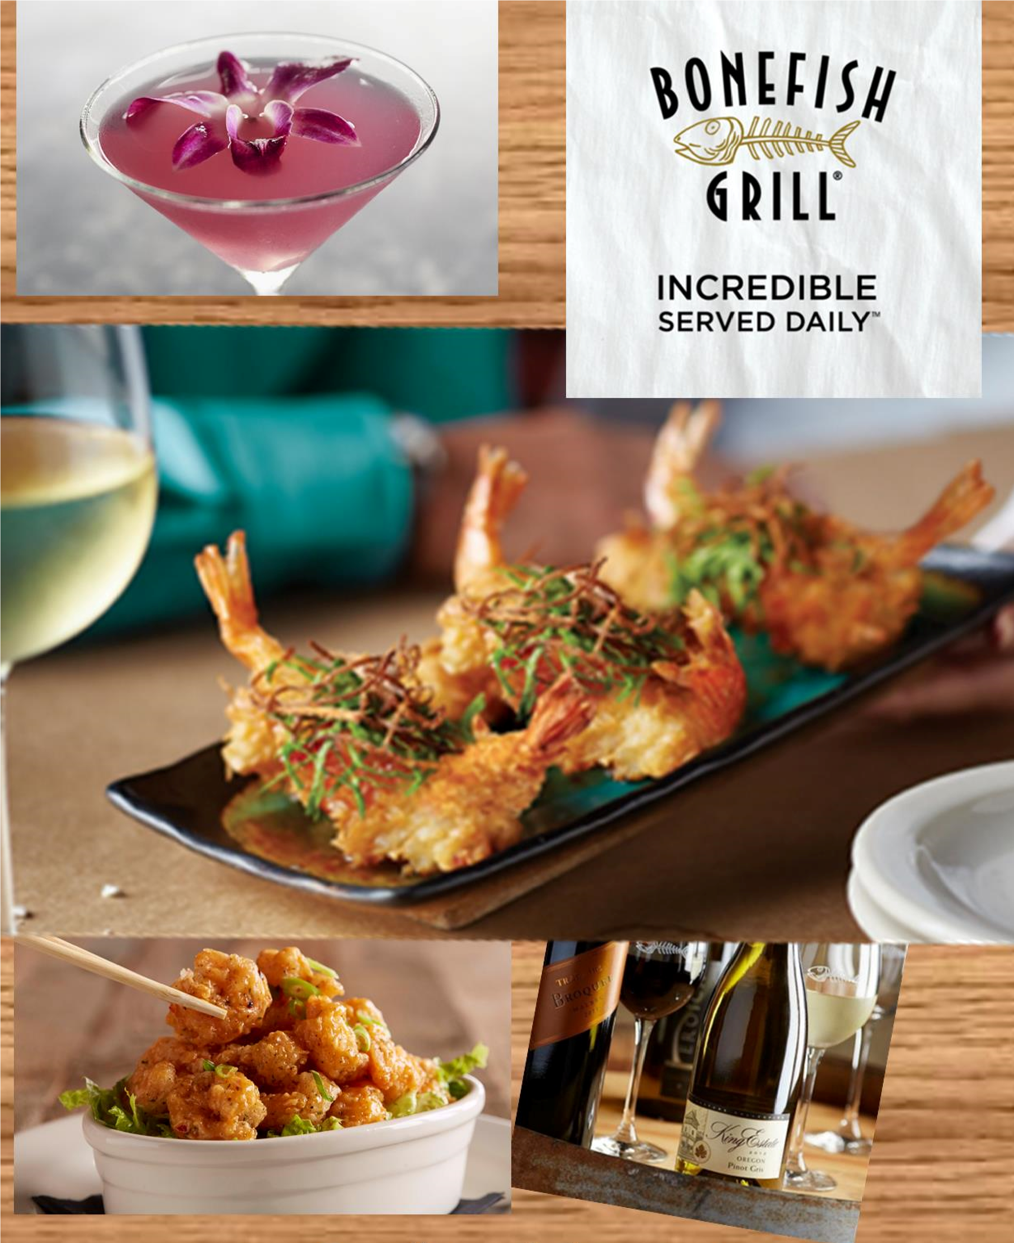

MENU I

STARTERS TO SHARE
Bang Bang Shrimp

SALAD COURSE
CLASSIC CAESAR SALAD | House-made Garlic Croutons

ENTRÉES

GRILLED ATLANTIC SALMON | with Lemon butter

MEDITERRANEAN CHICKEN | Lime Tomato Garlic Sauce + Feta Cheese

ANGLER’S SIRLOIN STEAK | Perfect Medium
Vegetarian Option

DESSERT
Seasonal Inspired Dessert

Included tea + fountain sodas

$35 per person
*Plus tax and gratuity
Includes tea + fountain sodas

MENU II

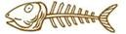

STARTERS TO SHARE
Bang Bang Shrimp
AND
Wagyu Beef + Ginger Potstickers

SALAD COURSE

BONEFISH HOUSE SALAD | Citrus Herb Vinaigrette

ENTRÉES

SEASONAL INDULGENT FISH | with Lemon Butter

DYNAMITE SHRIMP |Dynamite Aioli+ Feta Cheese Crumbles

GRILLED PAN ASIAN CHICKEN |Sweet Soy Ginger Sauce + Mango Salsa + Rice

GRILLED FILET MIGNON | Cooked to Perfect Medium

VEGETARIAN OPTION

DESSERT
Seasonal Inspired Dessert

$40 per person
*Plus tax and gratuity
Includes tea + fountain soda

MENU III

STARTERS TO SHARE
Bang Bang Shrimp
AND
Calamari or Wagyu Beef +Ginger Potstickers

SALAD COURSES
BONEFISH HOUSE SALAD | Citrus Herb Vinaigrette

CLASSIC CAESAR SALAD | House-made Garlic Croutons

ENTRÉES

LILY’S CHICKEN | Goat Cheese, Spinach, Artichokes + Basil Lemon Butter

WILD ARCTIC IMPERIAL COD | Shrimp, Scallop, Crab Meat + Lemon Butter

SCALLOP + SHRIMP SKEWER | with Lime Tomato Garlic Sauce

GRILLED FILET MIGNON | Cooked to Perfect Medium

VEGETARIAN OPTION

DESSERT
SEASONAL CRÈME BRULEE | Fresh Berries + Whipped Cream

$45 per person
*Plus tax and gratuity
Includes tea + fountain soda

MENU IV

STARTERS TO SHARE
|
Bang Bang Shrimp + Petit Maryland Crab Cakes

SALAD COURSES
BONEFISH HOUSE SALAD | Citrus Herb Vinaigrette

CLASSIC CAESAR SALAD | House-made Garlic Croutons

ENTRÉES |

GRILLED CHILEAN SEA BASS | with Lemon Butter Sauce

RHEA’S CHICKEN | Goat Cheese, Spinach, Artichoke, Sun -dried Tomatoes + Basil Lemon Butter
SEASONAL INDULGENT FISH | with Lemon Butter

GRILLED FILET MIGNON | Cooked to Perfect Medium

VEGETARIAN OPTION

DESSERT
SEASONAL CRÈME BRULEE | Fresh Berries + Whipped Cream

$55.00 per person
*Plus tax and gratuity

Includes tea + fountain sodas

MENU V

STARTERS TO SHARE
|
Bang Bang Shrimp, Ahi Tuna Sashimi, Wagyu Beef + Ginger Potstickers

SALAD COURSES
BONEFISH HOUSE SALAD | Citrus Herb Vinaigrette

CLASSIC CAESAR SALAD | House-made Garlic Croutons

ENTRÉES |

CHILEAN SEA BASS IMPERIAL | with Lemon Butter Sauce

FILET SURF + TURF | Cooked to Perfect Medium with Grilled Shrimp

CHICKEN NEUWIRTH | Goat Cheese, Spinach, Artichoke, Sun- dried Tomatoes + Basil Lemon Butter
SEASONAL INDULGENT FISH | with Lemon Butter

VEGETARIAN OPTION

DESSERT
SEASONAL CRÈME BRULEE | Fresh Berries + Whipped Cream

$65.00 per person
*Plus tax and gratuity

Includes tea + fountain sodas

MENU VI

STARTERS TO SHARE
|
Bang Bang Shrimp, Ahi Tuna Sashimi, Wagyu Beef + Ginger Potstickers

SALAD COURSES
BONEFISH HOUSE SALAD | Citrus Herb Vinaigrette

CLASSIC CAESAR SALAD | House-made Garlic Croutons

ENTRÉES |

CHILEAN SEA BASS IMPERIAL | with Lemon Butter Sauce

FILET SURF + TURF | Cooked to Perfect Medium with Grilled Shrimp

CHICKEN NEUWIRTH | Goat Cheese, Spinach, Artichoke, Sun- dried Tomatoes + Basil Lemon Butter
SEASONAL INDULGENT FISH | with Lemon Butter

VEGETARIAN OPTION

DESSERT
SEASONAL CRÈME BRULEE | Fresh Berries + Whipped Cream

$85.00 per person
*Plus tax and gratuity

INCLUDES (2) glasses of signature wine, craft beer or house spirits
Includes unlimited coffee, tea + fountain sodas

Beverage Selections

$30-32 Per Bottle

Ecco Domani Pinot Grigio, Italy

William Hill Chardonnay, Central Coast, CA

Jacob’s Creek Moscato, Australia

Avalon Cabernet Sauvignon, CA

Concannon Pinot Noir, CA

Columbia Crest Merlot, Washington

$35-38 Per Bottle

King Estate Pinot Gris, Oregon

Kendall Jackson Chardonnay, CA

Charles & Charles Red Blend, Columbia Valley, WA

Louis Martini Cabernet Sauvignon, Sonoma Coast

$49-59 Per Bottle

Kim Crawford, Sauvignon Blanc

Chalk Hill Chardonnay, Sonoma Coast

Conundrum Red Blend, CA

Hess “Allomi” Cabernet Sauvignon, Napa Valley

Reserve Selections $65 per bottle

Perrier Jouet “Grand Brut” Champagne, France

Cloudy Bay Sauvignon Blanc, New Zealand

Cakebread Cellars Chardonnay, Napa Valley

Estancia Meritage, Paso Robles

Stag’s Leap Petite Syrah, Napa Valley

Swanson Vineyards Merlot, Napa Valley

Hall Cabernet Sauvignon, Napa Valley

(All Wine Served in Private Rooms are by Bottle Only)

Beer Selections

Craft, Specialty, Import & Domestics:

Blue Moon, Sam Adams Boston Lager, Sierra Nevada Torpedo IPA, Bud Light, Miller Lite, Coors Light, Michelob Ultra, Budweiser, Heineken, Corona Extra, Newcastle, Stella Artois, Sierra Nevada Pale Ale

$5.00 per bottle

Open Bar

Martini’s range from $8.00 - $10.00 per martins

Liquor selection range from $8.00 - $12.00 per cocktail

To book, please contact- Robert Hughes 706-955-6552 Roberthughes@bonefishgrill.com

