City Stage Theatre & Lobby…………………………………$350/hour.
*availability based upon theatre/rehearsal schedule.
Theatre seating capacity: 195 stationary seats
Lobby Reception capacity: 200 (standing only)

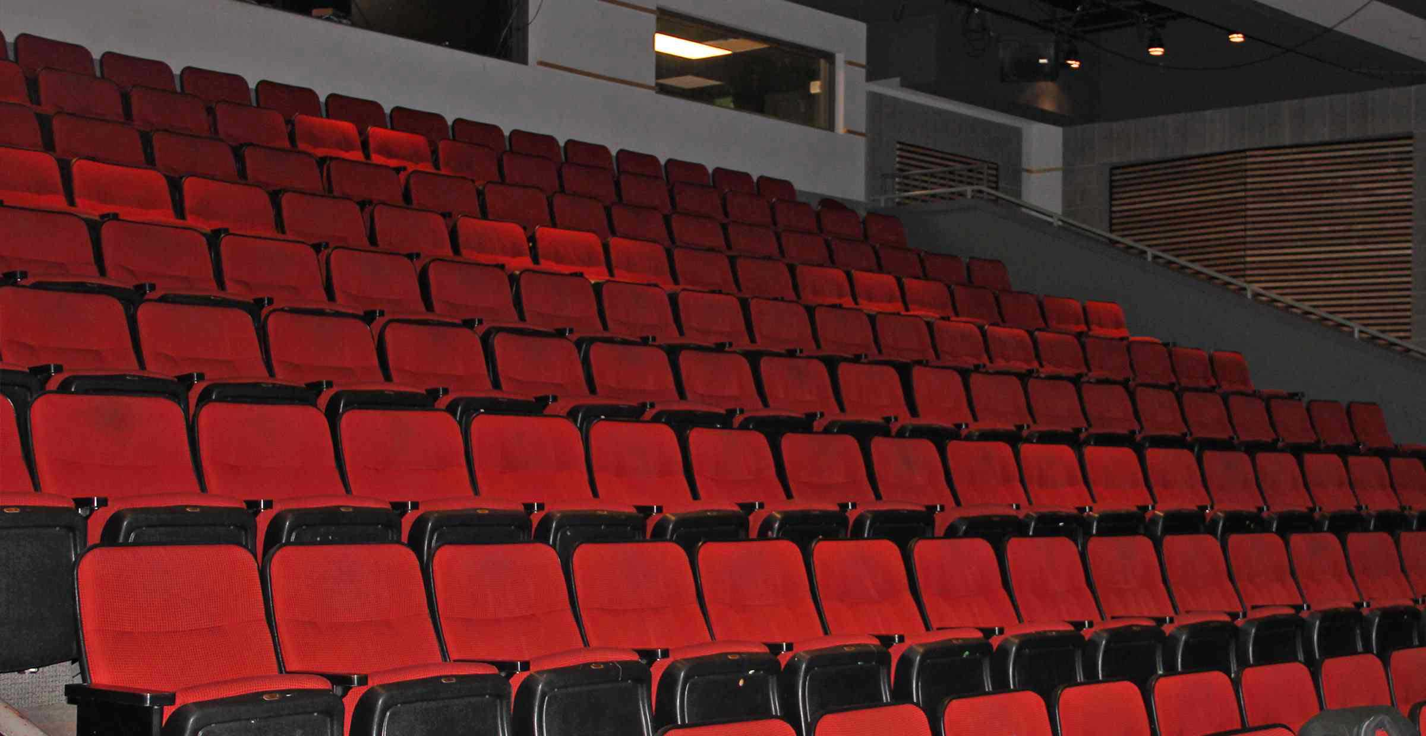

AMENITIES:
Furniture:
- 195 cloth covered stationary theatre seats
- 20 cloth covered adult size chairs with arms
- Lobby has 4 small 30” silver cocktail tables w/ chairs
Audio/ Visual:
- Rear projection screen (9’ x 12’ drops from ceiling)
- Rear projection LCD projector (5,000 lumens)
- Front projection screen (drops down from ceiling 21’ wide)
  - *client would need to rent front projection screen for use of this equipment.
- In-House Sound System (built in lobby and auditorium)
- Intelligent Lighting
- Full surround sound with proper 5.1 (DVD) capability
- One analog port in lobby
- 4 Analog ports in booth
- Lapel mics available

Other Amenities:
- Power Point capabilities from stage or projection booth
- Internet access available from stage or projection booth
- Telephone/teleconferencing capabilities w/ Gentner box
- Hearing impaired headsets
- Electrical outlets & circuit dedication (all outlets are 20amp max. capacity)
- Run of show/laptop from booth and/or stage.
- Wireless clicker
Other Considerations:
- Standard Rental package includes: Podium, 2 wireless handheld mics, house sound system, VHS/DVD/CD, rear projection screen and projector, house lighting and 1 AV Tech to assist in sound booth.
- Theatre performances may have equipment or props on stage. Additional costs to remove any items from stage or theatre lobby may be assessed.
- Colored tape is sometimes used on the stage floor to highlight “spike marks” for theatre shows, this tape cannot be removed.
- The digital telephone line for City Stage is 460-2286.
- The 4 analog telephone lines used in conjunction with the Getner Box are; 460-2211; 460-1076; 460-1077 and 460-1079.
*Gentner Box- a devise used for telephone conferencing that patches into the sound system.

