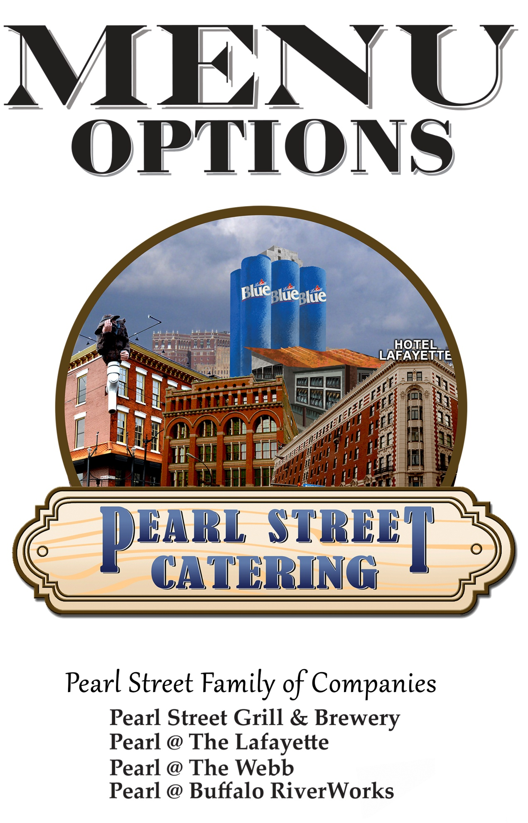

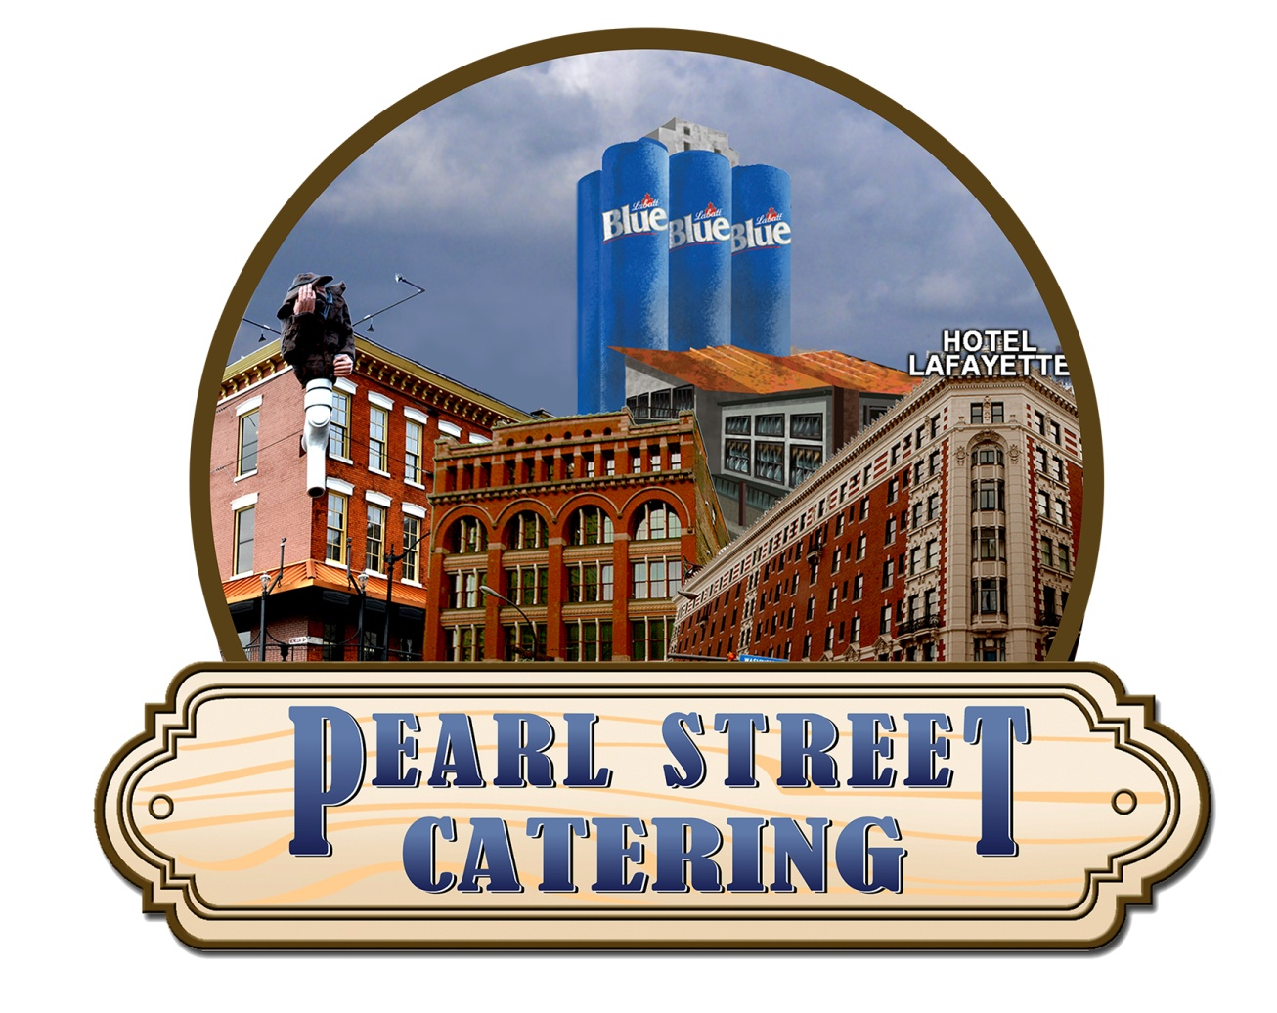



**Pearl Street Catering Banquet Services**

**Host your event with Pearl Street Family of Companies:**

Pearl Street Grill & Brewery

Pearl @ The Webb

Buffalo RiverWorks

Each building boasts a rustic, urban setting, perfect for any event in the heart of Downtown Buffalo NY.

We can accommodate parties from 30 to 1000’s of guests within our three facilities. All of our food and beverage option are of the highest quality and we are prepared to help accommodate any of your special needs.

Any type of event you are hosting, from a corporate banquet, to a birthday party or a wedding reception, our team is prepared to accommodate your needs. You will find that the menu has something for everyone. We are happy to customize menus according to taste and dietary needs.

The Pearl Street Family of Companies is committed to your happiness. We look forward to working with you!

**Catering Office:**

**Phone Number:** (716) 856-0057

**Email:** [**catering@pearlstreetgrill.com**](mailto:catering@pearlstreetgrill.com)

Morgan White: Director of Catering

Abigael LaFaver: Sales Manager

Diane Gawel: Executive Office Assistant

**HOURS:** Monday, Wednesday, Friday 8am-4pm

Tuesday and Thursday 9am-5pm

**TOURS:** By appointment only, however you are welcome to take a look at our rooms on your own as long as there are no events taking place!



**Breakfast & Brunch**

All breakfast & brunch buffets include coffee, tea & chilled orange juice

**Continental Breakfast -$ 16.50/p**

* Warm muffins, danishes and breakfast breads
* Seasonal fruit tray
* Bagels with cream cheese, jam , peanut butter
* Assorted milks and cereal
* Yogurt Cups
* Granola Bars

**Early Riser Buffet - $19/p**

* Bagels with cream cheese, jam and peanut butter
* Fresh fruit and yogurt
* Home Fries
* Scrambled Eggs
* French Toast Casserole
* Breakfast Sausage and Bacon

**Brunch Buffet - $28/p**

* **Pick Three from the Following Options:**
  + Home-fried Potatoes
  + French Toast Casserole
  + Mashed Potatoes
  + Six Cheese Bowtie Pasta
  + Seasonal Vegetables
  + Potato Pierogi
* **Pick Two from the Following Options:**
  + Eggs Benedict with Creamy Hollandaise
  + Chicken ala King with Biscuits
  + Pearl Street’s Chicken Picatta
  + Bacon
  + Vegan Hash

*\*Additional Entree Selection* ***$ 3.25 /pp***

**Breakfast/Brunch Enhancements**

* Vegetable Breakfast Pizza**-$4/pp**
* Basket of Muffins for the Table **-$4/pp**
* Chef Tended Omelet Station with Assorted Ingredients **-$7/pp**
  + *(additional $50 attendant fee)*
* Carving Station *(additional $50 attendant fee)*
  + Ham, Turkey, or Roast Beef - **$7.25/pp**
* Waffle Bar: Individual Waffles top with chocolate chips, fresh strawberries and blueberries, whipped cream and syrup - **$7/pp**



**Served Lunch Menu- $20/pp**

A choice of 3 entrées all served with warm bread

* **Vegetable Stuffed Bell Peppers** - Bell pepper stuffed with sautéed broccoli, onion, zucchini & squash with a hearty marinara sauce served over rice.
* **Turkey Ciabatta**- Deli sliced slow roasted turkey breast on toasted focaccia with lettuce, sliced tomatoes, smoked bacon, cheddar, and herb mayo. Served with pub fries.
* **Buffalo Beef On Weck** - The traditional Buffalo favorite served on a homemade Kimmelweck Roll with horseradish and pub fries.
* **Beer Battered Fish & Chips** - Cod served with pub fries, tartar sauce, & coleslaw.
* **Pot Roast & Mashed Potatoes** – Our signature award winning beer braised pot roast served with mashed potatoes.
* **Chicken Caesar Salad-** Romaine lettuce topped with grilled chicken, Caesar dressing and shaved parmesan.
* **Quinoa Salad**- Citrus dressed cold quinoa salad with tomatoes, white onions & cucumbers
  + Add Chicken for **$3.00/pp**

**Lunch Buffets**

* **Soup, Salad & Sandwich-$20/pp**

**Includes**: Our Smoked Gouda & Chicken Wild Rice Soups. Fresh garden salad station with homemade chips. Assorted portabella, turkey, roast beef, cheese slices and fresh rolls. Served with cranberry relish, mayonnaise, mustard, horseradish and pickles.

* **Hot Lunch Buffet-$24/pp**

**Includes**: Six cheese bowtie pasta, seasonal vegetable medley, creamy mashed red potatoes, tossed garden salad with dressings and condiments, warm rolls.

**With Choice of Two Entrees:**

* + Honey Basil Chicken Breast on Seasoned Rice (GF)
  + Pearl Street’s Chicken Picatta
  + Grilled Bruschetta Chicken (DFA/GF)
  + Beef Stroganoff
  + Beer-Braised Pot Roast
  + Beef on Weck (GFA)
  + Blackened Mahi served with a Black Bean Corn Salsa (GF)

*\*Additional Entrees at* ***$ 3.50 /pp***

**Lunch Selections**

*For events ending by 4pm*



**Hors d'oeuvres**

*Pricing is per tray of 50 pieces unless otherwise noted*

* Phyllo Wrapped Asparagus with Asiago-**$185**
* Bacon Wrapped Scallops (GF)-**$185**
* Caprese Skewers - $90
* Char -grilled Flank Steak Skewers-**$160**
* Cheddar Mac n Cheese Bites- **$110**
* Cucumber Crostini, Whipped Dill Cream Cheese & Tomato (GF/VA)-**$67**
* Golden Fried Fantail Shrimp-**$105**
* Herb & Parmesan Stuffed Mushrooms-**$90**
* Lemon Pepper Sesame Chicken Skewers with Teriyaki Glaze-**$140**
* Meatballs - BBQ, Swedish or with Marinara-**$78**
* Sausage Stuffed Mushrooms-**$95**
* Shrimp cocktail (GF)…**Market Price**
* Spanakopita-**$129**
* Smoked Salmon Crostini with a Whipped Caper Sauce- **$145**
* Teriyaki Steak Phyllo Cup - $155
* Tomato Bruschetta with shaved Asiago and Balsamic glaze **-$65**
* Vegetable Pot Stickers with Soy Sauce (GF/DF/V/TNF)-**$135**
* Pierogi- **$ 75**
* Sausage or Cheese Stuffed Raviolis- **$115**
* Crab Cakes with Wasabi Mayo- **$190**

**Pizza & Wing Selection:**

* Cheese & Pepperoni Pizza-**$49** 36 squares
* Chicken Finger Pizza**-$60** for 36 squares
* White Veggie Pizza-**$55** for 36 squares
* Chicken Wings-**$115**/100 pieces
  + (Mild, Medium, Hot, BBQ or Garlic Parmesan)
  + (Dry Rubs –Lemon Pepper, Ranch, Italian Herb and Cajun)

**Mini Sliders (30 sliders per order)-$137**

* Beer-Braised Pot Roast with blue cheese
* BBQ Pulled Pork
* Portabella mushrooms with caramelized onions (V)
* Tequila-Lime Chicken

**Tray Selections:** *serve 40 people*

**Antipasto Tray (GF)** Marinated baby mozzarella, spiced olives, pepperoni slices, artichokes, pepperoncini, hummus & vegetables, grape tomatoes in basil oil-**$120**

**Vegetable Tray (GF)** - Fresh crisp vegetables served with ranch dip-**$80**

**Fresh Fruit Tray (GF)** - Fresh seasonal fruit-**$85**

**Cheese & Cracker Tray** - Three domestic cheeses with premium crackers-**$95**

*Each Display is available for one hour*

**Vegetable & Fresh Fruit Crudité (GFA)**

With ranch dip, assorted domestic cheeses and crackers- **$5.50/pp**

* Add Imported Cheeses (muenster, gruyere, brie)- **$4.00/pp**
* Add Hot Dip**- $4.75/pp**

**Antipasto Display (GFA)**

Capicola, hard salami, prosciutto, pepperoni, goat cheese, fresh mozzarella, cheddar cheese, olives, tomatoes in basil oil, cherry peppers, pepperoncini, seasoned red peppers, artichokes, bruschetta spread & fresh bread- **$9.50/pp**

**Hot Pretzel Display**

Pretzel bites with warm Gouda beer cheese dip, whole grain mustard, lake effect mustard & whipped cinnamon butter- **$8.50/pp**

**Hot Soup Station**

Our award winning beer cheese Gouda soup and Chicken Wild Rice soup accompanied by ciabatta bread, scallions and parmesan cheese (VA)- **$5.50/pp**

**Hot Dips**

* Spinach & Asiago Cheese dip- **$6.00/pp**
* Stuffed Banana Pepper dip- **$6.00/pp**
* Buffalo Chicken Wing dip- $**6.00/pp**

All Served with a vegetable crudité and fresh bread

**Hors d'oeuvre Displays**





*All buffets include garden salad served with house made dressings*

**Buffalo Buffet-$24/pp**

**Includes:** Baked ziti, potato pierogi, boneless chicken wings, Buffalo style chicken wings, roast beef on weck sandwiches, vegetable and cheese & pepperoni pizzas. Accompanied with stilton blue cheese, BBQ sauce, hot sauce and horseradish, celery and carrots

**The Downtown Renaissance Buffet - $47/pp -** Served with Warm Rolls.

**Includes:** Beef Tenderloin with roasted garlic demi-glace, Shrimp Scampi (DFA/VA), Sautéed chicken breast in a Madeira wild mushroom sauce over wild rice, Sautéed vegetable medley and rosemary roasted potatoes.

**Taste of Pearl Buffet- $33/pp -**Served with Seasonal Vegetables & Warn Dinner Rolls

**A Choice of One Starch:**

* Rosemary Red Roasted Potatoes
* Mashed Potatoes

**A Choice of One Pasta:**

* Six Cheese Bowtie Pasta
* Baked Ziti with Marinara (DFA)
* Cheese Tortellini with Sun-dried Tomato Cream Sauce
* Penne with Vodka Sauce
* Vegetable Primavera

**A Choice of Two Entrees:**

* Pearl Street’s Chicken Picatta with Seasoned Wild Rice
* Honey Basil Chicken Breast on Wild Rice (GF)
* Grilled Bruschetta Chicken with Balsamic Glaze (DFA/GF)
* Chicken Parmesan in a Hearty Red Sauce
* Bone in Chicken (GF)
* Beer Braised Pot Roast
* Char grilled Flank Steak with Mushroom & Roasted Garlic Sauce
* Blackened Mahi served with a Black Bean Corn Salsa (GF)
* Beer brined Pork Loin with an Apple Chutney
* Eggplant Parmesan in a Marinara sauce (V)

*\*A Third Entree (listed above) can be added for* ***$3.50 per person***

**Dinner Buffets**



**A Choice of Three Entrees**

**A 4th option may be offered at an additional $2.50 per person.

**A duel entrée may be offered with an additional $3 to the higher cost item.

** Assigned seating and color coded place cards with meal selections are required.

Dinners include: a Garden Salad with Warm Rolls and Seasonal Vegetable Medley.

Your choice of: Rosemary Red Roasted Potatoes or Smashed Red Potatoes.

**­­Meats**

* 7oz Hand Cut Filet Mignon with Roasted Garlic Demi-glaze (GF)- **$60/p**
* Prime Rib served with Au jus - **$42/p**
* 10 oz Strip Steak with Herb & Garlic Compound Butter (GF)- **$40/p**
* Beer Braised Pot Roast and Gravy- **$29/p**
* Our Stuffed Beer Brined Pork Chop- **$32/p**

**Poultry**

* Sausage Sage Stuffed Breast of Chicken: topped with spinach, mushrooms & red pepper cream sauce- **$30/p**
* Pearl Street’s Chicken Picatta: breast of chicken lightly breaded & topped with a creamy lemon sauce- **$30/p**
* Char-grilled Chicken: hand tenderized breast of chicken topped with spinach, roasted red peppers and provolone cheese. (GF)- **$32/p**
* Sautéed Breast of Chicken with Marsala Mushroom sauce- **$33/p**
* Chicken Parmesan- **$32/p**
* Caprese Chicken: - **$32/p**
* Grilled Brushetta Chicken with Balsamic Glaze - $32/p

**Pasta** (pasta entrees do not come with vegetables or starch)

* Cheese Tortellini with Sundried Tomato Cream Sauce- **$26/p**
* Penne a la Vodka - **$24/p**
* Six Cheese Bowtie Pasta- **$25/p**
* Seasonal Vegetable Primavera- **$24/p**

**Seafood**

* Baked Salmon Fillet topped with Dill Béchamel Sauce (GF)- **$34/p**
* Shrimp Scampi- **$32/p**
* Blackened Mahi served with pico de gallo (GF)- **$32/**

**Vegetarian/Vegan**

* Vegetable Stuffed Peppers Served with Rice (GF/V)- **$25/p**
* Vegetable Stir Fry (GF/V)- **$24/p**
* Eggplant Parmesan with Linguine and Marinara Sauce- **$24/p**
* Vegan Creole Bowl (GF/V)- **$26/p**

**Sit Down Dinners**



**Station Style Parties**

Choose a minimum combination of three dinner stations from this list,   
out for 90 minutes

**Buffalo Station-$10/pp**

Buffalo style chicken wings, fresh carrot & celery sticks, mini chicken pierogi with BBQ sauce and stilton, mini beef on weck sliders, and homemade crispy potato chips with ranch dip

**Garden Salad & Smashed Potato Station or Baked Potato Station-$10.25/pp**

Mixed greens, ranch & balsamic dressings, craisins, sunflower seeds, house baked croutons, shredded cheddar-jack cheese, carrots, crisp cucumbers, cherry tomatoes with diced chicken and steak.

* Top your mashed potatoes with cheddar cheese, bacon, ham, sour cream, scallions, butter and beef gravy

*OR*

* Top your baked potato with bacon, broccoli cheese sauce, sour cream, chives, and our brew house chili
  + Add on feta or goat cheese crumbles- **$1.25/pp**
  + Add on strawberries, mandarin oranges and blueberries- **$3/pp**
  + Add on pecans, walnuts or almonds- **$4.00/pp**

**Carving Station (GF) - $11/pp**

**Choice of 2:** Carved roast beef with au jus, carved turkey breast with cranberry relish or Honey baked country ham with Lake Effect mustard

* Sub grilled center cut beef tenderloin with rosemary demi-glace- **Market Price**
* Sub roasted prime rib of beef with au jus- **$5.50/pp**
* Sub beer brined pork loin with apple cider gravy- **$4.50/pp**
* Sub citrus baked salmon with a Béchamel sauce- **$5.50/pp**
  + *The above carving choices are priced in addition to the carving station.*
  + *Additional**Chef Attendant fee of $100.00*

**Mexican Station- $10.50/pp**Mexican chicken, ground beef, chipotle shrimp, peppers and onions, white cilantro lime rice, tortilla chips, soft tortilla shells, shredded cheddar-jack cheese, sour cream, guacamole, salsa, diced tomato, jalapenos, shredded lettuce and black beans

**Pearl’s Pulled Slider Bar- $10.75/pp**

BBQ pulled pork, creamy tequila lime chicken, portabella mushrooms with rolls, pulled chicken with a tequila lime sauce, sauce pickled onions, crumbly blue & shredded cheddar-jack cheese. Served with coleslaw, chips, mayonnaise & horseradish

**Pasta Station- $10.50/pp**

Your choice of 2 of the following pastas:

* Cheese Tortellini in a sundried tomato basil cream sauce
* Six Cheese Bowtie Pasta
* Penne Vodka
* Baked Ziti
* Seasonal Vegetable Primavera



**Non-Alcoholic Beverages**

* Unlimited soda-**$3.50/p**
* Unlimited coffee and tea station-**$3.50/p**
* Unlimited coffee, tea and soda station for the duration of your event-**$5.00/p**
  + Add gourmet flavored syrups or hot chocolate to coffee station- **$2.50/p**

**Open Bar Packages**

Must purchase a minimum of **$21/p** in food to purchase a bar package

* **Absolutely No Shots**

**Full Service Bar with Well Liquor, Handcrafted Draft Beer, Wine & Soda:**

* 2 Hours-**$18/p**
* 3 Hours-**$22/p**
* 4 Hours-**$26/p**

**Full Service Bar with Call Liquor, Handcrafted Draft Beer, Wine & Soda:**

* 2 Hours-**$22/p**
* 3 Hours-**$28/p**
* 4 Hours-**$30/p**

**Full Service Bar with Premium Liquor, Handcrafted Draft & Bottled**

**Beer, Wine & Soda:**

* 2 Hours-**$28/p**
* 3 Hours-**$33/p**
* 4 Hours-**$38/p**

**Handcrafted Beer, Wine & Soda Bar:**

* 2 Hours-**$16/p**
* 3 Hours-**$19/p**
* 4 Hours-**$22/p**

**Drink tickets:**

* Well liquor, Handcrafter Draft Beer, Wine & Soda: **$6.50/p**
* Call liquor, Handcrafter Draft Beer, Wine & Soda: **$7.50/p**
* Premium liquor, Handcrafter Draft Beer, Wine & Soda: **$9.00/p**

**Cash Bar or Bar Tab:**

An attendant fee is required for any event without an open bar package. This fee is charged per hour.

* $25 per hour

**Additional options:**

* House Prosecco toast- **$3/p**
* Wine during dinner- **$19** per bottle of our featured house wines.
* Bottled Labatt beer may be added to a bar package for an additional- **$2/p**
* Corkage fee of **$15** per bottle
* Build your own Bloody Mary or Mimosa bar with assorted juices and toppings
  + **$7.50/p** for One Hour
  + **$11/p** for Two Hours

**Punch Bowls:** One bowl typically serves 30 guests

* Non-alcoholic punch- **$60** per bowl
* Red or white wine punch- **$105** per bowl
* Mimosa punch- **$95** per bowl

**Beverage & Bar Menu**



All dessert stations include a coffee station.

**Sundae Bar (GFA)- $8.00/p**

Attended station with assorted cookies, iced fudge brownies, vanilla & chocolate ice cream, chocolate fudge, strawberry sauce, &hot caramel sauce, sprinkles, nuts, cherries, cones and whipped cream

**Warm Apple Crisp Station-$8.00/p**

Baked on site and served with creamy vanilla ice cream, hot caramel sauce and whipped cream

**The Sweet Finish Station-$7.25/p**

Assorted cookies, iced fudge brownies & assorted squares

**Pearl’s Dessert Table-$11.00/p**

A decorated display including assorted cakes, cheesecakes, squares, cannoli, chocolate mousse, iced fudge brownies, mini cream puffs & éclairs

* Add vanilla ice cream- **$2/p**

**Served Desserts:-Market Price**

* In house selection

**Waffle Station - $7/p**

Individual Waffles top with chocolate chips, fresh strawberries and blueberries, whipped cream and syrup

**Individual Dessert Trays**- 50 pieces

(Does not include a coffee station):

* In house baked cookies **$50**
* Brownies **$48**
* Cannoli **$73**
* Chocolate covered strawberries $90

**Sweet Desserts**



**For Parties Under 75 Guests**

**First station out for 2 hours**

Vegetable & fruit crudité display (GF) with ranch dip and assorted domestic cheese with crackers

**Choose 1 of the following hot dips to add to your crudité display:**

* Spinach & Asiago Cheese dip
* Stuffed Banana Pepper dip
* Buffalo Chicken Wing dip

*All served with fresh bread*

**Second station that will stay out for 1hour**

**Choose 3 of the following:**

* Herb & Parmesan Stuffed Mushrooms
* Teriyaki Steak Phyllo Cup
* Pot Stickers with Soy Sauce (DF/GF/V)
* Golden Fantail Shrimp with cocktail sauce
* Meatballs (Swedish, BBQ or marinara)
* Lemon Pepper Chicken Skewers

**Choose 2 of the following:**

* Char-grilled Flank Steak Skewers
* Bacon Wrapped Scallops (GF)
* Smoked Salmon Crostini with a Whipped Caper Sauce
* Crab Cakes with a Wasabi Mayo
* Sausage or Cheese Stuffed Ravioli with Marinara Sauce

**$27/p** plus tax and 21% service charge

**\*\*See our beverage and bar page for non and alcoholic selections.**

**Pearl’s Cocktail Party Package**



Complimentary centerpieces, linens and Prosecco toast included.

**Display Station**

An Antipasto display station with imported cheeses, shrimp cocktail and your choice of hot dip to be accompanied by fresh vegetables.

**One Hour of Passed Hors d’oeuvres**

Includes vegetable pot stickers, flank steak skewers, smoked salmon crostini with a caper dill whip and bacon wrapped scallops.

**Four Hour Open Bar**

Includes premium and call liquor brands, handcrafted draft beer, bottled Labatt beer, varietal wine and soda.

**Wines During Dinner**

One bottle of house red and white for each table

One bottle of Prosecco for each table

**All Dinners include:**

* Our Specialty Salad (Spinach, Toasted Pecans, Craisins, Goat Cheese, with a Vinaigrette) or a Caesar Salad
* Warm Rolls and Roasted Asparagus.
* Choice of Rosemary Roasted Potatoes or Mashed Potatoes (with or without gravy)

**And a Choice of THREE of the Following Entrees:**

* 7oz Hand cut filet mignon with roasted garlic butter
* Vegan Creole Bowl
* Sautéed Chicken breast with a wild mushroom Madeira wine sauce
* Caprese Chicken Breast
* Broiled Pepper Corn Swordfish with a Béchamel sauce
* Shrimp Scampi with angel hair pasta

**Add three jumbo shrimp to each entrée at **$4/p**

**Additional entrees upon request**

**Pearl’s Dessert Table**

A decorated display including assorted cakes, cheesecakes, squares, cannoli, chocolate mousse, iced fudge brownies, mini cream puffs & éclairs

* Add vanilla ice cream **$2/p**

**Late Night Station**

A choice of One Late Night food station.

**$126 per person** plus a 21% administration fee and NYS tax

**The Roosevelt Package**



Complimentary centerpieces, linens and Prosecco toast included.

**Display Station**

Crisp vegetable crudité with dip, fresh fruits, assorted domestic cheese & premium crackers

* Add a hot dip for **$4.25/p**

**One Hour of Passed Hors d'oeuvres**

Includes tomato bruschetta, spanakopita, Caprese Skewers (GF), and phyllo wrapped asparagus with asiago

**Four Hour Open Bar**

Includes call liquor brands, handcrafted draft beer, bottled Labatt beer, varietal wine and soda.

**All Dinners** include a garden salad, warm rolls, sautéed vegetable medley, and a choice of roasted potatoes or smashed potatoes.

**A Sweet Finish** Includes a coffee bar with gourmet flavored syrups, tea, assorted cookies, iced fudged brownies and assorted dessert squares.

**And a Choice of THREE of the Following Entrees:**

* Award Winning Beer Braised Pot Roast with Gravy
* Stuffed Pork Chop
* Pearl Streets Chicken Picatta: breast of chicken lightly breaded & topped with a creamy lemon sauce
* Grilled Bruschetta Chicken with Balsamic Glaze (GF)
* Sausage Sage Stuffed Breast of Chicken: topped with spinach, mushrooms & red pepper cream sauce
* Six Cheese Bowtie Pasta
* Cheese Tortellini in a Tomato-basil Cream Sauce
* Baked Salmon with a dill béchamel sauce (GF)
* Vegetable Stuffed Pepper (V/GF)

**Additional options available

**$86 per person** plus 21% administration fee and NYS tax

**Pearl’s Served Reception Package**



Complimentary centerpieces, linens and Prosecco toast included.

**Display Station**

Crisp vegetable crudité with dip, fresh fruits and assorted domestic cheese & premium crackers.

**One Hour of Passed Hors d'oeuvres**

Includes tomato bruschetta, spanakopita, caprese skewers, and phyllo wrapped asparagus with asiago.

**Four Hour Open Bar**

Includes call liquor brands, handcrafted draft beer, bottled Labatt beer, varietal wine and soda.

**A Sweet Finish** Includes a coffee bar with gourmet flavored syrups, tea, assorted cookies, iced fudged brownies and assorted dessert squares.

**All Dinners** include a garden salad, warm rolls & sautéed vegetables, a choice of potato, a choice of pasta, and 3 entrees (including up to 1 carved meat)

**Potatoes:**

Rosemary roasted red potatoes or mashed red potatoes.

**Pastas:**

Six cheese bowtie pasta, cheese tortellini in a sundried tomato basil cream sauce, Penne Vodka, or Seasonal Vegetable Primavera (DFA/VA)

**Entrees:**

* Sautéed Chicken in a Madeira Wine Sauce served over seasoned rice
* Honey Basil Chicken served over seasoned rice (GF)
* Pearl Streets Chicken Picatta topped with a creamy lemon sauce over seasoned rice
* Blackened Mahi Mahi with pico de gallo (GF)
* Award Winning Beer Braised Pot Roast

Chef Tended Carving Station Choices:

* Top round of beef with au jus and is served with weck rolls, Kaiser rolls and horseradish (GF)
* Beer brined pork loin with apple cider gravy
* Honey baked country ham with Lake Effect mustard (GF)
* Turkey breast with cranberry relish (GF)

**$86 per person** plus a 21% administration fee and NYS tax

**Pearl’s Buffet Reception Package**



Complimentary centerpieces, linens and Prosecco toast included.

**Display Station**

Crisp vegetable crudités with dip, fresh fruits and assorted domestic cheese & premium crackers

**One Hour of Passed Hors d'oeuvres**

Includes Tomato bruschetta, spanakopita, caprese skewers, and phyllo wrapped asparagus with asiago

**Four Hour Open Bar**

Includes call liquor brands, handcrafted draft beer, bottled Labatt beer, varietal wine and soda.

**A Sweet Finish** Includes a coffee bar with gourmet flavored syrups, tea, cookies, iced fudged brownies and assorted dessert squares.

**A Choice of Three Stations**

**Carving Station (GF)**

Choice of 2: carved roast beef with au jus and carved turkey breast with cranberry relish or Honey baked country ham with Lake Effect mustard.

**Mexican Station**Mexican chicken, ground beef, chipotle shrimp, peppers and onions, cilantro lime white rice, tortilla chips, soft tortilla shells, shredded cheddar cheese, sour cream, guacamole, salsa, diced tomato, jalapenos, shredded lettuce and black beans

**Buffalo Station**

Buffalo style chicken wings, creamy stilton dressing, carrot and celery sticks, mini chicken pierogi with BBQ sauce, mini beef on weck sliders, and homemade potato chips with ranch dip.

**Garden Salad & Smashed or Baked Potato Station (GF)**

Mixed greens, assorted dressings, cranberries, sunflower seeds, house baked croutons, shredded cheddar, carrots, crisp cucumbers and cherry tomatoes with diced chicken and steak.

* Top your mashed potatoes with cheddar cheese, bacon, ham, sour cream, scallions, butter and beef gravy
  + OR
* Top your baked potato with bacon, broccoli cheese sauce, sour cream, chives, and our brew house chili

**Pearl’s Pulled Slider Bar**

BBQ pulled pork, creamy tequila lime chicken, portabella mushrooms with rolls, pickled onions, crumbly blue & shredded cheddar. Served with coleslaw, chips, mayonnaise & horseradish.

**Pasta Station**

Your choice of 2 of the following:

* Penne Vodka
* Cheese Tortellini in a sundried tomato basil cream sauce
* Six Cheese Bowtie Pasta
* Seasonal Vegetable Primavera
* Baked Ziti

**$86 per person** plus a 21% administration fee and NYS tax

**Pearl’s Station Style Reception Package**



Complimentary centerpieces, linens and prosecco toast included.

This package is available plated or buffet style

**Antipasto Display Station**

With capicola, hard salami, prosciutto, pepperoni, goat cheese, fresh mozzarella & assorted domestic cheeses, olives, tomatoes in basil oil, cherry peppers, pepperoncini, artichokes, bruschetta spread & fresh bread

**One Hour of Passed Hors d'oeuvres**

Includes Golden fantail shrimp, lemon pepper chicken skewers, cucumber crostini with whipped dill cream cheese (V/GF), and teriyaki steak phyllo cup.

**A Four Hour Open Bar**

Including premium and call liquor brands, handcrafted draft beer, bottled Labatt beer, varietal wine and soda.

**Wines During Dinner**

1 bottle of house red and white for each table.

**All Dinners include**

* Our specialty salad (Spinach, Toasted Pecans, Craisins, Goat cheese, with a vinaigrette) or Caesar Salad
* Warm Rolls and Sautéed Seasonal Vegetables
* Choice of Rosemary Roasted Potatoes or Mashed Potatoes with Gravy.

**And a Choice of THREE of the Following Entrees:**

* Strip Loin served with a Demi-Glace
* Prime Rib served with Au Jus (GF)
* Beer Braised Pot Roast with Gravy
* Breast of Chicken with Sausage Sage Stuffing Topped with Spinach, Mushrooms, in a Red Pepper Cream Sauce
* Grilled Bruschetta Chicken with Balsamic Glaze (GF)
* Sautéed Breast of Chicken with Marsala Sauce
* Baked Salmon Filet with a Dill Béchamel Sauce (GF)
* Vegetable Stuffed Pepper with Rice (GF)
* Cheese Tortellini with a Sun Dried Tomato Basil Cream Sauce

* Additional Options available Upon Request

**Sundae Bar: Attended station with assorted cookies, iced fudge brownies, vanilla & chocolate ice cream, chocolate fudge, strawberry sauce, hot caramel sauce, sprinkles, nuts, cherries, cones and whipped cream.**

**Late Night Snack Station**

A choice of one Late Night food station.

**$107 per person** plus a 21% administration fee and NYS tax

**Pan-American Reception Package**



Complimentary centerpieces, linens and Prosecco toast included.

**This package is only available in November, January, February & March**

Additional minimums may apply

**4 Hour Call Bar Package**

Call liquor brands, handcrafted draft beer, varietal wine and soda.

**Hors d'oeuvres Station**

Our smoked Gouda Beer Cheese soup and Chicken and Wild Rice soup accompanied with ciabatta bread, parmesan and scallions along with a choice of one of our hot dips served with fresh vegetables and bread.

* Spinach & Asiago Cheese dip
* Stuffed Banana Pepper dip
* Buffalo chicken wing dip

**Choice of:**

A Served Dinner including a served garden salad with warm rolls**.** Entrees are served with seasonal vegetables and smashed potatoes.

**Guest select from the following three options:**

* Beer Braised Pot Roast
* Pearl’s Chicken Picatta
* Six Cheese Bowtie Pasta

**-OR-**

**A Buffet Style Dinner**

* Beer Braised Pot Roast with Smashed Potatoes
* Pearl’s Chicken Picatta with Smashed Potatoes
* Six Cheese Bowtie Pasta
* Smashed Potatoes
* Seasonal Vegetables
* Served Salad and Rolls

**A Premium Coffee & Tea Station**

With gourmet syrups and hot chocolate with marshmallows.

**Warm Apple Crisp Station**

With vanilla ice cream and warm caramel sauce.

**$70 per person** plus a 21% administration fee and NYS tax

**Winter Magic Reception Package**



This package requires a 30 person full price minimum.

Additional minimums may apply upon booking

All packages include the use of a podium and wireless microphone.

Free WIFI available. Projector rental upon request.

**Seminar Package - $35/p** plus tax and 21% administration charge

Includes coffee, tea, orange juice and soda.

**Continental Breakfast**

A variety of warm fresh mini muffins, danishes, fruit tray, individual yogurt cups & bagels with cream cheese, jam, peanut butter & butter.

**A Meeting Break**

With granola bars and vegetable tray with dip

**Lunch Buffet with Soup, Salad & Sandwiches**

Assorted portabella, turkey, roast beef sandwiches with condiment trays and rolls. Our smoked Gouda soup, bowl of garden salad and dressings, pasta salad and homemade chips

**Executive Package-$44/p** plus tax and 21% administration charge

Includes coffee, tea, orange juice and soda.

**Breakfast Buffet**

Scrambled eggs, bagels with cream cheese, French toast casserole, breakfast sausage and bacon, and home fried potatoes.

**A Meeting Break**

With a fresh fruit tray, cheese and crackers

**Hot Lunch Buffet**

Sautéed vegetables, mashed red potatoes, baked ziti with marinara sauce, chicken piccata and pot roast. Served with a bowl of garden salad and dinner rolls.

**Dessert**

Cookies and brownies

**Enhancements**

Add a bag of pretzels or chips- **$2.00/p**

Add bottled water- **$3.00 /per bottle**

**Professional Packages**



**EVENTS:** All events hosted in a private banquet room require a 50 person full price minimum. We can accommodate a 30 person minimum, but an additional $125 room fee applies for events after 4pm. Daytime events that end by 4pm there is a $75 room fee. Additional minimums may apply based on the date and time of the event. There is a 21% administration charge applied to all food and beverage. This fee is administered to the house. It is NOT a gratuity and is **NOT** issued to the employees. Employees are paid a higher than minimum tipped wage. No additional tip is necessary, additional tipping is at your discretion. All services incur NYS tax, unless a valid Tax Exempt certificate is given.

**DEPOSITS/CONTRACTS**: A deposit **AND** signed contract are necessary to confirm a date and a room. Only the contact on the contract can make changes. Events booking within 14 days, a 50% deposit is due to guarantee the room and date. All deposits will be deducted from the balance due at the completion of your event. We will not host an event without a signed contract or deposit. All deposits are determined at the discretion of Pearl Street Catering Department. All Deposits are non-refundable. Only the person signing the contract is authorized to make changes to the contract or event, pre-event and/or during the event.

**GUARANTEES:** The final number of guests must be specified by 12pm, two weeks prior to the event. It is the clients’ responsibility to call or email in the final number. The final number cannot decrease after this time. If hosting a served meal, guaranteed numbers for each meal choice must be submitted two weeks prior to event. We cannot guarantee entrée choices if final numbers increase the week of your event. Final billing will be based on the final guaranteed number, or actual number of guests, whichever is greater. Color coded place cards AND assigned seating arrangements are the responsibility of the client and must be dropped off at least 2 hours prior to the event. We reserve the right to substitute meals if the above is not provided. In the event that the final numbers are not given, final billing will be based on the greater number of estimated or actual number of guests. Pricing will be locked in **1 year prior** to your event. Once your contract is signed you cannot decrease your price per person.

**PAYMENTS**: We accept cash, money order and certified check for payments. We will take an IN STATE personal check up to 2 weeks prior to the event.

Checks for any event held at **Pearl Street Grill** or **The Webb** would be made out to *“Pearl Street Grill and Brewery”*.

* Events at **The Hotel Lafayette** made out to *“The Pan American Grill and Brewery”*.
* Events at **Buffalo RiverWorks** made out to *“Buffalo RiverWorks”*.

We accept all major credit cards. Any credit card payment incurs a 2% convenience fee. NO credit card payments will be accepted over the phone. The card holder will need to be present. *Any payments made in person are accepted Monday through Friday between the hours of 11am and 6pm.

**Pearl Street Catering Policies & Guidelines**



**Pearl Street Catering Policies & Guidelines**

**CANCELLATIONS:** Cancellations with more than six months notice will not incur any additional charges, although your non refundable deposit will be retained. Events cancelling with less than six months notice, your deposit will be retained and a 25% service charge is billed based on expected revenue loss. Events cancelling within 2 weeks will be charged an additional 50% service charge based on expected revenue loss. In the event of severe weather or another sever situation beyond Pearl Street Caterings’ control, the event can be re-scheduled in full at a mutually agreed upon date within one month of initial date.

**SET UP/TIME FRAME:** If the duration of your event surpasses the contracted time frame, additional charges may apply. We reserve the right not to extend alcohol service within or beyond your scheduled time frame. If extensive set up is required, additional charges may apply. It is the client’s responsibility to notify us of any special set up needs. We are happy to provide house music stations and a wireless microphone for any event.

NO OUTSIDE FOOD OR BEVERAGE CAN BE BROUGHT IN.

ALL FOOD AND BEVERAGE MUST BE PURCHASED FROM PEARL STREET CATERING.

*Exceptions are: Cakes, cupcakes, donuts, pies, Italian cookies and candy buffets.*

We reserve the right to change contracted food items if the quality does not meet our standards.

ALL ITEMS MUST BE TAKEN THE NIGHT OF YOUR EVENT.

WE ARE NOT RESPONSIBLE FOR ANY ITEMS LEFT OVERNIGHT.

**Catering Office:**

**Phone Number:** (716) 856-0057

**Email:** [**catering@pearlstreetgrill.com**](mailto:catering@pearlstreetgrill.com)

Morgan White: Director of Catering

Abigael LaFaver: Sales Manager

Becky Jones: Sales and Events Manager at Buffalo RiverWorks

Diane Gawel: Executive Office Assistant

**TOURS:** Are by appointment only, however you are welcome to take a look at our rooms on your own as long as there are no events taking place!