*Dinner either Buffet Style or Served : Prices*

*vary with Choice of Entrée(s)*

*Alcoholic and Non*

*-*

*Alcoholic Beverages :*

*Prices vary with Beverage Choices*

*Hors d’oeuvres Package*

*Elevated Skirted Head Table*

*Linen Table Cover and Colored Napkins*

*Chair Covers and Bows*

*Dance Floor*

*Complimentary Mirror on Table*

*Champagne to the Bridal Table*

*Formally Dressed Wait Staff*

*Cake Cutting & Serving*

*Decorated Pillar Package*

*Event Planner and Hostess*

989

-

422

-

4000

**A Full Service Resort**

**On Beautiful Houghton Lake**

100

Clearview Drive

Houghton Lake, Michigan

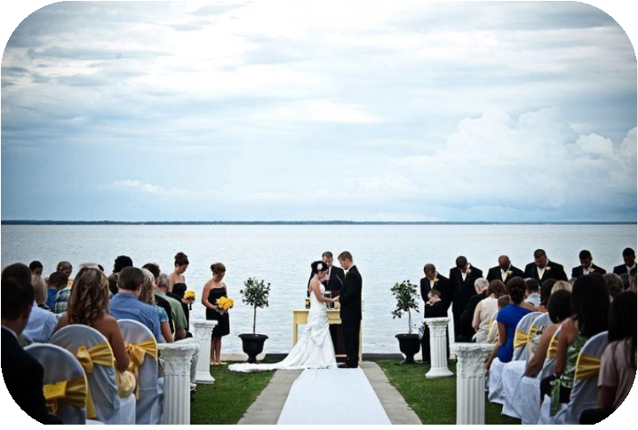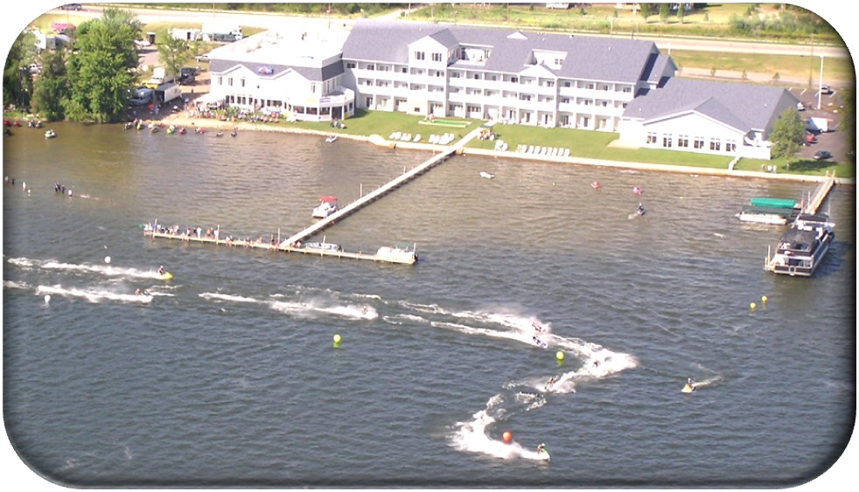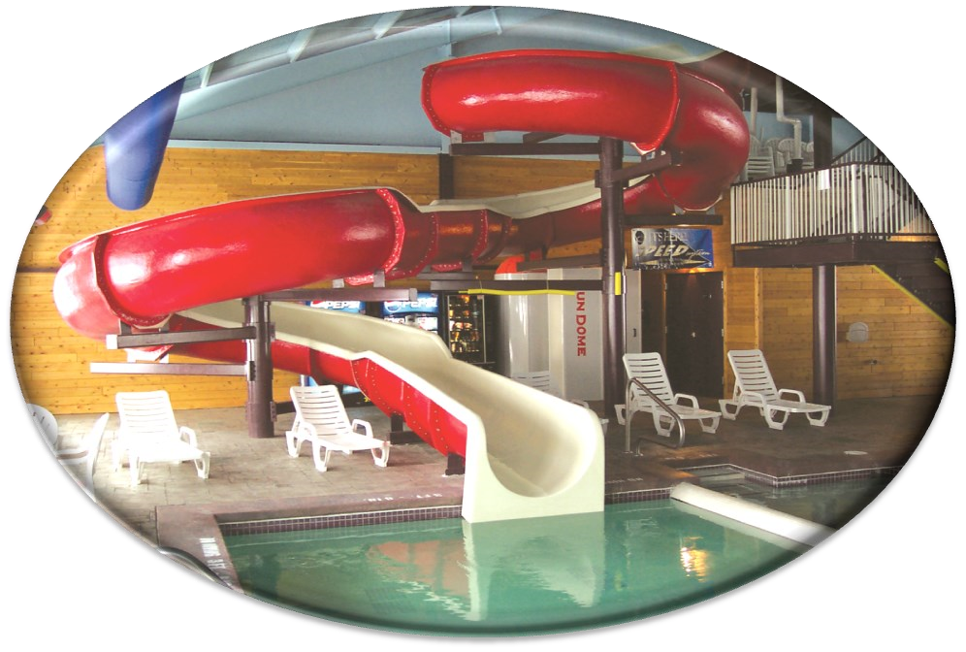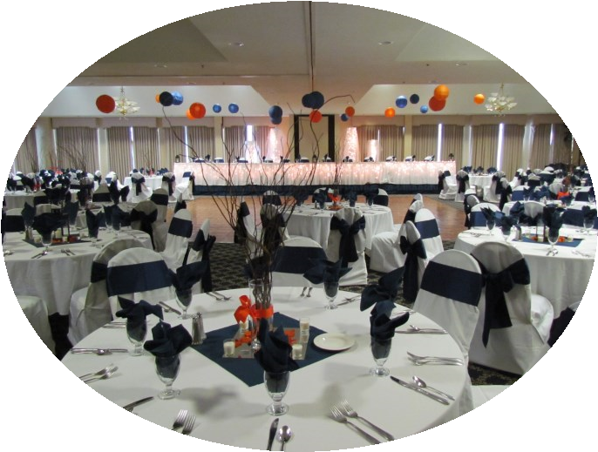

**Lakeside Lawn**

**Ceremonies**

A Full Service Resort

Lakeside Resort and Conference Center

100

Clearview Drive

Houghton Lake, MI 48629

Phone: 989

-

422

-

4000

Fax: 989

-

422

-

4600

E

-

mail:

brooklynncssales@gmail.com

Lakeside Resort and Conference Center

Clearview Drive

100

Houghton Lake, MI 48629

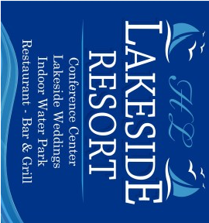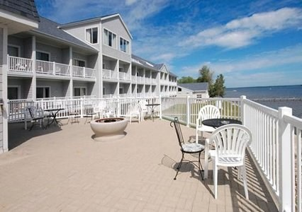

Conference and

Banquet Facilities

A full

-

service family

restaurant, the

Lakeside

Bar And Grille

is located on the premises and

features seafood, steak

and Specialties, as well

as child selections, great

-

burgers and fantastic

pizza's. Enjoy a pleasant atmosphere at

the

Lakeside Bar and Grille

where you can

take in the inviting views of Houghton Lake

and the

surrounding area from the delightful screened

in patio and new deck for wonderful views.

Beautiful Rehearsal Dinners, Great

Christmas Parties for all budgets.

Fully Decorated For All Your Needs

You Name It And We Can Do It.

•

Onsite Restaurant And Bar

Screened in patio

(

dining option during May

-

September)

•

Complimentary Full Hot Breakfast

•

Meeting and Banquet Space

•

Complimentary Meeting Planning Assistance

by our professional staff

•

Audio/Visual Equipment Rentals

•

Indoor Waterpark

•

4

nearby golf courses

•

Complimentary boat dockage for guests

•

Complimentary High

-

Speed Internet Access

•

Wireless Internet Access (Public Areas)

•

24

-

Hour Front Desk

•

24

-

Hour Coffee Service

•

Game Room

•

Fitness Center

•

Business Center

•

Complete Event Catering and Services

•

Room Service

•

Handicap Access

•

Laundry Facilities

•

Wake

-

Up Calls

•

Complimentary Self Parking

Something for

Everyone

Lakeside Bar and

Grille

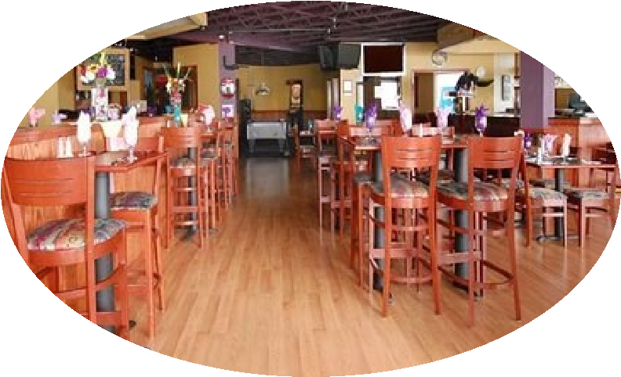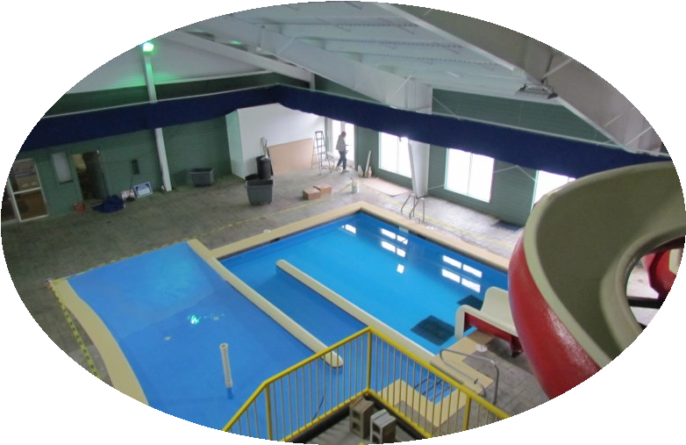

From “Storybook” Fairytale Weddings to

Seminars and Meetings, Lakeside Resort

Welcome the opportunity to host your

next special event. ur Professional Staff

will assist you with everything you need

to make your event worry free.

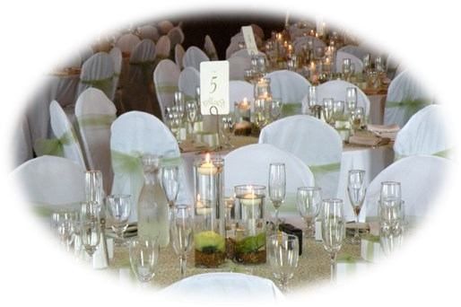 your meeting space holds 400

Lakeside banquet rooms exit to balconies

that overlook the lake. Perfect for meeting

breaks or a quiet moment.

In addition, we have the resources to help with event planning such as golf outings,

reunions or picnics.Off-site entertainment can easily be arranged as well.