

Metro Hub: Created for Community
1265 Ellis Street
www.metrohub.ca

Metro Community provides services for those experiencing profound material poverty, including homelessness. A portion of Metro Hub revenues will be dedicated to ensuring these services continue and in time expand. Thank you for partnering with us to ensure all members of our community are served with dignity.

RENTAL POLICIES

ACTIVITY GUIDE
1. Rental by any group does not mean that Metro Hub endorses the beliefs and practices of the rental group.
2. Smoking / Vaping are not permitted in our building(s) at any time.
3. Metro Hub reserves the right to permit others to use and occupy the facilities at the same time as the renter.
4. Metro Hub reserves the right to refuse any event that may be political in nature, sexually exploitive, or detrimental/in conflict to the services we provide to our community members.
5. If information provided about your event is found to not be accurate, the event may be cancelled without notice or while in progress with no refund.

DEPOSIT, PAYMENT & REFUNDS
1. To secure the date of your booking we require:
a. A completed Metro Hub Event Request Form (online)
b. A booked walkthrough.
c. A signed Metro Hub Rental Contract
d. A deposit of 50% of the venue rental cost (due 7 days from signing contract)
2. The final balance for rental plus damage deposit is due no later than 5 business days prior to the event.
3. Bookings cancelled up to 14 days prior to the event date will receive a 50% refund of the deposit. Bookings cancelled within 14 days of the event will forfeit the full deposit.
4. A certificate of liability insurance and special event permit are due 2 weeks prior to event.

FEES
1. All booking fees are hourly based on a minimum 3-hour booking (see Rental Fee Structure).
2. Fees include onsite manager for all Metro Hub facility rentals.
3. For rentals involving the auditorium lighting, sound, or video, the use of one of Metro Hub Audio Video Technicians is mandatory; fees will be applied to final invoice. Depending on AV needs additional technicians may be required.
AV Technician $50 per hour person (minimum 3 hrs)
Streaming rates available upon request.
4. At the discretion of Metro Hub, a paid site host (security) may be required; you will be contacted if this applies to your event.
5. Tables, chairs and other equipment available onsite; set up fees may be added $50 per hour
6. Storage fees will be applied to any items left by renters.

RENTAL FEE STRUCTURE
Time frames include deliveries, set-up, and take down time. An additional late-night fee of $300 per hour will be added for events after 11 pm. Please contact bookings@metrocommunity.ca to get a quote for multiday use. Registered charities can apply for a 30% discount.

Monday - Thursday 9 AM - 11 PM $200 per hour
Friday & Saturday 9 AM - 11 PM $250 per hour
Sunday evening rentals may be accommodated upon request.

INCLUDED IN AUDITORIUM RENTAL:
Maximum capacity: 350 for stand-up / seated concert events; 250 for sit-down banquet events
Onsite manager will be present for all events
Lounge - 30’ deep x 37’ wide with bar area and washroom
Large Auditorium- 52’ deep x 85’ wide
Bar Area in auditorium - 12’ deep x 24’ wide
Kitchen access corridor - 30’ deep x 9’ wide
Wheelchair accessible washrooms
Kitchen with:
60" Gas Range with 36" Griddle
Convection Ovens
Reach-in Refrigerator
Reach-in Freezer
Commercial Dishwasher
5 ft Round Tables (seat up to 8) – 30 qty
Pedestal Tables (adjust up to 35" tall) – 12 qty
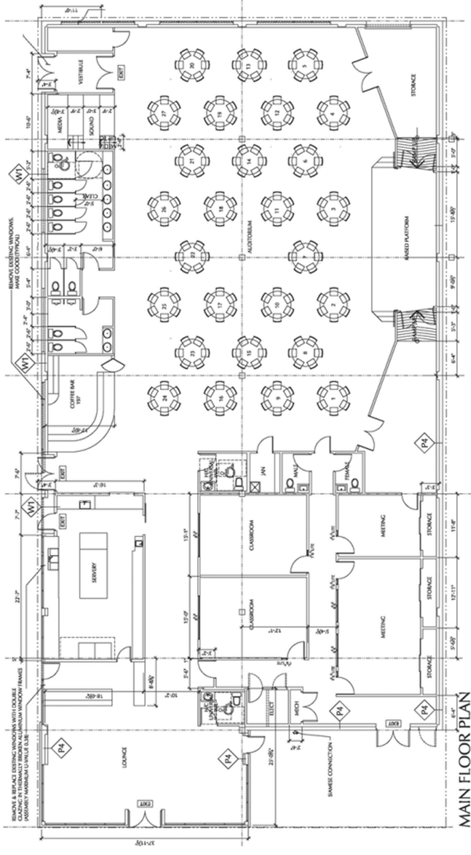
6 ft Rectangle banquet tables - 10 qty
Conference Tables 1.5 ft wide – 12 qty
Chairs Black – 350 qty
Chairs Blue - 100 qty
Coat racks & hangers

Additional spaces available for rental separately:
Lounge - 30’ deep x 37’ wide with bar area and washroom with kitchen access
Additional meeting rooms with washroom access
Please contact bookings@metrocommunity.ca for availability and pricing.

FOOD & BEVERAGE
1. Renters will arrange for their own food and beverage caterers and the caterer will need to visit the venue prior to the event for kitchen orientation. Catering services are not available through Metro Hub. Kitchen facilities must be supervised by a person with a Food Safe certificate.
2. Fridges are available for food storage but must be arranged in advance.
3. Alcohol is only permitted inside the premises according to BCLCB laws, however, NO HARD ALCOHOL is permitted. You will need a Special Event Permit and ensure that your bartenders have a Serving it Right registration number. It is recommended that the renter offer safe ride home options for their guests.

INSURANCE
1. The insurance policy of Metro Hub does not cover liability for rental groups, their guests, or participants.
2. Metro Hub requires a certificate of liability insurance confirming coverage for your event (minimum $5,000,000) and naming the following as additionally insured for any legal liability resulting from negligence on your part, or that of your guests:
Metro Hub (1265 Ellis St, Kelowna, BC, V1Y 1Z7)
3. Renter will be liable for any physical damages, legal actions, and/or loss of reputation or business opportunities that Metro Hub may incur as a consequence of the actions of Renter or any of Renter’s guests while Renter is in control of the venue and shall indemnify and hold harmless Metro Hub against any and all legal actions which may arise from Renter’s use of the venue.
4. Each user group and renter are responsible for the behavior of their own guests and participants. Any damage done to the building or Metro Hub property by guests and participants will be the responsibility of the renter and must be reported to the Metro Community office. Compensation for damage caused by negligence may be required.

WALKTHROUGH, SETUP & TAKE DOWN PROCEDURES
1. A facility walkthrough must be booked prior to the event to verify technician and setup needs.
2. The day of the event a Metro Hub team member will be on site to disarm the alarm and unlock the assigned entrance doors at the setup start time agreed upon in the rental contract.
3. A member of the Metro Hub team must be on site for the duration of a rental event.
4. The renter, including their members and guests, are responsible to stay within the designated rooms booked by their group.
5. Decorating and takedown for your event will take place within the event rental time unless arrangements are made in advance; additional fees may apply.
6. Renters are responsible to leave the facility in as good as or better condition than at the start of the event; Leaving it dirty may result in additional custodial fees. Stacking chairs in groups of 10 would be appreciated by custodial team.
7. It is the responsibility of the Metro Hub team to lock and secure the building after an event.
8. The last hour of the rental should be planned for cleanup. Failure to adequately clean up will result in the hiring cleaners at your expense.

EQUIPMENT, FURNITURE, DÉCOR, SUPPLIES & STORAGE
1. Certain custodial supplies and services are included in the cost of your rental. If you are holding an all-day event or an event that spans several days with numerous people in attendance, you may be billed a custodial supply fee.
2. No equipment or property may be removed from the building without permission and approval. This includes but is not limited to, kitchen and technical equipment, musical instruments, and furniture.
3. Renters are responsible for loss or damage of equipment brought into the building.
4. Metro Hub does not have space to provide storage for rental users; additional fees will apply if renter items left on premises at the end of the rental.
5. Moving of any accessories (plants, art, fixtures on the wall, small furniture) must be declared and approved prior to the event.
6. Tables and chairs can be decorated; as well, free-standing decorations can be used. Draperies, lights and additional furniture can be added to your décor. No duct tape, scotch tape, pins, nails, or other materials are to be affixed to the space, and house lights should remain in position. 3M Command hooks may be used with extreme caution.
7. Dishware and linens are not available onsite.
8. Exits must remain accessible and exit signs must be visible at all times.

