

220 Eagle Crest Drive

Evansville, In 47715

(812)476-4000

Raquel West

Sales Coordinator

rwest@hamisterhospitality.com

# GENERAL INFORMATION

**Guarantee** A guaranteed number of attendees is required three (3) business days prior to the function. In the event the guarantee is not received within three (3) business days the Hotel will assume the guarantee to the maximum number previously expected. If less than the guaranteed number of guests actually attends the event, you will be charged for the guarantee number. Guarantees for Saturday and Sunday are due the preceding Wednesday. Monday and Tuesday guarantees are due the preceding Thursday.

**Meeting Spaces** Any changes made to room setup the day of the event is subject to a $100.00 room reset fee and will reflect on your final bill.

**Food and Beverage** Food and Beverage may not be brought into the hotel’s public areas or function space by patrons or guests attending functions. In addition, due to license restrictions and Vanderburgh County Health Department, no food or beverage may be taken off the hotel premise under any circumstances.

**Taxes and Service Charges** It is agreed that any and all applicable taxes and a 20% service charge will be paid, in addition to the charges listed in this menu and all written agreements.

**Payment and Billing** The Hilton Garden Inn requires payment for all functions to be paid in full 15 days prior to the function unless credit for billing has been arranged. A deposit may be required in order to hold your space for your function. The deposit is NON-REFUNDABLE.

**Menu Selection** Menu selection should be submitted to the Hotel Sales Department no later than two weeks prior to your scheduled function. Notifications on all changes and cancellations must be made with the Hotel Sales Department. If you have a special menu in mind, we welcome the opportunity to customize a menu for you.

***UPDATED PRICING EFFECTIVE 2/14/2020

# GARDEN ROOM RENTAL & CAPACITY

Garden Room A – 690 Square Feet

$175 (up to 4 hours)

$250 (4 hours or more)

Garden Room B – 529 Square Feet

$150 (up to 4 hours)

$200 (4 hours or more)

Garden Room – 1219 Square Feet

$250 (up to 4 hours)

$450 (4 hours or more)

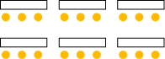

**Theatre Banquet Classroom**

1. **– 60**   **A - 40**   **A – 30**
2. **– 40 B - 30 B - 20**

**Garden – 100**  **Garden – 70 Garden - 6**0

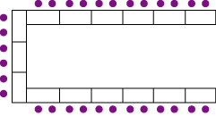 

**U-SHAPE CONFERENCE**

**A-25 A-20**

B-15 B-15

GARDEN-60 GARDEN-40

# AUDIO VISUAL

* Projector $100
* Screen $15
* TV Monitor $20
* DVD Player $15
* Audio Conference\Speakerphone $25
* Accessories Extension Cord $5
* Flip Chart Easel with Pad & Markers $25
* Flip Chart Easel with Self-Adhesive Pad & Markers $30
* Additional Flip Charts $10
* Flip Chart Easel $15
* White Board Easel with Markers & Eraser $20
* VGA Cable $5
* HDMI Cable $5
* Laser Pointer $10
* Laptop Converter $5
* Podium and microphone $25
* Power Strip $5
* Wireless microphone $30
* AV Cart $15

AV upon Demand Services/On-site (Day of) additional $50 service fee. ****Wireless Internet and business center services Complimentary****

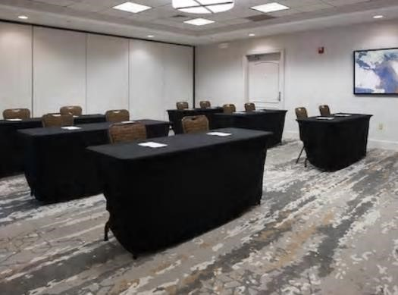

# PLATED BREAKFASTS

**Accompanied by water, fresh juice and coffee** **service**

**10 Person Minimum**

**Sweet Tooth $14.00 per person**

French Toast or Pancakes

With Berry Compote

**Smart Start $16.00 per person**

Oatmeal with Assorted Toppings

Yogurt with Granola

**Homestyle Breakfast $16.00 per person**

Scrambled Eggs

Bacon or Sausage

Breakfast Potatoes or Hash Browns

Fresh Biscuits with White Pepper Gravy

**Breakfast Bowl $15.00 per person**

Breakfast Potatoes

Cheddar Cheese

Scrambled Eggs

White Pepper gravy

Sautéed Onions, Peppers & Mushrooms

**Denver Omelet $18.00 per person**

Ham, Bell Peppers, Onions

Cheddar Cheese

Breakfast Potatoes or Hash Browns

Biscuits with Assorted Jelly

# BREAKFAST BUFFET

**Accompanied by water, fresh juice and coffee** **service**

**10 Person Minimum**

**$24.00 per person**

Scrambled Eggs (Whites Available Upon Request)

Sausage Links

Bacon

Biscuits & White Pepper Gravy

Breakfast Potatoes or Hash Browns

Assorted Danishes

Assorted Muffins

Fresh Fruit Tray

Add on Pancakes or French toast with Syrup for $3.00 per person

# SPECIALTY BREAKS

**6 Person Minimum**

**Morning Break $8.00 per person**

Assorted Bagels & Cream Cheese

Served with Coffee

**Pastry Break $8.00 per person**

Assorted Muffins & Danishes

Assorted Bread & Jams

**Sweet & Salty Break $10.00 per person**

Assorted Chips

Pretzels

Assorted Cookies

**Fresh Break $10.00 per person**

Fresh Fruit

Granola Bars

Served with Coffee

# DESSERTS

**6 Person Minimum**

NY style Cheesecake

$6.00 per person

Caramel Crunch Cake

$6.00 per person

Apple Pie

$4.00 per person

Chocolate Mousse Pie

$5.00 per person

Assorted Pastries

$15.00 per dozen

# LUNCH BUFFETS

**Accompanied by Rolls and Butter and Served with Iced Tea and Water Minimum guarantee of 10 people applies.**

**$26.00 per person**

(Vegetarian and dietary restricted meals available upon request)

## Entrée: Choose one

Choose two for an additional $5.00 per person

Grilled Chicken

BBQ Pulled Chicken

Steak Medallions

BBQ Pulled Pork

Pasta with Marinara Sauce or Alfredo Sauce

## Sides: Choose two

Choose additional sides $3.00 per person

Mixed Green Salad Steamed Rice

Sautéed Vegetables

Mashed Potatoes

Cole Slaw

# PLATED LUNCHES

**Accompanied by Rolls and Butter and Served with Iced Tea and Water Minimum guarantee of 20 people applies.**

**$23.00 per person**

(Vegetarian and dietary restricted meals available upon request)

Each person will receive one entree, two sides and dinner rolls

**Choose Two Entrees**

Grilled Chicken

BBQ Pulled Chicken

Steak Medallions

BBQ Pulled Pork

**Each Entrée Is Served With: Choose Two** Mixed Green Salad Steamed Rice

Sautéed Vegetables

Mashed Potatoes

Cole Slaw

# ENTRÉE LUNCH SALADS

**Accompanied by Rolls and Butter and Served with Iced Tea and Water Minimum guarantee of 6 people applies.**

**Field Green Salad $14.00 per person**

Mixed Field Greens with Tomatoes, Cucumbers, Shredded Carrots, and Croutons

Served With Ranch and Balsamic Vinaigrette

**Classic Caesar $14.00 per person**

Crisp Hearts of Romaine Lettuce, Croutons and Parmesan Cheese

Served With a Caesar Dressing

**Baby Spinach Salad $14.00 per person**

Fresh Baby Spinach with Red Onions, Candied Pecans, Oranges, and Sugar Snap Peas

Served with Vinaigrette

**Garden Salad $14.00 per person**

Mixed Green Salad with Cucumber and Tomatoes

Served with your choice of dressing

Add chicken to any salad for an additional $3.00 per person

Add salmon to any salad for an additional $6.00 per person

# BOXED LUNCHES

**$23.00 per person**

**6 Person Minimum**

**Boxed Lunches accompanied by a piece of fresh fruit, chips and a cookie.**

**Served with Soft Drink or Bottled Water.**

Turkey Club on a Croissant

Chicken Salad on a Hoagie Roll

Ham and Swiss Club

Vegetable Wrap

Chicken Caesar Wrap

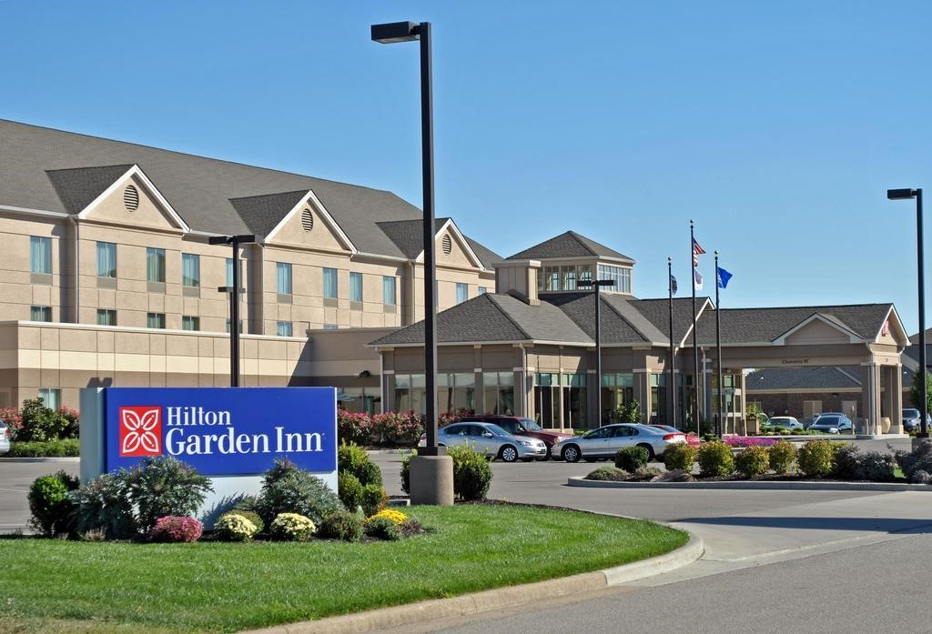

# JUST FOR FUN

**6 Person Minimum**

## Yogurt Bar

$8.00 per person

* Strawberry Yogurt
* Vanilla Yogurt
* Raisins
* Seasonal Fruits and Berries
* Granola
* Fresh Assorted Juices

## Burger Bar

$15.00 per person with Chips

$20.00 per person with Fries

* 8 ounce Ground Beef Burgers
* Sesame Seed bun
* Romaine Lettuce
* Roma Tomatoes
* Red Onion
* Bacon
* Cheese (Cheddar, Swiss, Pepper Jack, Mozzarella)

## Salad Bar

$10.00 per person

* Mixed Greens, Arugula or Spinach
* Croutons
* Shredded Cheddar
* Cucumber
* Cherry Tomato
* Red Onion
* Italian, French, Ranch & 1,000 Island Dressing

## Taco Bar

$15.00 per person

* Hard and Soft Taco Shells
* Ground Beef, Grilled Chicken or Pulled Pork
* Shredded Cheese
* Tomato
* Onion
* Jalapenos
* Sour Cream
* Shredded Lettuce
* Salsa
* Guacamole

# DINNER BUFFETS

**Accompanied by Rolls and Butter and Served with Iced Tea and Water.**

**Minimum guarantee of 10 people applies.**

**$30.00 per person**

**Choose a second entrée for $35.00 per person**

(Vegetarian and dietary restricted meals available upon request)

## Entrée: Choose One Option

Pan Roasted Chicken Breast

Country Fried Chicken

Marinated Shrimp

Grilled Pork Chop

Oven Baked Salmon

Grilled Ribeye or Sirloin

Fried Pollock

BBQ Pulled Pork or Chicken

## Sides: Choose Two

Oven Roasted Potatoes

Seasonal Vegetable

Twice Baked Potatoes

Steamed Rice

Green Beans

Mashed Redskin Potatoes

## Dessert included: Choose One

NY Style Cheesecake

Chocolate Mousse Pie

Caramel Crunch Cake

Apple Pie

# PLATED DINNER

**Accompanied by Rolls and Butter and Served with Iced Tea and Water.**

**Minimum guarantee of 20 people applies.**

**$35.00 per person**

(Vegetarian and dietary restricted meals available upon request)

## Entrée: Choose Two Options

Pan Roasted Chicken Breast

Country Fried Chicken

Marinated Shrimp

Grilled Pork Chop

Oven Baked Salmon

Grilled Ribeye or Sirloin

Fried Pollock

Fried Tofu

BBQ Pulled Pork or Chicken

## Includes

Chef Choice Vegetable Medley

Oven Roasted Potatoes,

House salad

## Dessert included: Choose one

NY Style Cheesecake

Chocolate Mousse Pie

Caramel Crunch Cake

Apple Pie

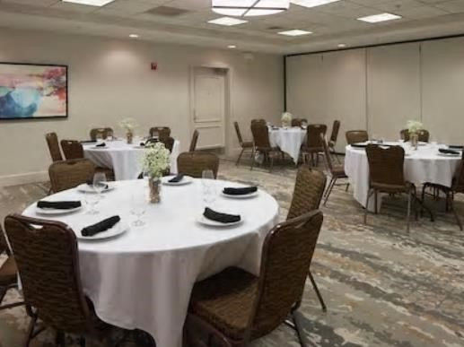

# RECEPTION MENU

**Hor d’oeuvres:**

Each tray feeds up to 25 People

**Fruits and Dip $100**

Fresh cut assorted fruits with sweet cream cheese and yogurt dip

**Vegetables and Dips $70**

Fresh cut vegetables with honey mustard and ranch

**Mixed Greens $35**

Spring mix, carrots, cucumbers, red onion

**Egg rolls (chicken or pork) $75**

Served with sweet chili sauce

**Antipasto Board $130**

Chef’s choice of cured meats, cheese, crostini and pickled vegetables

**Platters/ a la carte**

Each tray feeds up to 25 People

Chicken Salad Sandwiches $115

Turkey Club Sandwiches- $125

Sliced Turkey & Ham Sandwiches with Sliced Cheese $125

BBQ Pulled Pork, Served with Fresh Rolls $150

Chicken Caesar Wraps-$100

Roast Beef & American Wraps-$130

Lasagna $100

Shrimp Cocktail (Market Price)

Cheese and Fruit Tray $120

Chicken Wings- $120

Chicken Fingers- $75

BBQ Meatballs $70

French Fries- $45

Cole Slaw $25

Pan Roasted Chicken Breast- $75

Country Fried Chicken- $75

Grilled Pork Chop- $150

Oven Baked Salmon- $100

Grilled Ribeye or Sirloin $175

Fried Pollock $80

Fried Tofu $45

Potato Salad- $35

# BAR MENU

**BARTENDER FEE** $75.00/4 Hours

## HOSTED BAR

Full Bar House Brands $7.00 per drink

Full Bar Premium Brands $10.00 per drink

Domestic Beers $6.00 per drink

Premium Beers $7.00 per drink

## CASH BAR

House Cocktails $7.50 each

House Wines $7.50 per glass

Domestic Beers $6.50 per bottle

Premium Cocktails $10.75 each

Premium Wines $10.75 per glass

Premium Beers $7.00 per bottle

**Bloody Mary and Mimosa Bars available prices vary

**Champagne $45.00 per bottle (serves 6)

# BEVERAGES

Coffee and Decaf $40.00 per 1.5 gallon

Assorted Hot Teas $10.00 flat rate (if added to coffee)

Iced Tea $10.00 per pitcher

Assorted Cans of Soda $2.50 per consumption Fresh Juices $10.00 per carafe