# Hourly Event Pricing

Perfect Venue for Birthdays, Anniversaries, Holiday Parties, Corporate Events, Corporate Meetings, Socials, Memorials, Showers, Retirement Parties, Family or Class Reunions, Graduation Parties, Proms, Fundraisers, Concerts, Film Shoot, or any type of Special Event!

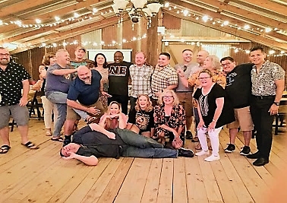 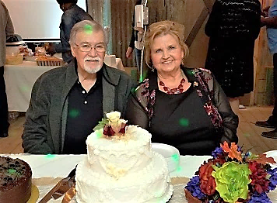 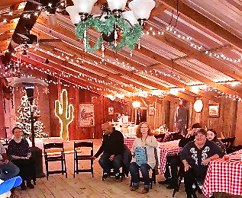 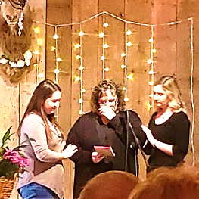

**Birthday Parties Anniversary Parties Holiday Parties Memorials**

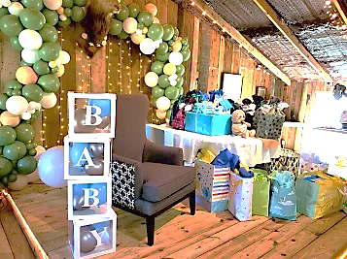 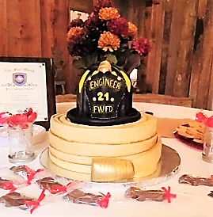 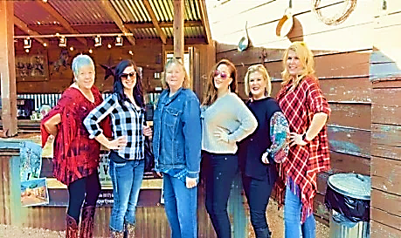 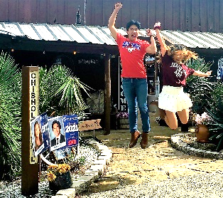

**Showers Retirement Parties Reunions Graduation Parties**

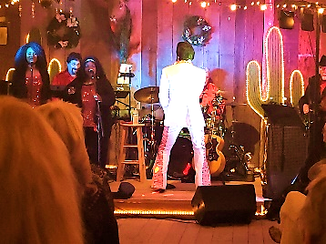 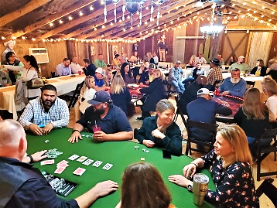 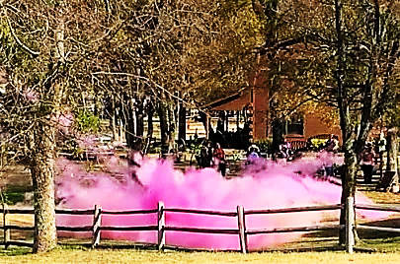 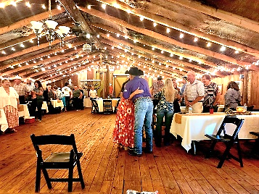

**Special Events Fundraisers Gender Reveals ALL Celebrations!**

# EVENT BARN PRICING

(150 people maximum)

**Package Friday - Saturday Sunday - Thursday**

12-Hour Rental $4,200 $3,400

8-Hour Rental $3,200 $2,400

6-Hour Rental $2,400 $1,600

4-Hour Rental $1,600 $800

# SALOON PRICING

(15 people maximum)

**Small Group ½ Off Discount** - any event under **15 people** (max) will receive

**50% OFF** the prices listed above if the event is held inside the Saloon.

# Hourly Event Details

**Includes:**

**Entire Authentic Western Town** – with seating area around the fire pit

**Event Barn** – climate-controlled barn with a stage and decorative lighting

**Sound System** - venue provides an excellent PA sound system with a wireless microphone

**Tables & Chairs** – venue provides enough tables & chairs to seat 120 ppl (max) at tables inside the Event Barn with a dance floor or 150 people (max) without a dancefloor. The Chisholm Trail Rustic Venue has: **20 tables** and **150 mahogany padded wood resin chairs**. Our table sizes are: **12** -8ft rectangular tables, **4** -6ft rectangular tables, **1** -4ft rectangular tables, **2** -60” round tables & **2** -72” round tables.

**Saloon** – authentic bar that provides additional seating for 15 people and includes a refrigerator/freezer

**Chowline**– set-up and serve food from our outdoor covered serving bar

**Outdoor Pavilion**– covered seating area with picnic tables behind the Event Barn

**Outdoor Games**– corn hole, jenga, darts, horseshoes

**Additional Items for Rent from the Venue:**

**$50** – **Parking Attendant** (recommended for over 50 guests)

**$100** – **Extra LARGE Screen Rental & Projector** (for a slideshow)

**$200** – **Day-Of-Coordinator**

**$50 per hour** – Photo shoot on property

**$30 per table** -*or-* **$500 for all tables to be fully decorated** ($100 discount)

**Fully Decorated Tables by Studio 100 - includes décor listed below:**

(Decorator will set up and take down everything for you)

-Cream Colored Tablecloths **($10/each)**

-Table Runners – colors of your choice **($5/each)**

-Wooden Cut Centerpieces **($5/each)**

-Lantern Centerpiece w/ Battery Operated Candle **($5/each)**

-Silk Flowers – colors of your choice **($5/each)**

-Glass Bowls -or- Mason Jar Centerpieces **($5/each)**

(NOTE: you may also rent individual items listed above or bring your own decor and decorate yourself)

**Food** – bring your own food OR bring your own caterer...OR use one of our preferred caterers if you prefer.

**Alcohol** – we are a BYOB venue which means you & your guests are allowed to bring in your own alcohol for personal consumption, however, the venue requests that if you want your guests ‘served’ at your event (highly recommended for your own liability, especially for an event over 75 people), you are required to hire a TABC Licensed & Insured Bartender. If you don’t know a bartender, then we have great ones to recommend to you.

**Day Of Event** – your rental period begins & ends at agreed upon time and that includes the time to decorate, and to clean-up so please take that into consideration when deciding which package to choose for your event. If you prefer, you can hire our on-site decorator to do everything for you ahead of time and everything will be ready when you arrive

**Deposit** – **50% DOWN** NON-REFUNDABLE Retainer Fee to Secure the Date **–** remaining balance should be paid in equal monthly payments, however the entire balance must be *paid in full 60 days prior* to your event