*The Golden Doors Venue Pricing*

***Lillybelle , Betty Parlor ,Terrace Room rental ends at 12:00am -OUT BY 12***

*The Betty Parlor - 6 hours $600.00 8 hours $700.00*

*The Lillybelle – 6 hours $700.00 8 hours $800.00*

*The Terrace Room – 6 hours $600.00 8 hours $700.00*

***The Diamond Ballroom out by 12:00am***

*6 hours- $1800 * 8 hours -$2000 * 10 hours $2500.00 * 12 hours $2800*

***The Lounge on Townsend***

*Rental is $1200.00 for 6 hours –no re-set in this area 6 hours*

*A $200 room reset fee is required if furniture is moved*

***Full table setup***

***$30.00****-- Full table setup (Chair cover, tablecloth, Overlay or, runner, add $20 for centerpiece*

***\*\*Events must conclude by 12:00 am\*\****

***HOLIDAY RENTALS ADD $200.00 MORE PER ROOM—NO EXCEPTIONS***

*\*Please do not ask for an early entry –you may purchase additional time if you feel it is necessary. The time you booked is the time you and/or vendors may enter the building.*

***Tables and chairs are a part of the rental. No linens***

*The venue does not PROVIDE linens for the food tables—Caterers are responsible for the linens*

*setup for (decorations) and clean up are a part of the rental time.*

*Please keep that in mind. Your time will begin upon (vendors) entrance to the venue the day of your event.*

*Thanksgiving Day*

*PRICING*

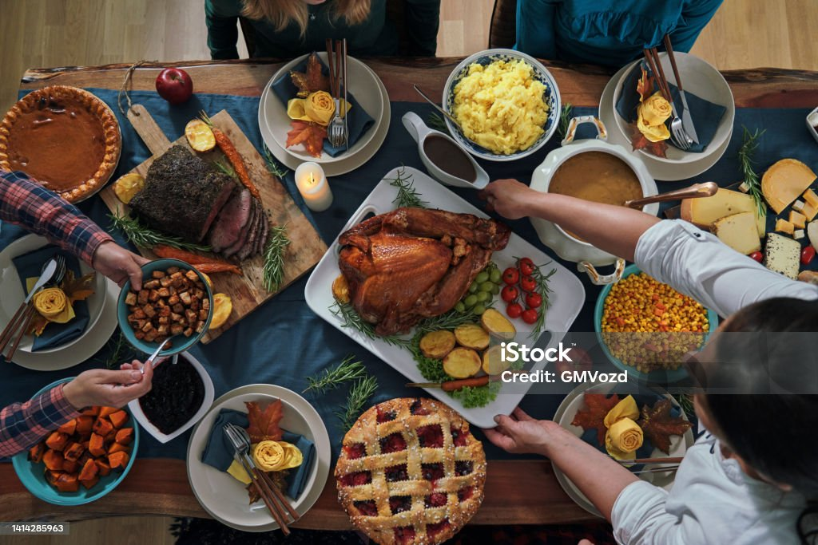

*Don’t want to host Thanksgiving dinner at your home?*

*Is your family too big for everyone to fellowship in one place?*

*We have a solution. Rent a space at The Golden Doors for 5 hours*

*Venue must be vacant by 7pm at the latest*

*The Betty Parlor accommodates up to 60 people- $300.00*

* *Lillybelle accommodates up to 70 people- $450.00*
* *Terrace Room accommodates up to 70 people- $500.00*
* *Diamond Ballroom up to 150 people- $700.00*

*No DJ’s*

*Call 336-307-2410*