Hunters Green Golf Club



Events Package

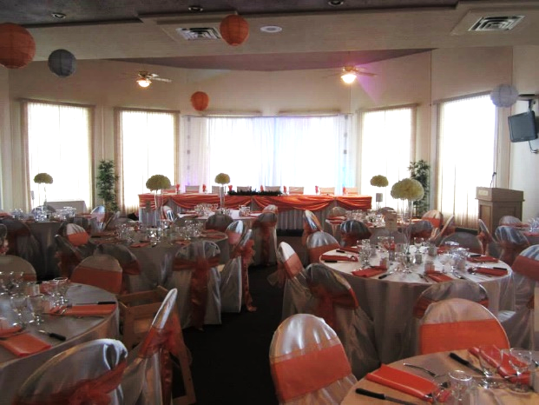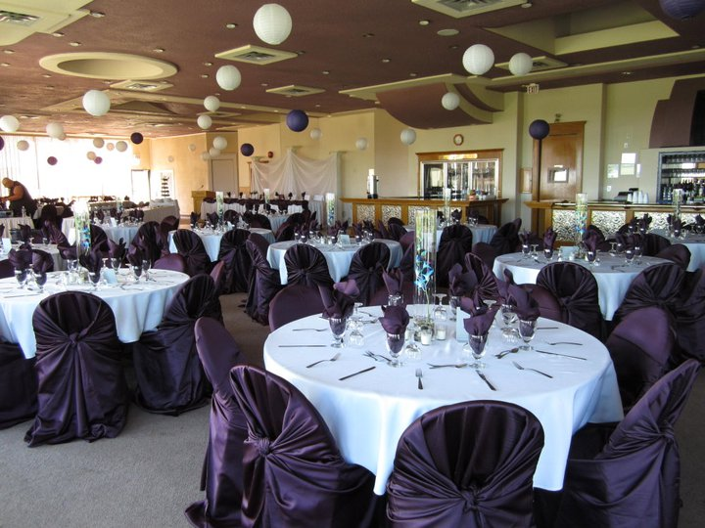

Banquet Hall

Come and take a peek at our spacious 10,000 square foot Banquet Hall, with seating up to 250 guests, hardwood dance floor, expansive bar with brass accents, boasting spectacular views of the 18th Fairway and the sunset reflecting off the lake, with the downtown Edmonton skyline in the distance.



Room Rental  
 **Weddings & Banquets** - $1200.00 (5pm - 2am)

**In-Hall Ceremony** - $400.00 (2 hours prior to reception)

**Hourly Rental** - $100.00/hr (minimum 3 hours)

**Gift Opening** - $300.00 (11am - 2pm)

**Christmas Parties** - $600.00

A **non-refundable** function deposit of $600.00 is require to secure the date and time of your function.

*Prices Include set up and tear down of tables and chairs, in addition to the provision of white table linens and napkins for the head table, buffet table and guest tables.*

Bar Service  
  
Cash Bar

*All guests pay full price for drinks.*

Toonie Bar  
*All guests pay $2.00 for a drink. Event host pays the difference.*

Open Bar

*All drinks charged to event hosts.*

Alcohol Price List

Domestic Beer

*$5.25*Premium/Imported Beer

*$5.75*Coolers

*$5.75*House Wine

*Glass - $6.00  
Bottle - $24.00*  
Single Highball

*$5.25*Double Highballs

*$9.50*

Premium Highball

*$6.50*

Double Premium Highballs

*$11.50*

*Requests for particular spirits will be entertained if sufficient time is available to order.*

*Two Bartenders are required for functions that exceed 140 guests.*

Amenities

Speakers Podium

*$15.00*

Sound System & Wireless Microphone

*$135.00*

52” Mounted Television

*$15.00*

DVD Player

*$15.00*

Large Fabric Backdrop

*$350.00*

Large Fabric Backdrop with Accent Color

*Accent color is customized to your wedding colors/theme*

*$450.00*

Additional Table Skirts

*$15.00 each*

On-Course Photography

*Package includes course escort, unlimited number of carts for your bridal party and photographer, photos at a variety of our on course locations, and complimentary bottled water for all guests (90 minutes)*

*$250.00*

Preferred Vendors



www.mysticaentertainment.com  
780.245.3782

www.ltdevents.ca  
780.267.8608

Location

**From St. Albert**: Sturgeon Road turns into 127th Street, turn left on Township

RD 542

**From Edmonton**: Access from 127th Street, turn right onto Township RD 542

Access from **66th Street and 82nd Street**, turn left on 195 Ave (Valour Ave).

*Note: No direct access from 97th Street*

Stay Connected  
  
Check out our website at **huntersgreen.ca**

Phone: 780-973-6686

Fax: 780-973-6696

Email: info@huntersgreen.ca

Facebook: facebook.com/huntersgreenGC

Twitter: twitter.com/HuntersGreenGC

Instagram: @huntersgreenGC



At Hunters Green, we provide a variety of succulent dishes to choose from.

Below we have noted some of the more common meal combinations selected by our guests.   
In the following page, you will find a detailed description of all our menu items

CLASSIC BUFFET  
2 Salads, 2 Entrees, 2 Vegetables, 1 Accompaniment  
*Starting at $30.00/plate*

PREMIUM BUFFET  
3 Salads, 2 Entrees, 2 Vegetables, 2 Accompaniment, 1 Specialty Side  
*Starting at $39.00/plate*  
  
  
SIGNATURE BUFFET  
3 Salads, 2 Entrees, 2 Vegetables, 2 Accompaniment, 2 Specialty Sides  
*Starting at $43.00/plate*

*All buffet options include complimentary coffee and tea*

*All prices noted are listed per plate. Please note that there are a   
required minimum 100 plates required for weddings and a   
minimum 50 plates required for banquets, with a minimum   
price per person of $30.00

**All prices are subject to 5% GST and 18% gratuity.

***All prices are subject to change

Hunters Green  
*Event Catering*

**VEGETABLES**

Honey Glazed Carrots  
*sliced carrots coated in brown sugar & honey glaze and sprinkled with freshly chopped dill*  
$3.00

Mixed Vegetables  
*Seasonal mixed vegetables tossed in garlic butter*  
$3.00

Corn O’Brien  
*sautéed kernel corn, diced red and green peppers, onion and chopped bacon*  
$3.00

Green Beans Almondine  
*Fresh green beans with toasted almonds and julienne red peppers*  
$3.00

**ACCOMPANIMENTS**

Garlic Whipped Potatoes  
*Alberta-grown russet potatoes whipped with butter, heavy cream, minced garlic and fresh parsley*  
$2.00

Baked Potatoes  
*served with sour cream, bacon bits and chives*$2.00

Vegetable Rice Pilaf  
*long grain white rice and a vegetable mirepoix cooked in chicken stock and herbs*  
$2.00

Herb Roasted Potatoes  
*yellow & red skinned potatoes tossed in oil & herbs, roasted until golden*  
$2.00  
  
Parmesan & Herb Roasted Potatoes  
*yellow & red skinned baby potatoes tossed in olive oil and herbs, roasted until golden and sprinkled with grated parmesan*  
$2.25

Dinner Buns  
*white and whole wheat buns served with butter*  
$6.00/dozen

**SPECIALTY SIDES**

Pyrohy  
*locally made Baba’s own pyrohy – assorted varieties, inquire for selection*  
Starting at $4.25

Cabbage Rolls  
*locally made Baba’s own cabbage rolls – assorted varieties, inquire for selection*  
Starting at $4.25

Kielbasa with Sauerkraut  
*Ukrainian sausage cooked in sauerkraut with dice apple and bacon*  
$4.25

**KIDS MENU**

Chicken Fingers  
*served with fries and apple juice*  
$9.00

Hotdog  
*served with fries and apple juice*  
$9.00

**SALADS**

Pasta Salad  
*tricolored rotini pasta mixed with diced carrots and celery, tossed in a house made creamy dressing*  
$2.00

Creamy Coleslaw  
*shredded green and purple cabbage with shredded carrots, tossed in a coleslaw dressing*  
$2.00

Classic Caesar  
*crisp romaine, herb croutons, tossed in creamy Caesar dressing, topped with grated parmesan*  
$3.00

Greek Salad  
*English cucumber, tomato, red & green pepper, purple onion and Kalamata olives tossed in house made Greek dressing topped with feta cheese*  
$4.00

Greek Pasta Salad  
*penne rigate pasta tossed with diced tomatoes, cucumbers, purple onions, green pepper and topped with feta cheese*  
$4.00

**ENTREES**

Herb Roasted Chicken  
*boneless, skinless chicken breast seasoned with a mixture of 7 different herbs and spices*  
$8.95

Honey Glazed Ham  
*oven roasted and brushed with a sweet homemade honey glaze*  
$8.95

Oven Roasted Turkey Breast  
*slow roasted and served with dressing and gravy*  
$11.95

Roast Beef with Rosemary Merlot Au Jus  
*dry rubbed and slow roasted and served in a rosemary merlot au jus*  
$12.95

Steak  
*8 oz. striploin*  
$12.95



**QUESTIONS ABOUT OUR MENU?**

Contact us at 780-973-6686 or send us an email at info@huntersgreen.ca

**LATE LUNCH**

Hamburger Sliders  
*mini hamburgers with selection of condiments – min order of 4 dozen*  
$29.00 per dozen

Pulled Pork Sliders  
*mini barbeque pulled pork sandwiches – min order of 4 dozen*  
$29.00 per dozen

Pizza  
*14” Rounds – 10 slices per pizza*  
Cheese - $18.00  
Pepperoni - $19.00  
Hawaiian - $19.00

Munchie Bowls  
*mixture of Sun Chips, Doritos, Cheetos and Pretzels*  
$9.00 per bowl

**PLATTERS***all platters serve 50 guests*

Meat Platter  
*sliced turkey, black forest ham, pepperoni, roast beef*  
$125.00

Cheese Platter  
*cheddar, marble, Monterey Jack*  
$125.00

Vegetable Platter  
*assorted seasonal vegetables and ranch dressing*  
$95.00

Pickle Platter  
*assorted pickles, olives and pickled onions*  
$85.00

**DESSERT**

Dessert Squares  
*nanaimo bars, dutch chocolate brownies, tiger brownies*  
$3.00

Gourmet Mini Tarts  
*price per 4 dozen*  
Lemon - $40.00  
Apple - $48.00  
Cherry - $60.00  
Blueberry - $60.00

Premium Dessert Cups  
*Jell-O and Mousse Cups, with flavors varying according to season*  
Inquire for pricing

Éclair Tray  
*selection of premium baked goods including Cream Puffs and Éclairs*  
Serves 50 guests  
$58.00

Season Fruit Tray  
*seasonal until end of August*  
Serves 50 guests  
$115.00