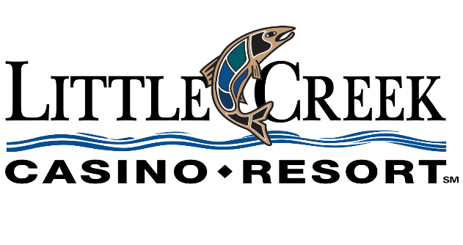

|  |
| --- |
| Sales & Catering inquiry |
|  |
|  |

|  |  |  |  |  |
| --- | --- | --- | --- | --- |
| Name | Company/Organization | Email | | Phone |
| Ken Ramos | Cobat Veterans Motorcyle Association | Trescvma11.9@gmail.com | 360-5619474 | |

|  |  |
| --- | --- |
| Event Specs |  |
| Event Type (Conference, Meeting, Reunion, etc.): | Annual Event Non-Profit |
| Estimated Attendance: | 450 |
| Date(s) of Event: | July or August 2025 |
| Date(s) of Hotel Room Block: | yes |
| Are Date(s) Negotiable? |  |
| Banquet Space (Quantity and/or Sq Footage) | yes |
| Hotel Rooms (Quantity) |  |
| Anticipated Food & Beverage Needs: | undecided |
| Anticipated Audio/Visual Needs (If Any): | unsure |