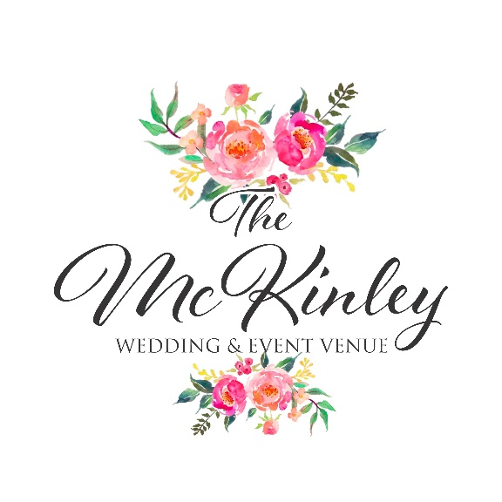

Weekday Package

*\*\*\*All packages include complimentary Stage, "The Glam Cottage", "The Guys Room", “The Cozy, Lit Pavilion”, & A Full Kitchen\*\*\**

***Only $750 To Book Your Date! PAYMENT PLANS AVAILABLE!***

**Our affordable weekday event options give you the choice of:**

* **Sunday (Time Subject to Prior Event Holder- Ask event coordinator about your date!)**
* **Monday**
* **Tuesday**
* **Wednesday**
* **Thursday**

**Standard Package Includes:**

**- *Twelve Hours Access to The McKinley: 12pm- Midnight***

***-Full Kitchen***

***-The Glam Cottage Suites***

***-The Guys Room***

***-Up to 25 Round White Tables***

***-Up to 250 Crystal Napoleon Chairs***

***-15 Rectangular White Tables $2, 550-***

*May Add On Additions, Per Additions Guide*