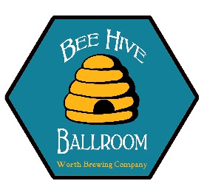Bee Hive Ballroom
Worth Brewing Company
Northwood IA, 50459
E-Mail: tyler@worthbrewing.com
worthbrewing.com

Worth Brewing Company has been the area's go to location for craft beer for 9 years. With our recent expansion we are able to offer more than a great brewery experience.
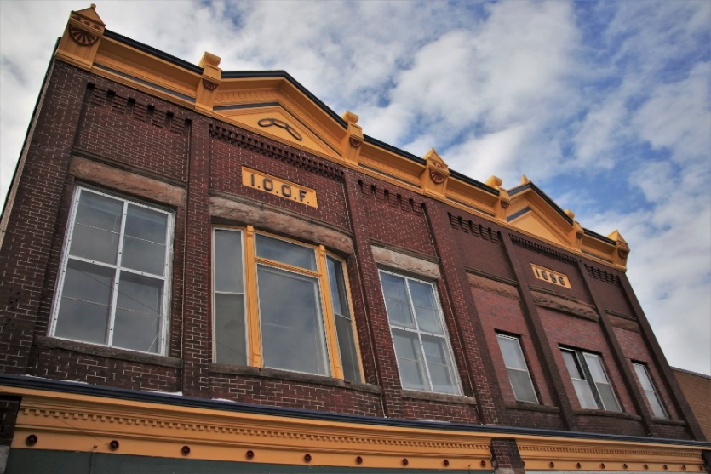
Sitting on the second story of the new Worth Brewing is the Bee Hive Ballroom. The Independent Order of Odd Fellows first used the ballroom as an event center in 1896. Under the layers and layers of past renovations we found a room frozen in time. From the original tin ceilings to the original floors this Ballroom looks much like it did 120 years ago.

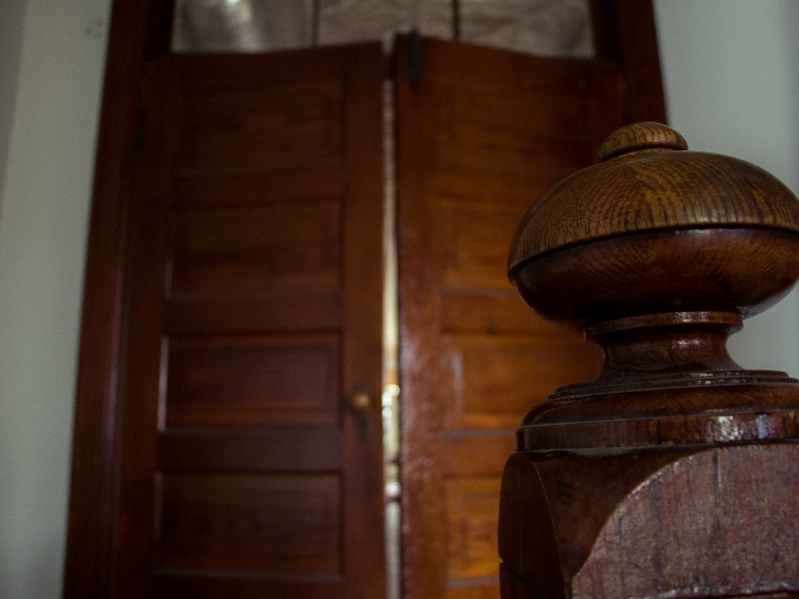
We worked hard to add the amenities you come to expect from a modern venue. Including large restrooms, green rooms, catering kitchen, P.A., bar and speakeasy.

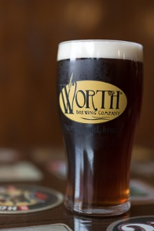
The Ballroom Bar features four taps with your favorite Worth brews, and private bartender. The attached catering kitchen can be used by any licensed vender and we provide a list of local caterers.
We are committed to bringing the same level of quality that we put into our beers into your next event. Please contact our retail manager Tyler Trenhaile for more information.

The Beehive Ballroom is available any day of the week and it is able to be used by non-profits and clubs free of charge.

*The Ballroom is still under construction and will be finished June 1.
