Wedding Dance Lessons

Looking for a great way to show off at your upcoming wedding? Perfect Dancing will help make your dreams come true!
What to expect:
Perfect Dancing specializes in teaching beginners the basic steps of Waltz, Foxtrot, Swing, Merengue, Tango, Hustle, Rumba, and Cha- Cha. We offer a fun and encouraging routine that will assist in helping the bride & groom gain confidence to showcase your dance skills in front of others. Another benefit to joining Perfect Dancing is to make a lasting impression on a special day. Whether you’re getting ready for your first dance at your upcoming wedding or looking to make a certain someone happy, the instructor of Perfect Dancing will assist you both in standing out on the dance floor!
How long are lessons:
Dance lessons will last approximately an hour. We will practice at your pace. Ballroom dancing improves physical coordination and has the power to completely transform your wedding reception performance.
How much are lessons:
There are several different packages to choose from:
- Try it Out Package: $333 (3) 1-hr lessons
- Social Package: $444 for (5) 1-hr Lessons
- Wedding Package: $555 (7) 1-hr Lessons

Where will we practice:
Due to our availability, we are able to travel to your location.
Option 2 we will discuss a enclosed location relatively close to both parties.

Present

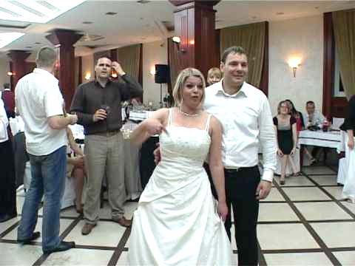

Future

Instructor: Jesse Harris
Contact: (407) 342-8429
Website: perfectdancing.wixsite.com/home
Perfectdancing1
@perfectdancing
@Perfectdancing
I look forward to teaching all levels, contact me today & schedule your 1st lesson!

