Gold Cocktail Party Menu –
for an affair with flair
Cool choices
- Crostini w/Grilled Peach, Burrata & Basil (V)
- Mediterranean Crostini – Hummus, Roasted Red Peppers & Olives (V)
- Crostini w/ tomato pesto, prosciutto & fresh horseradish
- Crostini w/ goat cheese, rosemary poached pear & Riesling caramel (V)
- Zucchini Rolls w/Herbed Cream Cheese, Pine Nut & Arugula (V) (GF)
- Asparagus wrapped in Parma w/Saffron Aioli (GF)
- Sautéed Shrimp in a Cucumber Boat w/ Wasabi Cream (GF)
- Marinated Trout w/ Lavender Honey Dip on Roasted Sunflower Canape
- Prosciutto & Pear rolls w/arugula & Parmesan (GF)
- Sliced Roast Beef on Red Onion Ragout in a Pastry Shell

Warm choices
- Smokey Feta Cigars w/Sun Dried Tomato Dressing
- Moroccan Chicken Kabobs w/Honey Chilli Dip (GF)
- Truffled Mac & Cheese on a spoon (V)
- Baby Beef Franks wrapped in a Pretzel w/Dijon Mustard
- Dates Stuffed w/ Genoa Salami glazed w/Wildflower Honey (GF)
- Dates wrapped in Bacon (GF)
- Phyllo triangles w/ kale & pine nuts w/ fire roasted red pepper dressing (V)
- Five Spice Chicken Breast bites w/Lemon Pepper Sauce (GF)
- Moroccan style pork tenderloin w/ dried apricot compote on a poppadum chip
- Teriyaki Glazed Shrimp w/Fennel Grapefruit Slaw in phyllo shell
- Baby Back Ribs glazed w/Red Pepper Jelly dusted w/Toasted Sesame Seeds (GF)
- Sea Bass Parcels with Cilantro & Lime
- Asian Turkey Sliders on a Black Bun w/Kimchi & Tamari Mayo
- Chicken Praline in Nut Crust w/Cranberry reduction (GF)
- Baby Portabellas stuffed w/Sun Dried Tomato & Artichoke (on a spoon) (GF) (V)
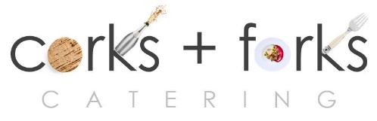

PO Box 8762 WPB FL 33407 PH: 561 339 2444
www.corksandforkscatering.com

