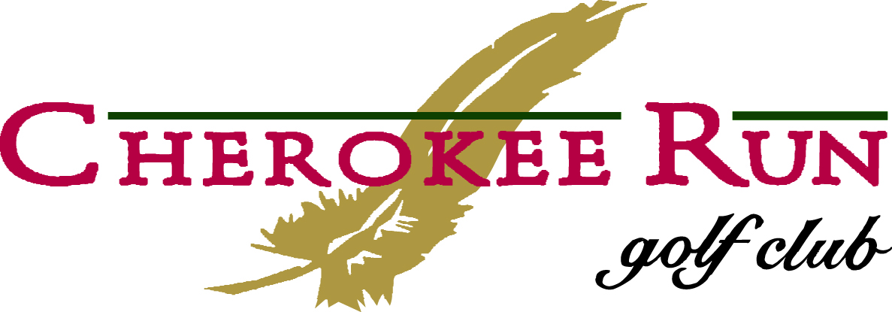

WEDDING & RECEPTION PACKAGE
This package is based on a maximum of 175 guests

Wedding Rehearsal
- Use of the Veranda between the hours of 2-7 pm the day before your wedding day to rehearse for one hour.

Wedding Ceremony
- Use of the Veranda for your ceremony starting at 6pm or later.
- White folding Chairs for your ceremony.
- White Arbor at Ceremony site.

Wedding Reception
- Use of the Palmer Dining Room for up to 4 hours starting at 6pm or later.
- Wooden Dance Floor
- Palmer Room Chairs
- 60” round tables for seating 8 guests per table
- 85x85 Table Linens (White or Black)
- 65x65 Table Linen Overlays (White or Black)
- Cloth Napkins (White or Black)
- Head Table for Bridal Party (maximum of 16 people seated at 6ft banquet tables)
- Table for DJ, Cake, and Gifts
- Buffet table with white skirting
- White Skirting for head table, cake table, gift table, and DJ table
- Centerpiece Hurricane Vase on round mirror with votive candles
- Dinnerware
- 1-Bartender for up to 50 guests. Each additional bartender $75.00
- Wait Staff to cut and serve the cake.

*Food and Beverage is an additional cost. Please refer to our menu selection.

INCLUSIVE PACKAGE PRICE $3,500.00.00

In order to book your event, please call Audrey 678-374-5614

